Proyecto Solar Fotovoltaico Distribuido de la Provincia de Jujuy
Perico I PV Power Plant
Document prepared by Sustainable and Carbon Finance LLC
Name of the project | Proyecto Solar Fotovoltaico Distribuido de la Provincia de Jujuy - Perico.
Project holder | INDUSTRIAS JUAN F. SECCO S. A
Project holder’s contact information | Hernán Juri  Dirección: Juan Pablo II 5665, Rosario, Santa Fe, Argentina  Email: hjuri@secco.com.ar  info@secco.com.ar  TE: +543414094000
Project participants | Industrias Juan F. Secco SA  Sustainable and Carbon Finance LLC
Version | 4
Date | 20/01/2025
Project type | Non-Conventional and Renewable Energy Sources (NCRES)
Grouped project | No.
Applied Methodology | Methodology: ACM0002 - Grid-connected electricity generation from renewable sources – Version 22.0
Project location (City, Region, Country) | Argentina  Perico, Jujuy province
Starting date | Indicate the start date of the project's activities  01/09/2024
Quantification period of GHG emissions reduction | 01/09/2024 to 31/08/2031
Estimated total and average annual GHG emission reduction amount | 92,052 t CO2  13,150 t/y CO2
Sustainable Development Goals | SDG 5: Gender equality  SDG 7: Affordable and clean energy  SDG 8: Decent Work and Economic Growth  SDG 10: Reduced Inequalities  SDG 13: Climate Action  SDG 17: Partnerships for the goals
Special category, related to co-benefits | N/A.

General template instructions:
- This template is for the project document under BCR Standard.
- Complete the information each tittle according to the Instructions relate back to the rules and requirements set out in the BCR Standard (paragraphs in font: Constantia, 11 pt., Italic, gray or “Template” style) using Constantia,12 pt., black or “Normal” style.
- Do not modify any features of the template, including styles.
- Submit the document as a non-editable PDF, deleting this table beforehand.
Note: The instructions, in this template, just serve as a guide and, do not automatically represent a complete list of the information that the project holder shall provide under each section of the template.
Table of contents
1 Project type and eligibility 6
1.1 Scope in the BCR Standard 6
1.2 Project type 6
1.3 Project scale 7
2 General description of the project 7
2.1 GHG project name 9
2.2 Objectives 9
2.3 Project activities 9
2.4 Project location 13
2.5 Additional information about the GHG Project 14
3 Quantification of GHG emissions reduction 15
3.1 Quantification methodology 15
3.1.1 Applicability conditions of the methodology 16
3.1.2 Methodology deviations (if applicable) 19
3.2 Project boundaries, sources and GHGs 19
3.2.1 Spatial limits of the project 20
3.2.2 Carbon reservoirs and GHG sources 20
3.2.3 Time limits and analysis periods 21
3.3 Identification and description of the baseline or reference scenario 21
3.4 Additionality 21
3.5 Uncertainty management 33
3.6 Leakage and non-permanence 33
3.7 Mitigation results 34
3.7.1 Eligible areas within GHG project boundaries (AFOLU sector projects) 34
3.7.2 Stratification (Projects in the AFOLU sector) 34
3.7.3 GHG emissions reduction/removal in the baseline scenario 34
3.7.4 GHG emissions reduction/removal in the project scenario 38
4 Compliance with Laws, Statutes and Other Regulatory Frameworks 40
5 Carbon ownership and rights 41
5.1 Project holder 41
5.2 Other project participants 41
5.3 Agreements related to carbon rights 42
5.4 Land tenure (Projects in the AFOLU sector) 43
6 Climate change adaptation 43
7 Risk management 46
7.1 Reversal Risk 47
7.1.1 Loss Event Report 48
8 Sustainable development safeguards (SDSs) 48
9 Stakeholder engagement and consultation 51
9.1 Summary of comments received 52
9.2 Consideration of comments received 53
10 Sustainable Development Goals (SDGs) 54
11 REDD+ Safeguards (For REDD+ projects) 56
12 Special categories, related to co-benefits (optional) 56
13 Grouped projects (if applicable) 56
14 Other GHG program 56
15 Double counting avoidance 56
16 Monitoring plan 57

- Project type and eligibility
  - Scope in the BCR Standard
The project is eligible under the scope of the BCR Standard by meeting one or more of the following conditions (Mark with an X).
The scope of the BCR Standard is limited to:
The following greenhouse gases, included in the Kyoto Protocol: Carbon Dioxide (CO2), Methane (CH4) and Nitrous Oxide (N2O). | X
GHG projects using a methodology developed or approved by BioCarbon, applicable to GHG removal activities and REDD+ activities (AFOLU Sector).
Quantifiable GHG emission reductions and/or removals generated by the implementation of GHG removal activities and/or REDD+ activities (AFOLU Sector).
GHG projects using a methodology developed or approved by BioCarbon, applicable to activities in the energy, transportation and waste sectors. | X
Quantifiable GHG emission reductions generated by the implementation of activities in the energy, transportation and waste sectors. | X
Within the scope of the BCR Standard, the project suits under activities in the energy sector, specifically as Non-Conventional and Renewable Energy Sources (NCRES). The project will reduce the emission of carbon dioxide (gas included in the Kyoto Protocol), will use the methodology approved by BioCarbon Registry applied to the energy sector and finally, the reduction of quantifiable GHG emissions is entirely related to the implementation of the project in the energy sector as mentioned above.
  - Project type
Activities in the AFOLU sector, other than REDD+
REDD+ Activities
Activities in the energy sector | X
Activities in the transportation sector
Activities related to Handling and disposing of waste
  - Project scale
According to the definitions of the Clean Development Mechanism, this project suits into the Large Scale category, with an installed nominal capacity of 16.5 MW.
- General description of the project
Jujuy province presented in 2021 the "Jujuy Verde: Carbon Neutral 2050 Program”, which is made up of a series of medium and long-term public policies promoted by the Government of Jujuy for the mitigation and adaptation to climate change, as well as empowering the population, public and private institutions, promoting a paradigm of sustainability that guides new ways of living and producing sustainably.
Strategic projects to mitigate and offset greenhouse gas emissions focus on energy, transportation, forests, soil, and waste.
During 2022, the Jujuy Legislature sanctioned the, Provincial Framework Climate Change Law N° 6230 whose purpose is to establish the guidelines for the provincial public policy on climate change "Jujuy Verde: Carbon Neutral 2050".
The last great step that the province has taken was manifested in 2023 with the change of its Constitution, where in the 70th article of the fifth chapter: “New Declarations, Rights, Duties and Constitutional Guarantees”, states:
"Climate change: 1- This constitution establishes that adaptation and mitigation of the negative effects of climate change are duties of the State and individuals, in order to promote the enjoyment of a safe climate and foster a low-carbon economy.”
Therefore, the implementation of this project is aligned with the Legal Framework of the province and facilitates and/or makes possible the fulfillment of the objectives set within the Jujuy Verde Program.
The project “Proyecto Solar Fotovoltaico Distribuido de la Provincia de Jujuy” is made up of 7 photovoltaic solar parks and 48MW total installed generation capacity, distributed in different locations in the province and connected to the 33 kV distribution grid held by EJESA (Empresa Jujeña de Energía S.A.), the province's energy Distribution company
This document focuses on the town of Perico I PV Power Plant (henceforth ¨the project”) located in the Valle Sur region, the only one whose generation suits within the large-scale category.
The project has the following characteristics:
- Energy will be generated and consumed in contiguous geographical spaces, thus avoiding the use of large transportation and transformation structures that increase the cost of the service. The project will be connected to a new pole mounted transformer, owned by EJESA, (the provincial energy distribution company), whose distribution system is connected to the Argentine National Grid SADI, (Sistema Argentino de Interconexión).
- The configuration optimizes the use of the existing transportation, transformation, and distribution infrastructure.
- The possibility of having small generation plants that feed the Argentine system, allows improving the reliability of supply and promoting the growth of nearby communities.
- The project's average power generation for the next 7 years is estimated at 36.879 GWh per year, resulting in emission reductions of 13,150 tCO2e per year and 92,052 tCO2e of emission reductions over the 7-year crediting period.
- ACM0002 (Version 22.0) methodology is applied since the purpose is the installation of a new renewable energy plant connected to the grid (Greenfield), otherwise the electricity would have been generated by the operation of existing power plants based on fossil fuels.
Sustainable Development Goals
- SDG 3: Ensure healthy lives and promote well-being for all and all ages
Generation of alliances and exchange with Perico's volunteer firefighters.
- SDG 5: Gender equality
Opportunities for permanent positions will be equal in terms of gender and financial remuneration.
- SDG 7: Affordable and clean energy
Up to 36.879 GWh/year incorporated into the country's energy matrix
- SDG 8: Decent Work and Economic Growth
Seeking zero fatal accidents.
Ensure that all employees hired by Secco and third parties are under Argentine labour law.
Prioritize the hiring of local workers.
- SDG 10: Reduced Inequalities
Hold an annual exchange meeting with the community and its representatives.
Avoid causes for complaints and, in the event of receiving them, give the treatment established in the procedure.
- SDG 13: Climate Action
Up to 13,150 tCO2/y will be reduced.
  - GHG project name
Proyecto Solar Fotovoltaico Distribuido de la Provincia de Jujuy – Perico, hereinafter referred as Perico Project.
  - Objectives
To meet the country's growing energy demand by generating 36.879GW/year of electricity from solar energy.
Reduce emissions by around 13,150 tCO2 /y, substituting the use of fossil fuels.
Contribute to the fulfillment of the objectives proposed by "Jujuy Verde: Programa Carbono Neutral 2050".
  - Project activities
The project is based on solar energy sources, through photovoltaic conversion technology to produce electricity, which will feed a new pole mounted transformer owned by EJESA whose distribution system is connected to the SADI (Argentine Interconnection System).
SADI is the acronym for “Sistema Argentino De Interconexión” and is the electrical grid that collects and transports all the energy produced and interconnects the different regions of Argentina.
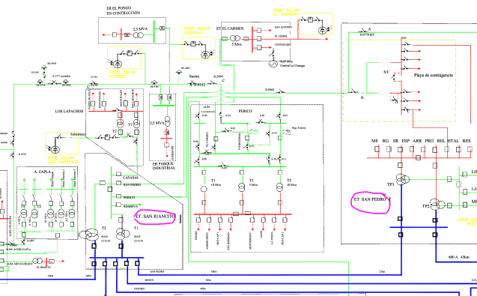
Figure 1, shows part of the SADI and EJESA network and the new Perico I PV power generation plant among others. A detailed description of the single-line diagram can be found in Annex ENGINEERING.
Figure SEQ Figure \* ARABIC 1Perico I PV and SADI connection

Figure 2 Main SADI power transformer substations connected with photovoltaic projects
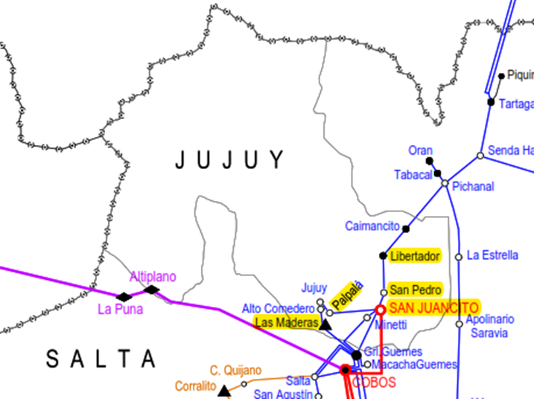

Table 1 SADI Transformer power stations
SADI TRANSFORMER POWER STATIONS LINKED TO RENEWABLE
PV PROJECTS IN JUJUY PROVINCE
 | SAN JUANCITO | LAS MADERAS | PALPALA | SAN PEDRO  JUJUY
SADI ID number | 483 | 279 | 368 | 497
Voltage | 500 kV / 132 kV / 33 kV | 132 kV / 33 kV / 13,2 kV | 132 kV / 33 kV / 13,2 kV | 133 kV / 33 kV / 13,2 kV
Region | NOA | NOA | NOA | NOA
GMS Coordinates | lat. 24°22'36" S, long. 64°59'51" O | lat. 24°36'36" S,  long. 64°13'13" O | lat. 24°15'33" S,  long. 65°11'14" O | lat. 24°14'16" S,  long. 64°41'46" O

The facilities to secure the 19.49MWp (16.5MW) according to PV syst - Simulation report Grid-Connected System version 7.4.2 (18th September 2023) consist of:

System summary
Table 2 System summary
Solar Modules | Wp | 655 | TSM-655DEG21C.20
N° of Modules |  | 29.760
Nominal Power | kWp | 19.493
Trackers |  | 496 | Vanguard 1P60 Dual row technology
Inverters | 300 kW AC  330 kVA AC | 62 | Huawei Technologies Model SUN2000-330 KTL
Transformers | 0,8/33kV  6.600 kVA | 3 | STS 1: 21958UAP9001205 equipment 30001215 model JUPITER-6000K-H1 33kV  STS 2: 21958UAP9001208 equipment 30001218 model JUPITER-6000K-H1 33kV  STS 3: 21958UAP9001207 equipment 30001217 model JUPITER-6000K-H1 33kV
Reclosers | 630A-33kV | 3
Voltage transformer | 33:$\sqrt{3}$/0,11:$\sqrt{3}$  Cl0,5-20VA | 3
Current transformer | 200-400/5/5A  Cl0,5s-30VA | 3
Main meter | Cl 0,2S | 1 | Schneider Electric ION 8650  SN: MW-2302A496-02
Back up meter | Cl 0,2S | 1 | Allen Bradley  PM 5000  SN: 217M4CA6BL
Figure 3 Power flow diagram
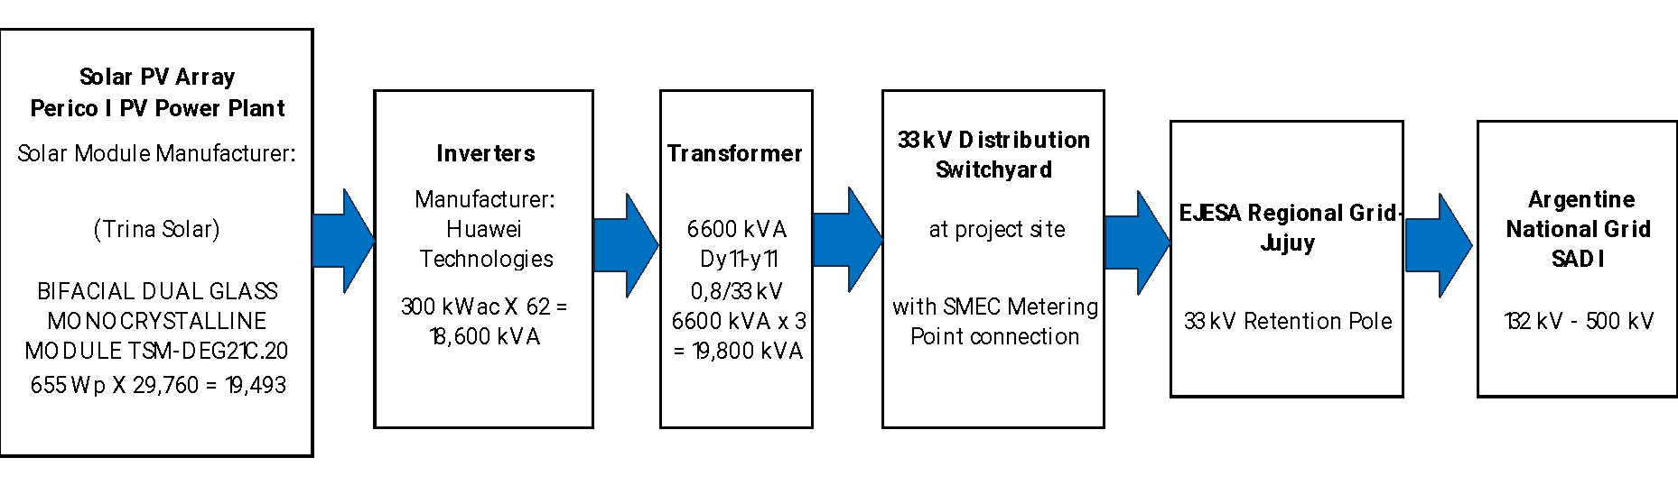
Figure 3 depicts the power flow diagram. Two-way digital meters (main and backup) are installed at the exit of the Distribution Center at project site to measure the electricity supply directly and continuously to the new interconnection point with EJESA. The accuracy class of the electricity meters is 0.2S, which will be verified after commissioning.
The expected useful life of the project equipment is 30 years, according to conservative solar industry standards in this context and the solar panels manufacturer.
  - Project location
The Project sector is in a rural area, within the municipal limits of Perico in the province of Jujuy, Argentina.
Country: Argentina
Province: Jujuy
Municipality: Perico
It is located at the intersection of RNN°66 and RPN°22 in front of the Ciudad Perico Industrial Park, it occupies an area of 45 hectares in a site classified by the Environmental Impact Study as having low landscape value, due to the previous transformation by agricultural activities.
The property coordinates are 24°21'21.45"S 65°06'21.75"O and the following figure shows the details of the polygon coordinates.
Figure 4 Perico Project Gauss Kruger coordinates
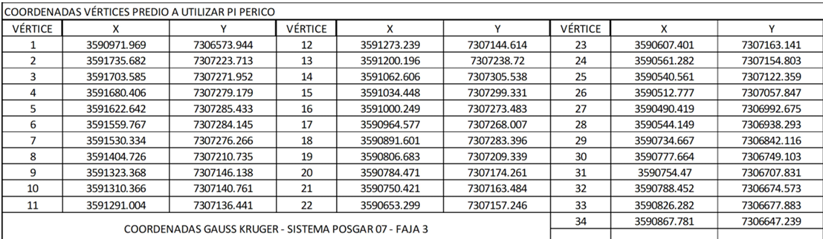
Figure 5 Perico Project location
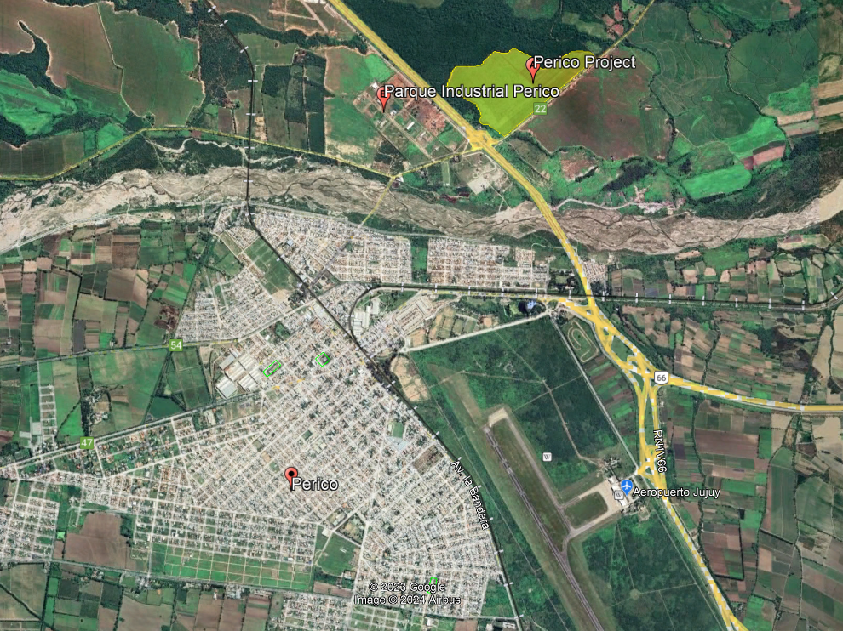
  - Additional information about the GHG Project
The photovoltaic plant will operate automatically and independently with minimal intervention. In the event of problems with the external power grid or the inverters, they will automatically disconnect from the grid. In most cases, the inverters will automatically reconnect once the problems have been resolved.
The installations have been designed under the parameters required by international standards for solar photovoltaic installations and national standards for power generation and transmission.
The solar panels will be connected in series forming strings, each string will be mounted on a support structure called a solar tracker in a row. Each solar tracker will be driven by an independent mechanism. This type of modular installation allows each structure to be placed independently to cause the least possible impact. Solar trackers are structures that allow the solar panel to face the direction in which the sun's rays penetrate the earth's atmosphere. In this way, the energy captured by the panels is greater, and energy production is increased for the same number of panels and surface area occupied.
Figure 6 Perico Project Layout
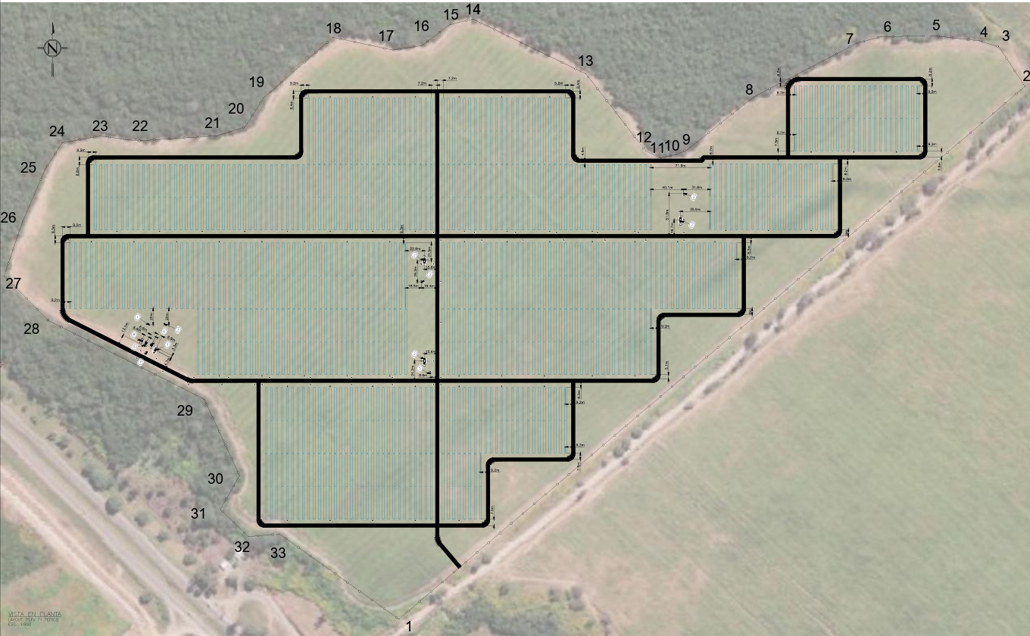
- Quantification of GHG emissions reduction
  - Quantification methodology
As stated in the approved methodology ACM0002 "Grid-connected electricity generation from renewable sources" (version 22.0): If the project activity is the installation of a new grid-connected renewable energy plant/unit, the reference scenario is as follows:
“If the project activity is the installation of a Greenfield power plant with or without a BESS as described under paragraph 4(a) or paragraph 5(a), the baseline scenario is electricity delivered to the grid by the project activity that would have otherwise been generated by the operation of grid-connected power plants and by the addition of new generation sources, as reflected in the combined margin (CM) calculations described in TOOL07.”
    - Applicability conditions of the methodology
As per Paragraph (2) of ACM0002 (Version 22.0, EB 122, Annex 2), “This methodology applies to grid-connected renewable energy generation project activities that include:
(a) Construction and operation of a Greenfield power plant; or
(b) Retrofitting, rehabilitation (or refurbishment), replacement or capacity addition of an existing power plant.
Further, the methodology applies to grid-connected renewable energy generation project activities which integrate Battery Energy Storage System (BESS) to a Greenfield power plant or to an existing solar photovoltaic or wind power plant.
Furthermore, the methodology applies to a grid-connected Greenfield pumped storage project (PSP) which is connected to a Greenfield renewable energy plant through a dedicated line and/or through the grid”
The project activity meets the applicability conditions of the approved consolidated baseline and monitoring methodology ACM0002, Version 22.0, Sectoral Scope 1, EB 122 for Greenfield projects. The following table explains and justifies compliance with the applicability conditions of the methodology used.
Table 3 Compliance of the project activity with respect to the applicability conditions of ACM0002
ACM0002 version 22.0 conditions of applicability | Applicability of the project activity
5. This methodology is applicable to grid-connected renewable energy generation project activities that:  - Install a Greenfield power plant;  - Involves a capacity addition to (an) existing plant(s);  - Involve retrofit of (an) existing operating plant/unit;  - Involves rehabilitation of an existing plant(s)/unit(s); or  - Involves the replacement of an existing plant(s)/unit(s); or  - Install a Greenfield power plant together with a grid-connected Greenfield pumped storage power plant. The greenfield power plant may be directly connected to de PSP or connected to the PSP through the grid | The project activity is the installation of a new grid Solar PV Power Plant at a site where no renewable power plant was operated prior to the implementation of the project activity, (Greenfield power plant), hence the project activity complies with point (a) of the applicability condition of paragraph 5
6. Paragraph (6) is missing in the methodology vs.22
7. In case the project activity involves the integration of a BESS, the methodology is applicable to grid-connected renewable energy power generation project activities that:  (a) Integrate BESS with a Greenfield power plant;  (b) Integrate a BESS together with implementing a capacity addition to (an) existing solar photovoltaic or wind power plant(s)/unit(s);  (c) Integrate a BESS to (an) existing solar photovoltaic or wind power plant(s)/unit(s)  without implementing any other changes to the existing plant(s);  (d) Integrate a BESS together with implementing a retrofit of (an) existing solar photovoltaic or wind power plant(s)/unit(s);  (e) Integrate a BESS together with a Greenfield power plant that is operating in coordination with a PSP. The BESS is located at site of the greenfield renewable power plant. | The project activity is a solar PV Greenfield power plant without integration of a BESS.  These criteria under paragraph (7) are not applicable.
8. The methodology is applicable under the following conditions:  (a) Hydro power plant/unit with or without reservoir, wind power plant/unit, geothermal power plant/unit, solar power plant/unit, wave power plant/unit or tidal power plant/unit;  (b) In the case of capacity additions, retrofits, rehabilitations or replacements (except for wind, solar, wave or tidal power capacity addition projects) the existing plant/unit must have started commercial operation prior to the start of a minimum historical  reference period of five years. The reference period is used for the calculation of baseline emissions and defined in the baseline emission section. Furthermore, no capacity expansion, retrofit, or rehabilitation of the plant/unit has been undertaken between the start of this minimum historical reference period and the  implementation of the project activity;  c) In case of Greenfield project activities applicable under paragraph 7(a) above, the project participants shall demonstrate that the BESS was an integral part of the design of the renewable energy project activity (e.g., by referring to feasibility studies or investment decision documents);  (d) The BESS should be charged with electricity generated from the associated renewable energy power plant(s). Only during exigencies may the BESS be charged with electricity from the grid or a fossil fuel electricity generator. In such cases, the corresponding GHG emissions shall be accounted for as project emissions following the requirements under section 5.4.4 below. The charging using the grid or using fossil fuel electricity generator should not amount to more than 2 per cent of the electricity generated by the project renewable energy plant during a monitoring period. During the time periods (e.g., week(s), months(s)) when the BESS consumes more than 2 per cent of the electricity for charging, the project participant shall not be entitled to issuance of the certified emission reductions for the concerned periods of the monitoring period.  (e) In case the project activity involves PSP, the PSP shall utilize the electricity generated from the renewable energy power plant(s) that is operating in coordination with the PSP during pumping mode. | The project activity is a solar PV Greenfield power plant and hence the criterion under point (a) is met.  The project does not involve any  capacity additions, retrofits or  replacements and therefore the criterion under point (b) is not applicable.  The project activity is a solar PV Greenfield power plant without integration of a BESS and hence the criteria under points (c) and (d) are not applicable.  The project activity is a solar PV Greenfield power plant without integration of a BESS and does not involve a PSP. For this reason the criterion under point (e) is not applicable.
9. In case of hydro power plants, one of the following conditions shall apply:  (a) The project activity is implemented in existing single or multiple reservoirs, with no change in the volume of any of the reservoirs; or  (b) The project activity is implemented in existing single or multiple reservoirs, where the volume of the reservoir(s) is increased and the power density, calculated using equation (7), is greater than 4 W/m²; or  (c) The project activity results in new single or multiple reservoirs and the power  density, calculated using equation (7), is greater than 4 W/m²; or  (d) The project activity is an integrated hydro power project involving multiple reservoirs, where the power density for any of the reservoirs, calculated using equation (7), is lower than or equal to 4 W/m², and all of the following conditions shall apply:  (i) The power density calculated using the total installed capacity of the integrated project, as per equation (8), is greater than 4 W/m²;  (ii) Water flow between reservoirs is not used by any other hydropower unit which is not a part of the project activity;  (iii) Installed capacity of the power plant(s) with power density lower than or  equal to 4 W/m² are:  - Lower than or equal to 15 MW; and  - Less than 10 per cent of the total installed capacity of integrated hydro power project. | The proposed project activity is the installation of a solar PV Greenfield power plant and not a Hydro power plant, therefore the applicability conditions under paragraph (9) are not met
10. In the case of integrated hydro power projects, project participants shall:  (a) Demonstrate that water flow from upstream power plants/units spill directly to the downstream reservoir and that collectively constitute to the generation capacity of the integrated hydro power project; or  (b) Provide an analysis of the water balance covering the water fed to power units, with all possible combinations of reservoirs and without the construction of reservoirs. The purpose of water balance is to demonstrate the requirement of specific combination of reservoirs constructed under CDM project activity for the optimization of power output. This demonstration has to be carried out in the specific scenario of water availability in different seasons to optimize the water flow at the inlet of power units. Therefore, this water balance will take into account seasonal flows from river, tributaries (if any), and rainfall for minimum of five years prior to the implementation of the CDM project activity. | The proposed project activity is the installation of a solar PV Greenfield power plant and is not an integrated hydro power project, therefore these criteria under paragraph (10) are no applicable
11. In the case of PSP, the project participants shall demonstrate in the PDD that the project is not using water which would have been used to generate electricity in the baseline. | The project activity is the installation of a grid connected PV power plant and not a power storage project. This paragraph is not applicable.
12. The methodology is not applicable to:  (a) Project activities that involve switching from fossil fuels to renewable energy sources at the project activity site, as in this case the baseline may be the continued use of fossil fuels at the site;  (b) Biomass-fired power plants/units. | The project activity is the installation of a new grid connected solar power project/ unit and does not involve switching from fossil fuel  to renewable energy, therefore  criterion described in point (a) is  not relevant to the project activity.  This is a solar power plant/ unit  and not a biomass fired plant,  therefore criterion described in  point (b) is not relevant to the project activity
13 In the case of modernizations, rehabilitations, replacements or capacity additions, this methodology is only applicable if the most plausible baseline scenario, as a result of the identification of the baseline scenario, is "continuation of the current situation, i.e., using the power generation equipment that was already in use prior to the implementation of the project activity and performing the usual maintenance". | The project activity is a new grid  connected solar power plant/ unit and not a retrofits, replacement or capacity additions and therefore this criterion is not applicable to the project activity.

Applicability conditions of “Tool 7: Tool to calculate the emission factor for an electricity system”, - Version 07.0 | Applicability of the project activity
3. This tool may be applied to estimate the OM, BM and/or CM when calculating baseline emissions for a project activity that substitutes grid electricity that is where a project activity supplies electricity to a grid or a project activity that results in savings of electricity that would have been provided by the grid (e.g. demand-side energy efficiency projects). | This condition is applicable. OM, BM, and CM are estimated using the tool under section 3.7.3 GHG emissions reduction/removal in the baseline scenario for calculating baseline emissions. The Argentine grid's emission factor is calculated by Argentina´s “Secretaría de Energía” which publishes and calculates the Emission Factor following TOOL07- v7.
4. Under this tool, the emission factor for the project electricity system can be calculated either for grid power plants only or, as an option, can include off-grid power plants. In the latter case, two sub-options under the step 2 of the tool are available to the project participants, i.e. option IIa and option IIb. If option IIa is chosen, the conditions specified in “Appendix 1: Procedures related to off-grid power generation” should be met. Namely,  the total capacity of off-grid power plants (in MW) should be at least 10 per cent of the total capacity of grid power plants in the electricity system; or the total electricity generation by off-grid power plants (in MWh) should be at least 10 per cent of the total electricity generation by grid power plants in the electricity system; and that factors which negatively affect the reliability and stability of the grid are primarily due to constraints in generation and not to other aspects such as transmission capacity. | The Argentine grid's emission factor is calculated by Argentina´s “Secretaría de Energía” which publishes and calculates the Emission Factor following TOOL07- v7.  Since the project activity is grid connected, this condition is applicable and the emission factor has been calculated accordingly
5. In case of CDM projects the tool is not applicable if the project electricity system is located partially or totally in an Annex I country. | The project activity is located in Argentina, a non-Annex I country. Therefore, this criterion is not applicable.
6. Under this tool, the value applied to the CO2 emission factor of biofuels is zero. | The project activity is a grid connected solar power project/ unit and does not involve emission from biofuels. Therefore, this criterion is not applicable.

As per applied methodology ACM0002 "Grid-connected electricity generation from renewable sources" (version 22.0) refers to “TOOL01: Tool for the demonstration and assessment of additionality” to demonstrate de additionality of the project activity, the following table explains and justifies compliance with the applicability conditions of the Tool01-Version 07.0.0

Applicability conditions of “Tool 01: Tool for the demonstration and assessment of additionality”, - Version 07.0.0 | Applicability of the project activity
9. The use of the “Tool for the demonstration and assessment of additionality” is not mandatory for project participants when proposing new methodologies. Project participants may propose alternative methods to demonstrate additionality for consideration by the Executive Board. They may also submit revisions to approved methodologies using the additionality tool. | The project activity is the installation of a new grid Solar PV Power Plant, (Greenfield power plant), and complies with point (a) of the applicability condition of paragraph 5 of the ACM0002 Methodology.  Project participants are not proposing a new methodology to demonstrate additionality, hence, this condition is not applicable.
10. Once the additionally tool is included in an approved methodology, its application by project participants using this methodology is mandatory. | This additionality tool is included in the ACM0002 approved methodology hence this condition is applicable.
As per applied “Tool 1: Tool for the demonstration and assessment of additionality -ver. 07.0.0” applies a step-wise approach for the demonstration of additionality that refers to: “TOOL27: Investment Analysis ver. 14.0” and “Tool 24: Common practice ver. 03.1” to demonstrate de additionality of the project activity, the following tables explains and justifies compliance with the applicability conditions of the mentioned tools:
Applicability conditions of “ Tool 27: Investment analysis; version 14.0” | Applicability of the project activity
2. This methodological tool is applicable to CDM project activities and programs of activities (PoAs) that conduct an investment analysis for the demonstration of additionality and/or the identification of the baseline scenario. | The project activity is the installation of a new grid Solar PV Power Plant, (Greenfield power plant), that applies “Tool 1: Tool for the demonstration and assessment of additionality - ver. 07.0.0” to demonstrate the additionality of the project activity.  According to paragraph 28 of Tool 1, project participants may select to complete steps 2 and 3 of the step-wise approach into Step 2 (Investment Analysis) or Step 3 (Barrier analysis). As per Step 2 (Investment Analysis) has been chosen to demonstrate additionality through “Tool 1: Tool for the demonstration and assessment of additionality -ver. 07.0.0” this condition is applicable.
3. In case the applied approved baseline and monitoring methodology contains requirements for the investment analysis that are different from those described in this methodological tool, the requirements contained in the methodology shall prevail. | As per “Tool 27: Investment analysis version 14.0” has been chosen in Step 2 of the step-wise approach of “Tool 01: Tool for the demonstration and assessment of additionality -ver. 07.0.0”, this condition is applicable.

Applicability conditions of “ Tool 24: Common Practice; version 03.1” | Applicability of the project activity
3. This methodological tool is applicable to project activities that apply the methodological tool “Tool for the demonstration and assessment of additionality”, the methodological tool “Combined tool to identify the baseline scenario and demonstrate additionality”, or baseline and monitoring methodologies that use the common practice test for the demonstration of additionality. | The project activity is the installation of a new grid Solar PV Power Plant, (Greenfield power plant), that applies “Tool 1: Tool for the demonstration and assessment of additionality - ver. 07.0.0” to demonstrate the additionality of the project activity.  This condition is applicable.
4. In case the applied approved baseline and monitoring methodology defines approaches for the conduction of the common practice test that are different from those described in this methodological tool, the requirements contained in the methodology shall prevail. | The project activity is the installation of a new grid Solar PV Power Plant, (Greenfield power plant), that applies methodology “ACM 002 Grid-connected electricity generation ver. 22.0” which refers to “Tool 1: Tool for the demonstration and assessment of additionality - ver. 07.0.0” to demonstrate the additionality of the project activity.  This condition will be taken into account regarding the mentioned methodological framework.
As per applied methodology ACM0002 "Grid-connected electricity generation from renewable sources" (version 22.0) refers to “TOOL05: Baseline, project and/or leakage emissions from electricity consumption and monitoring of electricity generation” to provide procedures to monitor amount of electricity generated in the project scenario when the electricity is supplied to a grid, the following table explains and justifies compliance with the applicability conditions of the Tool 05-Version 03.0.0
Applicability conditions of “ Tool 05: Baseline, project and/or leakage emissions from electricity consumption and monitoring of electricity generation; version 03.0.0” | Applicability of the project activity
5. If emissions are calculated for electricity consumption, the tool is only applicable if one out  of the following three scenarios applies to the sources of electricity consumption:  (a) Scenario A: Electricity consumption from the grid. The electricity is purchased from the grid only, and either no captive power plant(s) is/are installed at the site of electricity consumption or, if any captive power plant exists on site, it is either  not operating or it is not physically able to provide electricity to the electricity consumer;  (b) Scenario B: Electricity consumption from (an) off-grid fossil fuel fired captive power plant(s). One or more fossil fuel fired captive power plants are installed at the site of the electricity consumer and supply the consumer with electricity grid; or  Scenario C: Electricity consumption from the grid and (a) fossil fuel fired captive power plant(s). One or more fossil fuel fired captive power plants operate at the site of the electricity consumer. The captive power plant(s) can provide electricity to the electricity consumer. The captive power plant(s) is/are also connected to the electricity grid. Hence, the electricity consumer can be provided with electricity from the captive power plant(s) and the grid. | The project activity is the installation of a new grid Solar PV Power Plant, (Greenfield power plant), that supplies electricity to the grid and emissions are not calculated for electricity consumption  This condition is not applicable.
6. This tool can be referred to in methodologies to provide procedures to monitor amount of  electricity generated in the project scenario, only if one out of the following three project scenarios applies to the recipient of the electricity generated:  (a) Scenario I: Electricity is supplied to the grid;  (b) Scenario II: Electricity is supplied to consumers/electricity consuming facilities; or  (c) Scenario III: Electricity is supplied to the grid and consumers/electricity consuming facilities. | The project activity is the installation of a new grid Solar PV Power Plant, (Greenfield power plant), that supplies the electricity generated to the grid.  In such a condition, Scenario I of paragraph 6 applies to the project activity.  This condition is applicable
7. This tool is not applicable in cases where captive renewable power generation technologies are installed to provide electricity in the project activity, in the baseline scenario or to sources of leakage. The tool only accounts for CO2 emissions. | The project activity is not a captive renewable power generation technology installation.  This condition is applicable

    - Methodology deviations (if applicable)
Not applicable
  - Project boundaries, sources and GHGs
According to the guidance specified in ACM0002 Methodology (version 22.0), "the spatial extent of the project boundary includes the project power plant/unit and all power plants/units physically connected to the electricity system that the CDM project power plant is connected to".
    - Spatial limits of the project
The project boundary will include the photovoltaic generation and the Transformer Substation where the metering equipment is located, as shown in the following diagram.
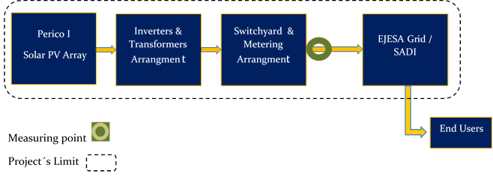
    - Carbon reservoirs and GHG sources
Perico’s photovoltaic power generation project comprises a single source or reservoir. According to ACM0002 - Grid-connected electricity generation from renewable sources – Version 22.0 - Section 5 paragraph 26, the emissions sources included in or excluded from the project boundary are:
Emission sources included in or excluded from the project boundary
Source |  | Gas | Included | Justification
Baseline | CO2 emissions from electricity generation in fossil fuel fired power plants that are displaced due to the project activity | CO₂ | Yes | Main emission source
Baseline |  | CH₄ | No | Minor emission source
Baseline |  | N₂O | No | Minor emission source
Project | For dry or flash steam geothermal power plants, emissions of CH4 and CO2 from non-condensable gases contained in geothermal steam | CO₂ | No | The GHG project does not flash steam geothermal power plant.
Project |  | CH₄ | No | The GHG project does not flash steam geothermal power plant.
Project |  | N₂O | No | The GHG project does not flash steam geothermal power plant.
Project | For binary geothermal power plants, fugitive emissions of CH4 and CO2 from non-condensable gases contained in geothermal steam | CO₂ | No | The GHG project does not binary geothermal power plant.
Project |  | CH₄ | No | The GHG project does not binary geothermal power plant.
Project |  | N₂O | No | The GHG project does not binary geothermal power plant.
Project | For binary geothermal power plants, fugitive emissions of hydrocarbons such as n-butane and isopentane (working fluid) contained in the heat exchangers | Low GWP hydrocarbon/refrigerant | No | The GHG project does not binary geothermal power plant.
Project | CO2 emissions from combustion of fossil fuels for electricity generation in solar thermal power plants and geothermal power plants | CO₂ | No | The GHG project does not solar thermal power plant and geothermal power plant.
Project |  | CH₄ | No
Project |  | N₂O | No
Project | For hydro power plants, emissions of CH4 from the reservoir | CO₂ | No | The GHG project does not hydroelectric power plant.
Project | For hydro power plants, emissions of CH4 from the reservoir | CH₄ | No | The GHG project does not hydroelectric power plant.
Project | For hydro power plants, emissions of CH4 from the reservoir | N₂O | No | The GHG project does not hydroelectric power plant.
Project | Charging of BESS using electricity from the grid or from fossil fuel electricity generators. | CO₂ | No | The GHG project consists of the installation of a solar power plant that does not consider the integration or use of BESS systems in the plant.
Project |  | CH₄ | No
Project |  | N₂O | No
Project | Utilization of electricity from grid or from fossil fuel generators by PSP for pumped mode. | CO₂ | No | The GHG project consists of the installation of a solar power plant that does not consider a pumped storage project (PSP) in the plant.
Project |  | CH₄ | No
Project |  | N₂O | No
Project | For PSP, emissions of CH4 from the reservoir | CO₂ | No | The GHG project consists of the installation of a solar power plant that does not consider a pumped storage project (PSP) in the plant.
Project | For PSP, emissions of CH4 from the reservoir | CH₄ | No
Project | For PSP, emissions of CH4 from the reservoir | N₂O | No

    - Time limits and analysis periods
In accordance with BCR Standard section 10.5, the project time frame corresponds to 7 years periods for the quantification of GHG emission reductions.

Project start date
The construction start date was October 27, 2023 and the start-up date or actual action of the Perico Project September 01, 2024.

Quantification period of GHG emission reductions
The Perico Project is framed within the activities in the energy, transport and waste sectors, the quantification periods are those established by the BCR Standard as 7 years and shall be renewed at least twice, for a maximum total length of 21 years (since 01/09/2024 to 31/08/2045).

Monitoring periods
The monitoring periods will be between one and three years as established by the Biocarbon Standard version 3.4 chapter 22 (closing date of December 31 of the calendar year).
  - Identification and description of the baseline or reference scenario
As demonstrated in point 3.1.1 "Applicability conditions of the methodology"; the project activity is the installation of a new photovoltaic solar power plant (Greenfield Power Plant). Regarding Section 5.2.1 Paragraph 27 of the applied methodology ACM0002 (version 22.0) : “If the project activity is the installation of a Greenfield power plant with or without a BESS as described under paragraph 4(a) or paragraph 5(a), the baseline scenario is electricity delivered to the grid by the project activity that would have otherwise been generated by the operation of grid-connected power plants and by the addition of new generation sources, as reflected in the combined margin (CM) calculations described in TOOL07.”
Baseline scenarios that are described in Sections 5.2.2. Paragraph 28 “Baseline scenario for capacity addition to an existing renewable energy power plant or integration of a BESS to an existing solar photovoltaic or wind power plant/unit” and Section 5.2.3. Paragraph 29 “Baseline scenario for retrofit or rehabilitation or replacement of an existing power plant” of the applied methodology ACM0002 (ver. 22), are not applicable since the project activity is the installation of a new PV power plant, (Greenfield Power Plant).
  - Additionality
Based on the BCR Guidelines for Baseline and Additionality Version 1.3|March 1, 2024, point (6) states “BCR Standard does not include activities that are automatically additional. That mean, in BCR Standard are not considered “positive list”of eligible project types. In addition, point (8) of the mentioned guideline states that project holders in sectors such as energy shall use the Tool provided by the CDM-EB, "am-tool-01-v7.0.0. Tool for the demonstration and assessment of additionality"
Procedure for demonstrating additionally in accordance with TOOL01.Version 07.0.0

The step-by-step approach proposed by TOOL01: Version 07.0.0 has been followed
to establish the additionality of the project. It is detailed below:

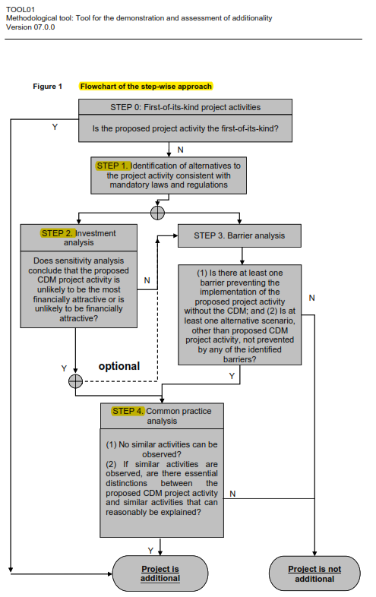

Step 0: Demonstration of whether the proposed project activity is the first of its kind.
The proposed project activity is a solar photovoltaic project; therefore, it is not the
first of its kind in Argentina. Currently, there are 56 photovoltaic solar parks in the country with a total installed capacity of 1,466.9 MW. According to CAMMESA's 2023 Annual Report, the total installed capacity of the electricity generating park was 43,744 MW, of which 1,366 MW corresponded to photovoltaic solar energy, that is, a little more than 3%. Although renewable energy in all its forms is expected to be the fastest growing in the coming years, its scale is still low and transportation restrictions coupled with Argentina's economic crisis are slowing down the process.
On the other hand, regarding the BCR Guidelines for Baseline and Additionality, Version 1.3, March 1, 2024 point (6) “BCR Standard does not include activities that are automatically additional. That mean, in BCR Standard are not considered “positive lists” of eligible project types”.

Step 1: Identification of alternatives to the project activity consistent with mandatory laws and regulations.
According to point (5) of the BCR Baseline and Additionality Guidelines, "…additionality means that verified carbon credits represent reductions in GHG emissions that exceed any GHG reductions:

a) required by law, regulation or legally binding mandate
b) that exceed any reduction or removal of GHGs that would occur in a conservative manner in the absence of the project activity.

In Argentina there are no national or provincial laws that requires electricity generating companies to supply energy from renewable sources.

According to the applied methodology ACM0002 version 22, Para. 27, " If the project activity is the installation of a Greenfield power plant with or without a BESS as described under paragraph 5(a) or paragraph 7(a) or paragraph 7(e) above, the baseline scenario is electricity delivered to the grid by the project activity that would have otherwise been generated by the operation of grid-connected power plants and by the addition of new generation sources, as reflected in the combined margin (CM) calculations described in TOOL07”.
Given that the baseline scenario consists of the installation of a new photovoltaic
plant without a BESS, (Greenfield power plant), that displaces electricity supplied by the grid and is expressly indicated by the methodology applied, no other analyses have been carried out to search for alternatives.

Step 2: Investment Analysis

According to paragraph 29 of TOOL01: v.07.0.0 "Tool for the demonstration and assessment of additionality" it is determined that the proposed project activity is not an economically or financially viable option. To carry out the investment analysis, the methodological tool "TOOL 27.v.12.0_ Investment Analysis" has been taken as a reference, which is valid from -02Nov.22, and whose period includes the date of decision to carry out the project, 28 December 22

Sub-step 2a: Determine the appropriate analysis method.

According to paragraph 32 of TOOL01: v.07.0.0 "Tool for the demonstration and
assessment of additionality", the following three options are available for project analysis:
Option I: Simple Cost Analysis
Option II: Investment Comparison Analysis
Option III: Benchmark analysis
https://cammesaweb.cammesa.com/informe-anual/
The project will generate revenue from the sale of electricity, so Option I is not
applicable.

Option II is also not applicable since there is no comparable investment alternative
available to the project participant.

Therefore, the most appropriate financial analysis method is Option III: benchmark analysis, where the returns on investment in the project activity are compared to a benchmark value available to any investor in the country.

Sub-step 2b: Option III. Apply Benchmark Analysis

In paragraph 36 of the "am-tool-01-v.7.0.0" it is indicated to "Identify the financial/economic indicator, such as IRR, most suitable for the project type and decision context”
The project proponents have considered the after-tax IRR for the investment analysis at the time of decision making. As project proponents, they are interested in the returns that the project generates on the investment costs that they finance in the form of 100 percent equity.
For the selection and validation of the appropriate benchmark for the calculated IRR, paragraph 15 of TOOL 27.v12.0 "Investment Analysis", states that "Local commercial lending rates or WACC are appropriate benchmarks for a project IRR.
Required/expected returns on equity are appropriate benchmarks for an equity IRR. Benchmarks supplied by relevant national authorities are also appropriate”.
Of these options, the proponents consider that the required/expected returns on equity are appropriate benchmarks for an equity IRR.

Comparative Base Value
According to paragraph 18 of TOOL 27.v.12.0, "If there is only one possible project
developer, either internal company benchmarks/expected returns may be applied, or the benchmark based on standard conditions in the market may be used."

Considering that the project activity has a single proponent that finances 100 percent of the project, (100 percent equity), for transparency and simplicity, the proponents consider the benchmark based on standard market conditions to be a reasonable indicator to evaluate the IRR of equity.

According to point 19 of TOOL 27.v.12.0, "If the benchmark is based on parameters
that are standard in the market, the cost of equity should be determined either by: (a) selecting the values provided in the Appendix; or by (b) calculating the cost of equity using CAPM". For the sake of transparency and simplicity, the project developers consider it reasonable to use as a benchmark for the IRR of capital the value of the Appendix of Tool 27 v.12.0 "Default values for the cost of equity (expected return on equity)" corresponding to Argentina Group 1, which is 23.48% in real terms. It is noted that at the date of preparation of this PDD, Tool 27 v.14.0_Investment Analysis_EB 122_31May2024-onwards is in force, which shows the value of 24.01% in real terms for Argentina Group 1 projects. Following a conservative approach, the minimum default value of 23.48% in real terms has been taken.
Finally, it should be noted that the cash flow presented in this process was prepared in real terms since it does not include inflation adjustment in any of its variables. For this reason, we consider that it is not necessary to adjust the benchmark rate for inflation, as proposed in point 16 of Tool 27 v.12.0 "In situations where an investment analysis is carried out in nominal terms and the available IRR benchmarks are in real terms, project participants shall convert the real term values of benchmarks to nominal values by adding the inflation rate"

Sub-step 2c: Calculation and comparison of financial indicators (only applicable to Options II and III).

Input values used in investment analysis (see Perico I - Cash Flow in Annex I)

Project details |  | Source
Project location | Jujuy Province
Total AC capacity (MW) | 16.5 | 20230628 - SECCO - JEMSE - ANDENDA I A CONTRATO ASOCIATIVO- Page 6
Commissioning date | 30/08/24 | Commissioning document
Plant life (years) | 30 | Pagina 119. Trina Solar’s Vertex Bifacial Dual Glass Performance Warranty
Generation and sale of energy
Production @ P50(%) | See Cash Flow "Produccion" spreadsheet | Supplier information. In accordance with Report EB 48-ANNEX 11_ Third party Adenda I. Page 29 a 36
Generation rate contract value (USD/MWh) | 79.00 | Ctto. PPA EJESA- JEMSE - Pagina 11- Artículo 6.1
Contractual term with EJESA-JEMSE and cash flow evaluation period | 20 years | Ctto. PPA EJESA- JEMSE - Pagina 11- Artículo 6.1
Canon JEMSE | 7.00 % | Oferta de Cesión de Posición Contractual- Página 4- Artículo 2
Operating, maintenance and overhead expenses
O & M Expenses | See Cash Flow "O&M" spreadsheet | Planilla 10_COp_JEMSE_Solar_48mW_2024.07
Overhead | 11.32% | Financial statements 31/12/2022 Pag. 17
Financial parameters
Total investment USD | 13,250,837.00 | S/project budget
Demobilization expenses | 0.00 | N/A
Terminal value | 0.00 | N/A
Equity Financing | 100.0% | Industrias Juan F. SECCO
Working capital
Days of accounts receivable | 35.00 | According to contract payment conditions Ctto. PPA EJESA- JEMSE - Pagina 14- Artículo 8.2.2
Accounting and tax depreciation
Depreciable value | See Cash Flow "Inversión" spreadsheet | Amortization values provided by technology supplier
Accounting / tax useful life | See Cash Flow "Inversión" spreadsheet | Amortization values provided by technology supplier
Taxes
Gross income (%) | 1.80% | Ley 6372. Resolución general (DPR) 1658/2024
Tax law 25,413 on credits | 0.40% | National Tax LEY 25413 - Decreto 380/2001, Art. 13° (texto s/D. 409/2018, art. 1 y D. 301/2021, arts. 8° y 9°)
Tax law 25,413 on debits | 0.40% | National Tax LEY 25413 - Decreto 380/2001, Art. 13° (texto s/D. 409/2018, art. 1 y D. 301/2021, arts. 8° y 9°)
Income Tax | 35.00% | National Tax LEY 20628 y modif., Art. 73°, texto s/LEY 27630, Decreto 824/2019 y RG (AFIP) 5168

Project Developer | IRR without VCC | ROE Benchmark
INDUSTRIAS JUAN F SECCO S. A. | 10.35% | 23.48%

The project activity cannot be considered financially attractive given that the project's IRR is lower than the benchmark ROE.

Sub-step 2d: Sensitivity analysis
In addressing Paragraph 27 and 28 of Tool 27 v.12.0 Investment Analysis, the following factors have been subject to sensitivity analysis:
1. Plant Load Factor
2. Operation and Maintenance Cost
3. Project Cost
4. Rate
The rationale for sensitivity is: "The ultimate objective of sensitivity analysis is to determine the probability of occurrence of a scenario different from the scenario presented, in order to provide a cross-check of the reasonableness of the assumptions used in the development of the investment analysis."

 | Equity IRR without Verified Carbon Credits |  | Benchmark (ROE)
Base case | 10.35% |  | 23.48%
Sensitivity Analysis | Equity IRR
Variation % | -10% | Normal | 10% | Variation with respect to benchmark
Energy Production | 8.94% | 10.35% | 11.71% | 100.5%
O&M | 10.43% | 10.35% | 10.26% | 125.1%
Project Costs | 11.77% | 10.35% | 9.15% | 99.5%
Energy Price | 8.94% | 10.35% | 11.71% | 100.5%

The results of the sensitivity analysis show that even with a variation of +10% in project cost, operation and maintenance cost, energy production and energy price, the IRR of the equity is significantly lower than the reference rate. It is also evident from the results given above that the project remains additional even under the most favorable conditions.

Reference index | Probability of default
Power Production  (Plant Load Factor) | The PLF has been considered for financial analysis according to the "Guidelines for Reporting and Validation of Plant Load Factors" set forth in EB48 Annex 11.  It is highly unlikely that a variation in the PLF of more than 10% will occur since the energy production and its reduction over the years was provided in the report of the equipment supplier (third party not involved in the project),
O&M | The sensitivity analysis reveals that O&M costs are irrelevant to the outcome of the IRR value. Furthermore, it is known that these costs are subject to upward escalation due to breakage and inflationary pressure. In short, their reduction over time is highly unlikely.
Project cost | The estimated project cost for the financial analysis is considered from the GPD available at the time of decision making. However, even if we consider actual project costs that differ very little from the estimates, the benchmark is not exceeded. In any case, the Sensitivity is analyzed for a variation of +/-10%.
Value of the fee | For the investment analysis, the tariff considered is 79,00 USD /kWh and is determined by the energy supply contract to JEMSE S.A., which is fixed for the entire 20-year contract period.

Result of Step 2:
The above shows that the investment is not financially attractive, (the IRR for the project activity is lower than the benchmark ROE), so it can be easily concluded that the project activity is additional and is not a business as usual (BAU) scenario.

Step 3: Barrier analysis
Barrier analysis has not been used.

Step 4: Common practice analysis
The step-by-step approach for the common practice analysis was carried out according to the methodological tool "am-tool-24_Common Practice v.03.1 EB84-Annex 7",

Step (1): calculation of the applicable capacity range or production range as +/-50 % of the total design capacity or production of the proposed project activity.
Range | Capacity | Unit
+50% in AC | 24.75 | MW
Capacity of the proposed project activity | 16.5 | MW
-50% in AC | 8.25 | MW

(Step 2): identify similar projects (both CDM and non-CDM) that meet all the following conditions:

a) The projects are located in the applicable geographical area;
b) The projects apply the same measure as the proposed project activity;
c) The projects use the same energy source/fuel and feedstock as the proposed project activity, if a technology switch measure is implemented by the proposed project activity;
d) The plants in which the projects are implemented produce goods or services with comparable quality, properties, and applications areas (e.g. clinker) as the proposed project plant;
e) The capacity or output of the projects is within the applicable capacity or output range calculated in Step 1;
f) The projects started commercial operation before the project design document (CDM-PDD) is published for global stakeholder consultation or before the start date of proposed Project activity, whichever is earlier for the proposed project activity".

The identification of similar projects (CDM and non-CDM) from (Step 2) is carried out as follows:
- Although the project is in the Province of Jujuy; according to paragraph 9 of the "am-tool-24_Common Practice v.03.1 EB84-Annex 7", the applicable area for the common practice assessment extends to the entire territory of the Argentine Republic.
- The project activity is a greenfield solar energy project and corresponds to the category, (measure), (b) of paragraph 10 of the "am-tool-24_Common Practice v.03.1 EB84-Annex 7 "Switch of technology with or without change of energy source including energy efficiency improvement as well as use of renewable energies". Therefore, all projects that apply the same measure (b) as the proposed project activity are candidates for consideration as similar projects.
- The energy source used by the project activity is solar. Therefore, only solar energy projects have been considered for the analysis.
- The project activity produces electricity; therefore, all power plants that produce electricity are candidates for consideration as similar projects.
- The capacity range of the projects is within the applicable capacity range of 8,25 MW to 24,75 MW.
- The project activity start date is foreseen for September 1, 2024. As the Kyoto Protocol was ratified by Argentina on July 13, 2001, therefore, projects that started commercial operation between July 13, 2001 and the date of submission of this PDD have been considered.
Number of similar projects identified according to data published by CAMMESA¹ in its monthly report and ReNaMi ² that comply with the requirements mentioned above.
N_{solar} = 16
(Step 3): within the projects identified in (Step 2), identify those that are not registered as CDM projects, projects submitted for registration, or project activities in the process of validation. Note their N_{all} number. CDM project activities, which have been registered or are in the process of validation, have been excluded in this step. The list of identified power plants is provided to DOE, (Common Practice Summary in Annex I) . After excluding registered and validating projects, the total number of projects is:
N_{all} = 11
Step (4): within similar projects identified in (Step 3), identify those that apply technologies that are different from the technology applied in the proposed project activity. Note their Ndiff number. According to "am-tool-24_Common Practice v.03.1 EB84-Annex 7", paragraph 12; project activities have been separated based on different technologies; item (d) Investment climate at the date of the investment decision, (iv) Legal regulations. Of the projects identified above, those projects employing "different technologies" have been excluded and the number of such projects has been identified as N_{diff}. Therefore, photovoltaic projects between 8.25 MW and 24.75 MW existing in the Republic of Argentina that have signed a Power Sales Contract that do not have the same contractual conditions of sale of energy as “the Project” , are assumed to be governed by different investment climates. Therefore, such projects that come under a different investment climate have been considered as N_{diff}.
All of the projects identified in (step 3), have Power Purchase Agreements (PPAs) with Compañía Administradora del Mercado Mayorista Eléctrico Sociedad Anónima (CAMMESA), therefore, they are differentiated by the "investment climate" and can be considered as projects that employ "different technologies".
Therefore:
N_{diff} = 11
(Step 5): calculate the factor F=1-N_{diff}/_{Nall} representing the proportion of similar projects, (penetration rate of the measure/technology), using a measure/technology similar to the measure/technology used in the proposed project activity and delivering the same result as the proposed project activity.
Calculate F = 1-N_{dif}/N_{all} = 1-(11/11) = 0
N_{all} - N_{diff} = 11 - 11 = 0
Result of (Step 5):
As,
i. F = 0; it is less than 0.2 y
ii. N_{all}-N_{diff} = 0; it is less than 3, therefore:
As the project activity does not satisfy conditions (i) and (ii), the proposed project activity is not a "common practice" within a sector in the applicable geographic area. All the above shows that the proposed project activity is not a common practice and is not financially attractive. Therefore, the project activity is additional.
  - Uncertainty management
The data used for the quantification of the baseline are based on the methodologies mentioned in point 3.7.3 and on the information provided by official agencies (Secretaría de Energía de la Nación) that have traceable and reliable data provided by each generator in Argentina.
  - Leakage and non-permanence
According to ACM0002 Methodology (version 22.0) “No other leakage emissions are considered. The emissions potentially arising due to activities such as power plant construction and upstream emissions from fossil fuel use (e.g. extraction, processing, transport etc.) are neglected.”
Monitoring of project and ensuring the permanence of project activities will be carried out through verifications, which will be carried out by a Conformity Assessment Body (CAB) and with a frequency between one and three years as established by the Biocarbon Standard version 3.4 chapter 22.
  - Mitigation results
The mitigation results achieved as a result of the implementation of the Perico project are verifiable under ISO 14064-3:2019 and in accordance with the requirements of the BCR standard.
    - Eligible areas within GHG project boundaries (AFOLU sector projects)
Nos applicable
    - Stratification (Projects in the AFOLU sector)
Nos applicable
    - GHG emissions reduction/removal in the baseline scenario
Based on ACM0002 Methodology (version 22.0) the baseline emissions include only CO2 emissions from electricity generation in fossil fuel fired power plants that are displaced due to the project activity. The methodology assumes that all project electricity generation above baseline levels would have been generated by existing grid-connected power plants and the addition of new grid-connected power plants. The baseline emissions are to be calculated as follows:
B𝐸𝑦 =𝐸𝐺𝑃𝐽, ×𝐸𝐹𝑔𝑟𝑖𝑑,,
Where:
B𝐸𝑦 = Baseline emissions in year y (t CO2/yr)
E𝐺𝑃𝐽,𝑦 = Quantity of net electricity generation that is produced and fed into the grid as a result of the implementation of the CDM project activity in year y (MWh/yr)
According to the calculation made by Secco through the PVSyst production calculation software for photovoltaic systems, the expected power generation for 20 years with a probability of occurrence P50 is shown in the table below;
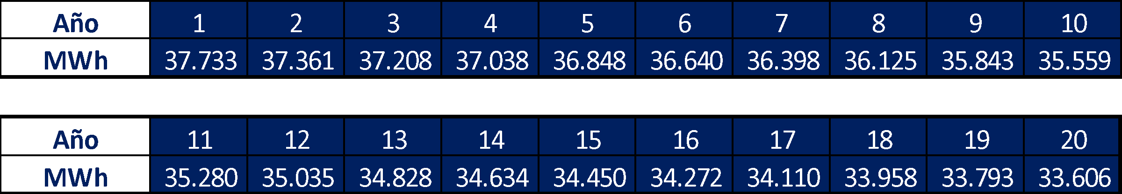
E𝐹𝑔𝑟𝑖𝑑, = Combined margin CO2 emission factor for grid connected power generation in year y calculated using TOOL07 (t CO2/MWh)
To determine the combined emission factor of the Argentine Interconnection System, (SADI), the following six steps described in paragraph 14 of "am-tool-07-v7.0" have been followed;
Step 1: Identify the relevant electricity systems.
To determine the electricity emission factors, the project's electricity system is defined by the spatial extent of power plants that are physically connected (including imports) through transmission lines that can be sent without significant transmission constraints. In this case, to the SADI.
Step 2: Choose whether to include off-grid power plants in the project electricity system (optional) Project participants may choose between the following two options to calculate the operating margin and build margin emission factor:
Option I: Only grid power plants are included in the calculation.
Option II: Both grid power plants and off-grid power plants are included in the calculation.
Option I is defined.
Step 3: Select a method to determine the operating margin (OM)
According to the data provided by CAMMESA and the "TOOL07: Tool to calculate the emission factor for an electricity system" the participation of Low-cost/must-run (LCMR) resources is less than 50%, (according to CAMMESA the LCMR generation reached 41%), therefore following the Flow chart below, Simple OM should be considered.
In this opportunity the ex-ante option is selected for Perico I Project, therefore:
For the simple OM, the simple adjusted OM and the average OM, the emissions factor can be calculated using either of the two following data vintages:
- Ex-ante option: if the ex-ante option is chosen, the emission factor is determined once at the validation stage, thus no monitoring and recalculation of the emissions factor during the crediting period is required. For grid power plants, use a 3-year generation-weighted average, based on the most recent data available at the time of submission of the CDM-PDD to the DOE for validation.
For off-grid power plants, use a single calendar year within the five most recent calendar years prior to the time of submission of the CDM-PDD for validation.
Step 4: Calculate the operating margin emission factor according to the selected method.
The simple OM may be calculated by one of the following two options:
(a) Option A: Based on the net electricity generation and a CO2 emission factor of each power unit; or
(b) Option B: Based on the total net electricity generation of all power plants serving the system and the fuel types and total fuel consumption of the project electricity system. Option B can only be used if:
(i) The necessary data for Option A is not available; and
(ii) Only nuclear and renewable power generation are considered as low-cost/must-run power sources and the quantity of electricity supplied to the grid by these sources is known; and
(iii) Off-grid power plants are not included in the calculation (i.e. if Option I has been chosen in Step 2).
As the Argentina´s Secretaría de Energía publish and calculate the Emission Factor following TOOL07 v7.0, the option B will be used. Under this option, the simple OM emission factor is calculated based on the net electricity generation and an emission factor for each power unit, as follows:
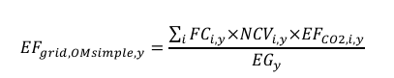Equation 9
The following table shows the Emission Factor Estimates made in the country; data provided by the Secretariat of Energy - Strategic Planning of the Nation

Table 4 Operating Margin
Step 5: Calculate the build margin (BM) emission factor
In terms of vintage data, project participants can choose between one of the following two options:
(a) Option 1 - for the first crediting period, calculate the build margin emission factor ex ante based on the most recent information available on units already built for sample group m at the time of CDM-PDD submission to the DOE for validation. For the second crediting period, the build margin emission factor should be updated based on the most recent information available on units already built at the time of submission of the request for renewal of the crediting period to the DOE. For the third crediting period, the build margin emission factor calculated for the second crediting period should be used. This option does not require monitoring the emission factor during the crediting period;
(b) Option 2 - For the first crediting period, the build margin emission factor shall be updated annually, ex post, including those units built up to the year of registration of the project activity or, if information up to the year of registration is not yet available, including those units built up to the latest year for which information is available. For the second crediting period, the build margin emissions factor shall be calculated ex ante, as described in Option 1 above. For the third crediting period, the build margin emission factor calculated for the second crediting period should be used.

Option 1 is selected for the Perico Project
Table 5 Build Margin
Build Margin
 |  | 2023
BM | tCO2/MWh | 0,0860
EG m,y | MWh | 24.574.691
Emisiones | tCO2 | 2.113.513
Suma control | tCO2/MWh | 0,08600366
BM | tCO2/MWh | 0,0860

Step 6: Calculate the combined margin (CM) emissions factor
The calculation of the combined margin (CM) emission factor (EFgrid,CM,y) is based on one of the following methods:
(a) Weighted average CM; or
(b) Simplified CM
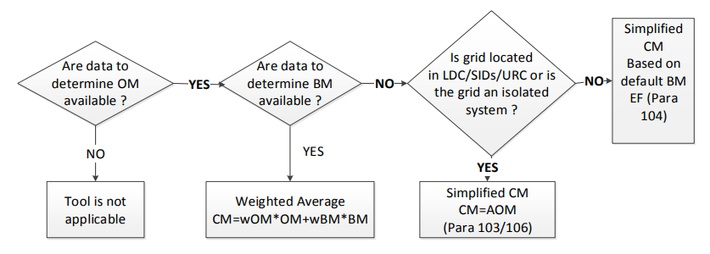
Therefore, option (a) Weighted average CM applies to the Perico I Project, where
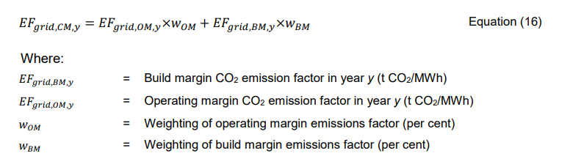
According to the tool,
The following default values should be used for W_{OM} and W_{BM} :
Wind and solar power generation project activities: W_{OM} = 0.75 and W_{BM} = 0.25 (owing to their intermittent and non-dispatchable nature) for the first crediting period and for subsequent crediting periods
Therefore, EF grid,CM,y = 0.3566 tCO2/MWh
    - GHG emissions reduction/removal in the project scenario
According to the methodology ACM0002 (Version 22.0), the emission reduction is calculated as:
Where:
PE_{y} = Project emissions in year y (tCO2e/year)
PE_{FF, y} = Project emissions from fossil fuel consumption in year y (tCO2/year)
PE_{GP, y} = Project emissions from the operation of binary, instantaneous steam or dry geothermal power plants in year y (t CO2e/yr)
PE_{HP, y} = Emission from hydroelectric power plant water reservoirs project in year y (tCO2e/year)
PE_{BESS,y} = Project emissions from charging of a BESS using electricity from the grid or from fossil fuel electricity generators (t CO2e/yr)
PE_{PSP,y} = Project emissions from utilizing electricity from the grid for pumping operation of PSP in excess to the production of the renewable power plan operating in coordination with the PSP (t CO2e/yr)
Project emissions due to fossil fuel consumption (PE_{FF, y}).
No emissions are expected from the project as the project activity only involves the generation of renewable electricity from the solar power plant without fossil fuel consumption, and according to paragraph 42 of ACM0002 "for all renewable energy power generation activities, emissions due to the use of fossil fuels for the backup generator can be neglected”, hence PE_{FF},y = 0.
Project emissions from the operation of dry geothermal, flash steam or binary geothermal power plants PE_{GP}, _{y}
The project is a solar power plant, therefore, this term does not apply and PE_{GP, y} = 0.
Emissions from hydroelectric power plant water reservoirs (PE_{HP, y})
The project is a solar power plant, therefore, this term does not apply and PE_{HP, y =} 0.
PE_{BESS, y} = Project emissions from charging of a BESS using electricity from the grid or from fossil fuel electricity generators (t CO2e/yr)
The project activity does not include the incorporation of a battery energy storage system, (BESS); consequently, PE_{BESS, y} =0
PE_{PSP,y} = Project emissions from utilizing electricity from the grid for pumping operation of PSP in excess to the production of the renewable power plan operating in coordination with the PSP (t CO2e/yr.)
The project activity is a grid-connected Greenfield PV power plant only and it does not involved any connection to a pump storage project, (PSP), through a dedicated line or through the grid. Consequently, PE_{PSP, y} =0

Table 6 Estimated net GHG reduction
Year | GHG emission reductions in the baseline scenario (tCO2e) | GHG emission reductions in the project scenario (tCO_{2e}) | GHG emissions attributable to leakages (tCO_{2e}) | Estimated Net GHG Reduction (tCO_{2e})
2024 (since 01/09/2024) | 4,485 | 0 | 0 | 4,485
2025 | 13,322 | 0 | 0 | 13,322
2026 | 13,268 | 0 | 0 | 13,268
2027 | 13,207 | 0 | 0 | 13,207
2028 | 13,139 | 0 | 0 | 13,139
2029 | 13,065 | 0 | 0 | 13,065
2030 | 12,979 | 0 | 0 | 12,979
2031 (until 31/10/2031) | 8,587 | 0 | 0 | 8,587
Total | 92,052 |  |  | 92,052

Total estimated annual average 13,150 tCO₂e/y
- Compliance with Laws, Statutes and Other Regulatory Frameworks
SECCO complies with Ley N° 19.550 de Sociedades, Ley N° 20.744 de Contrato de Trabajo (LCT), Ley N°24.557 de Riesgos del Trabajo, among others, besides has traceability of all the information mentioned in this document and has a legal and administrative area that guarantees access to and knowledge of the relevant legislation and regulations and updates of these when they occur.
SECCO is a private legal entity committed to due compliance with the laws and regulations applicable to its business, as well as to the care and satisfaction of its customers.
Considering that each sector and project has its own specificity, characteristics and technicality, SECCO carries out a decentralized regulatory control, i.e., each area involved identifies, monitors, analyzes and communicates internally the regulations relevant to its function. The details of how each area carries out the above and its traceability are detailed in the internal procedure "REGULATIVE MANAGEMENT SYSTEM".
In addition to the above, Secco has a telephone number and an email address in all generation plants and offices to make complaints, which are received by a compliance officer who guarantees their confidentiality and treatment.
- Carbon ownership and rights
  - Project holder
Individual or organization | INDUSTRIAS JUAN F SECCO S. A.
Contact person | Hernan Juri
Job position | Administration & Finance Manager
Address | Rosario, Argentina.  Juan Pablo II 5665 (Circunvalación Ave. and Uriburu Ave. collector)
Phone number | +54 (0341) 409-4000
Email | hjuri@secco.com.ar

  - Other project participants
Individual or organization | Sustainable Carbon Finance LLC
Contact person | Alejandra Camara
Job position | Proposer
Address | CABA, Argentina  La Pampa 1940
Phone number | Landline: +541147865007  Cellular phone: +5491135202929
Email | alejacamara@gmail.com
Sustainable Carbon Finance LLC has no agreements on the credits generated during the implementation of the Perico Project.
  - Agreements related to carbon rights
Regarding carbon rights, Industrias Juan F. Secco and JEMSE / EJESA signed an agreement on the production and supply of renewable energy that specifically addresses this issue. The following is the key information required and excerpts from the agreement that verify what is stated in this document
- parties signing the agreement(s);
Jujuy Energía y Minería Sociedad Del Estado (JEMSE)
Empresa Jujeña de Energía S.A. (EJESA)
INDUSTRIAS JUAN F SECCO S. A.
- purpose of the agreement;
JEMSE and EJESA develop a Power Purchase Agreement (PPA) in which EJESA agrees to purchase and pay for all registered energy generated within the framework of the Proyecto Solar Fotovoltaico Distribuido de la Provincia de Jujuy. Following this, JEMSE and SECCO develop an Associative Agreement in which JEMSE agrees to assign and transfer to SECCO its contractual position in the PPA Agreement. SECCO assumes ownership of the PPA Agreement and will pay JEMSE a fee described in the third clause of the Associative Agreement under Participation Percentage concept.
- date of the agreement;
28th December 2022
- name of the GHG project;
Proyecto Solar Fotovoltaico Distribuido de la Provincia de Jujuy Perico I PV Power Plant.
- period of quantification of GHG emission removals/reductions;
01/09/2024 to 31/08/2031
- responsibilities, obligations, and rights of each of the signatory parties.
SECCO is the exclusive beneficiary in all matters related to Green Certificates, Renewable Energy Certificates, Carbon Certificates and/or similar. See PPA Agreement-Art. 6.2 and Art. 12 in the Associative Agreement.
  - Land tenure (Projects in the AFOLU sector)
Not applicable
- Climate change adaptation
SECCO is a leading company in the country and the region, with more than 80 years of experience. In its beginnings, SECCO consolidated its position in the metal-mechanic activity by repairing the drive engines of the generator sets owned by its customers and its own, being the owner of an industrial plant in constant growth and updating with the latest technology located in the city of Rosario, Province of Santa Fe. Gradually and from the change in the business conception that took place in the country, SECCO was strengthened in the field of the provision of services developing great experience, particularly in the generation of electric power and gas compression.
The great growth of the company took place at the beginning of 2001 when, due to the economic situation of the country, SECCO began to grow exponentially with the generation of electric energy through engines generated with fossil fuels.
As early as 2005, the company's executive board made clear in a board minute the importance of combating climate change. In 2008 it submitted a project to CDM that dealt with the capture of waste gases at the wellhead to generate electricity. This project was not registered for various reasons, but it was a pioneer in the development of the methodology used:
(https://cdm.unfccc.int/Projects/Validation/DB/HIU1MR6WZ19GKZ73Y9UHXLBSQI0J2O/view.html)
Being a provider of integral solutions in power generation for the most demanding clients in the public and private sector, thanks to its technological advances and experience in the industry and hand in hand with internationally renowned brands, SECCO assembles, installs, commissions, enables, operates and maintains solar, hybrid, mono-fuel and multi-fuel power generation plants and units of high complexity capable of generating energy according to the specific requirements of each client. SECCO reaches every corner of the country, responding to diverse demands and ensuring the achievement of the expected results.
SECCO has more than 10 years of experience in Process Management for the design, construction, qualification, and operation of Power Generation Plants from renewable sources, performing from the design and engineering of the plants to the administrative management, environmental studies, commissioning and start-up of these, and in all cases developing a customized solution for each client and environmental needs.
The company has the know-how, personnel and capacity for the design, development of engineering and suppliers, construction, commissioning, operation and maintenance of photovoltaic and hybrid generation plants that meet the needs of each client.
As a background in photovoltaic, SECCO carried out the conversion project of the Piedra Negra Thermal Power Plant, which is located at 3,600 meters above sea level, incorporating a solar plant with more than 5 thousand panels and banks with lithium ion batteries for energy accumulation, in order to guarantee the reliability of the System, transforming it into the first Hybrid Power Plant (photovoltaic/storage/thermal) at altitude for an isolated system in Latin America, ensuring one of the highest percentages of availability in the market.
SECCO has more than 1,500 MW installed in more than 130 Generation Plants that generate in isolated systems or connected to the National Interconnected System (SADI) providing solutions tailored to the needs of each client with state-of-the-art and highly complex equipment. Has installed more than 50 MW in MSW Biogas Projects, more than 30 MW in substrate Biogas Projects and a hybrid plant composed of solar and thermal energy with energy accumulation to guarantee the reliability of the system. Last year, Industrias SECCO registered before the BCR Standard the "CASA La Calera, San Luis Solar Project" ID BCR-AR-131-1-001, a 20 MW photovoltaic project installed in the province of San Luis. To date, SECCO is working on the completion and installation of solar energy projects for 48 MW distributed in 7 solar plants in the province of Jujuy; totaling 178MW installed in renewable energy.
CT NAME | OBJECT | SOURCE | CLIENT | MW INSTALLED | YEAR PEM
CT LA CALERA | OWN CT WITH O&M | SOLAR | CEMENTOS AVELLANEDA S.A. | 20 | 2023
CT JEMSE | OWN CT WITH O&M | SOLAR | EJESA | 48 | 2023
CT SAN MARTIN NORTH III DI | OWN CT WITH O&M | BIOGAS MSW | CAMMESA | 4,2 | 2023
CT SAN MARTIN NORTH III AGC | OWN CT WITH O&M | BIOGAS MSW | CAMMESA | 7,5 | 2023
CT VARIOUS | RENTAL WITH O&M | BIOGAS SUST. with Heat Recovery | VARIOUS | 23 | 2021/2022
CT BLACK STONE | OWN CT WITH O&M | HYBRID (SOLAR + STORAGE + THERMAL) | EJESA | 12,4 | 2021
CT SAN MARTIN NORTE III D | OWN CT WITH O&M | BIOGAS MSW | CAMMESA | 7,5 | 2021
CT SAN MIGUIEL | RENTAL WITH O&M | BIOGAS MSW | TECSAN | 5,2 | 2021
CT ENSENADA | OWN CT WITH O&M | BIOGAS MSW | CAMMESA | 7,5 | 2019
CT BIOGAS AVELLANEDA | OWN CT WITH O&M | BIOGAS SUST. with Heat Recovery | CAMMESA | 7,5 | 2019
CT KDM | O&M | BIOGAS MSW | KDM S.A. | 24 | 2012
CT EDAM | O&M | BIOGAS SUBSTRATES | EDAM S.A. | 12,7 | 2012

In line with the above, in 2019 the Code of Ethics and Conduct was implemented, which expressly regulates SECCO's commitment to the implementation of best environmental practices in the different sectors in which it operates, as well as the continuous improvement of environmental protection, safety and hygiene systems to obtain results of lower environmental impact as an integral part of the company's operations strategy. The Code of Ethics is part of the Company's Integrity Program, which is in force and enforceable for all employees and internal officers, suppliers, distributors, service providers, consultants, among others. It is publicly available and can be accessed from the web page .
The above actions of the company contribute to achieving the objectives set out in the Second Adaptation Communication of the Argentine Republic and are in line with the same, where "35 priority adaptation measures are identified in seven sectors of the country to address the different territorial, socioeconomic and environmental.
- Risk management
The Environmental Impact Assessment (EIA) was carried out by independent experts and made it possible to analyze the type, magnitude, and complexity of the project and its relationship with the characteristics of the social, physical, and biological environment that could potentially be affected. The methodological analysis used complies with national, provincial, and municipal regulations.
The EIA was presented at the beginning of 2019 and involved the Identification and Characterization of Environmental Impacts, Risk Analysis and Environmental Sensitivity for the preparation, construction, and operation stages.
In May of the same year, the Secretariat of Environmental Quality approved the Feasibility of the project under Resolution No. 193/2019-SCA. In January 2023, a rectification was presented regarding generation and area (Exp. 1101-103-J/2019) and it was approved under Resolution N° 97/2023-SCA. Finally, in September 2023, the current scope of the project was approved by Resolution N°419/2023-SCA.
Chapter 6 of the EIA studies the Identification and Characterization of Environmental Impacts in all stages of the project.
The technique called Delphi Method was applied, which allows obtaining a table of Importance of the different environmental components considered for the description of the existing environmental situation, according to the importance or merit that they present to be "protected or conserved" from the impacts of the project or activity.
In conclusion, for the Perico Project, the perceptual component and Air are the most negatively impacted, while Employment continues to be recognized as the greatest beneficiary.
Chapter 7 establishes the Measures Mitigation Plan that arise in response to the negative impacts that were detected.
The site location; with immediate access through RN°66 and RPN°22; in the vicinity of Perico city, next to the industrial park, close to the city of San Salvador de Jujuy and adjacent to service networks, markets and airport caused the result of impact on native communities to have been defined as impact having the lowest category.
Internally SECCO has implemented an Integrity Program, which can be viewed on the website https://www.secco.com.ar/ composed of:
- Code of Ethics and Conduct
- Management Support
- Prevention of illegal activities with the public sector
- Training policy
- Whistleblower protection
- Whistleblower channels and ethics hotline
- Due diligence to business partners
- Customer due diligence
- Compliance Officer
- Complimentary gift policy

  - Reversal Risk
Risk and permanence tool version 1.1 was used for identifying potential financial risks, since environmental and social risks were considered in the EIA.
To consider the risk of increased investment and/or maintenance budget, sensitivity analyses were made to the economic model.
Regarding minimizing reversal risks, it should be considered the term of the current contract is 20 years from the Commercial Qualification of the Photovoltaic Plant (PPA-Art 3.3). And the contract also provides for early exit clauses that consider the payment of compensation and the mechanism for calculating the Asset Price in the event of reversion or upon termination of the contract (PPA-Cláusula Décimo Primera)
    - Loss Event Report
Not applicable.
- Sustainable development safeguards (SDSs)
The project is in accordance with Sustainable Development Safeguards SDSs Tool version 1.1. and with the Argentinian law N°27401 /2017 de Responsabilidad Penal de Personas Jurídicas.
It is important to highlight the land is property of the province of Jujuy and in art. 2.11.e) of the Association Agreement, it is established as an obligation on the part of JEMSE to cede to SECCO the full and peaceful use and enjoyment of the land, and in point f) JEMSE undertakes to guarantee the availability and permanence of the land for 20 years. There were no native populations on the ceded land.
The site selected is currently under dryland agriculture, with monoculture and for rent. In the middle term a progressive loss of profitability and production can be expected due to a lack of fertilization and erosion (wind, water), etc.
The location has immediate access through RN°66 and RPN°22; in the vicinity of Perico city, next to the industrial park and close to the San Salvador de Jujuy city and adjacent to service networks, hub markets, airport, etc.; These characteristics provides a favorable opportunity cost for other industrial, or service uses. It is foreseeable that in the next years will be pressure for a change in land use, associated with an urbanization process. Which demands spaces for logistics, production, marketing and energy generation.
As evidence Perico Project is attached the EIA, it contains details of what was analyzed in Chapter 5. Environmental Risk and Sensitivity Analysis and in Chapter 6. Identification and Characterization of Environmental Impacts.
The Delphi Method and Conesa Fernández Vítora methodology was applied.
Table 7 Perico Project Environmental characterization impacts
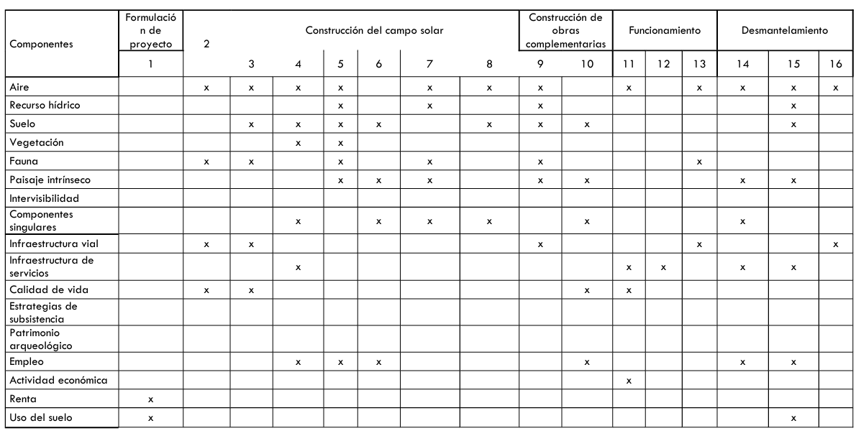
The following image shows the impacts classification according to the EIA, in conclusion the project does not cause significant variations, except that the Perceptual Component and Air (the most negatively impacted), while Employment is the greatest beneficiary.
Figure 7 Perico project environment impacts
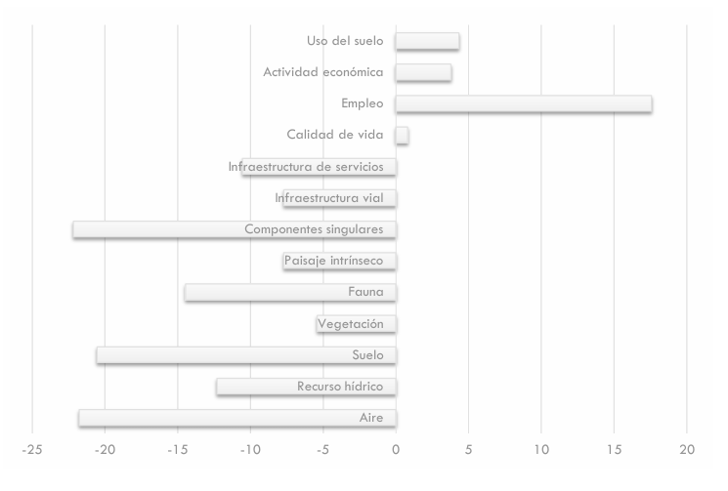
An Environmental Management Plan (EMP) was prepared whose objective is to ensure the correct environmental management of the different actions of the work during the construction, operation and closure or dismantling phases. In this way, the impact on the environmental quality of the receiving environment of the undertaking, in its natural and socioeconomic aspects, will be avoided.
The components: air, biotic, perceptual, soil, water resources, impacts on the Socio-Economic Environment and Territorial Development, road and service infrastructure has a detail EMP (Chapter 8 EIA).
The EIA involved both in-house and survey tasks in the area. Regarding socio-economic aspects, the impact of the project was analyzed on: biodiversity and ecosystems, cultural heritage, involuntary resettlement, native communities and erosion risk. The area of Direct Influence was even taken into account (covering the area where each solar plant will be installed and the immediately adjacent areas) and the Area of Indirect Influence (covering the El Pongo Farm, Perico Industrial Park, the urban center of Perico and Santo Domingo)
For the analysis, the methodology proposed by Hernández (2013) was adopted and as can be seen, the Perico Project resulted in a low rating, without the need to implement mitigation measures or management plans.
Table 8 Socio-economic aspects
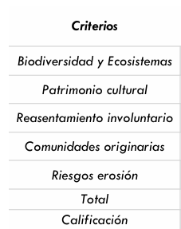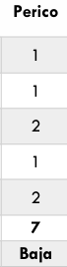

- Stakeholder engagement and consultation
The stakeholders meeting was conducting on November 3 2023 where the "Distributed Solar Photovoltaic Project of the Province of Jujuy" and specific details of the Perico project were described. Projects located in Perico, Cannava and Los Lapachos were grouped together in the same stakeholder meeting due to the proximity between the sites and that they are located in the same region called Valle Sur.
The consultation process is described below:
- the scope of stakeholder consultations: local authorities, media, schools educational authorities in the area and the community.
- the number of stakeholders consulted: 71 people attended the meeting
- the means used to invite interested parties to participate in the consultations; The invitation was sent to the Mayor (Intendente) of the municipality of El Perico and was published in the local newspaper "El Tribuno" and "El Pregón" on 10/27/23, 10/28/23 and 10/30/23.
- It was also published on social networks such as Facebook, JEMSE's website and Linkedin, Facebook of the Government of Jujuy and the graphic invitation was also placed in the House of Culture, Arturo Zabala Hospital and the Revenue Department.
- The information that was made available to stakeholders during the consultation process: The project presentation (characteristics, execution deadlines, generation), its coherence with the provincial objectives, the EIA and its results. It was also communicated that the project would apply to obtain carbon credits, and a general explanation about this.
- the meetings, workshops and other processes developed in the framework of the stakeholder consultation: The contact email contacto@secco.com.ar was made available during the stakeholders meeting difussion where they could send questions or doubts about the project.
For evidence regarding to invitations, meeting, assistance and opinion survey see the folder STAKEHOLDERS MEETING.
  - Summary of comments received
The comments received in the opinion survey are transcribed below.
Table 9 Summary of comments received
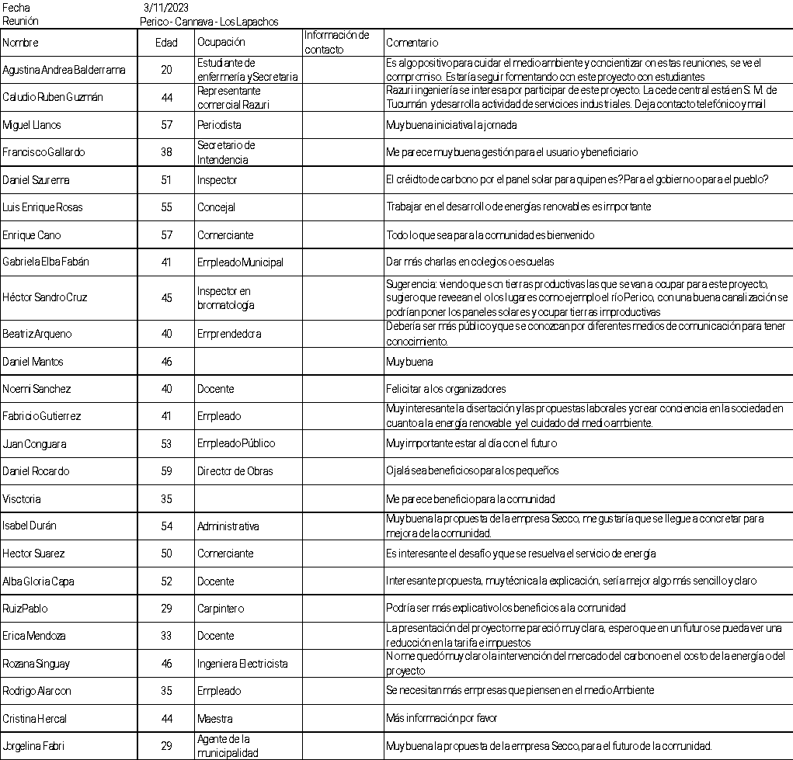
  - Consideration of comments received
Unfortunately, no participant left their contact information or sent the same comment to the postal address, so it was impossible to respond formally to the suggestions or questions. In any case, after the presentation, the concerns were discussed between the interested party and the representatives of JEMSE and SECCO.
- Sustainable Development Goals (SDGs)
The Tool for Determining the Contributions of GHG Projects to Achieving the Sustainable Development Goals (SDGs) proposed by BioCarbon was used as a support and basis for the identification of the SDGs on which the project has an impact and its rationale.
All the Sustainable Development Goals that are linked to the Perico Project, their description and objectives are specified below. It should be clarified that these were not incorporated in the Tool proposed by BioCarbon due to their specificity and their specific framework for action in the surrounding community.
  - SDG 3 Ensure healthy lives and promote well-being for all and all ages
SECCO understands that the development and strengthening of alliances is fundamental to achieving the necessary engagement with the community and surrounding organizations.
Objectives:
Organize at least one annual on-site training with Perico's volunteer firefighters and generate an exchange of knowledge. Ensure that they are familiar with the facilities and promote efficient emergency response.
  - SDG 5: Gender equality.
Searches for permanent personnel will not have any clarification on gender preference and the estimated salary for such functions is defined independently of who occupies the position.
As part of the Secco policy described above, during the construction and assembly phase an attempt was made to employ women. The search for personnel was open to both genders; no CVs were received from women who met the technical requirements. If a new search is to be carried out, it will be under the same modality.
Secco believes that the Argentina northern region preserves the idiosyncrasy and customs of the indigenous peoples more deeply than in the rest of the country and this is the reason why it was difficult to incorporate women into this kind of jobs.
Objective: to increase the participation of women involved in the Perico Project.
  - SDG 7: Affordable and clean energy
The project generates up to 36.879 GWh/year that are incorporated into the country's energy matrix.
Objective: to maintain photovoltaic generation following good operation and maintenance practices.
  - SDG 8: Decent Work and Economic Growth
The project generated temporary jobs during construction and assembly, and during operation at least 2 people from Jujuy are employed on a stable basis for operation and maintenance.
Due to the socio-economic characteristics of the Argentina northern region, it is important that Secco monitors and ensures that all employees hired by Secco and third parties are under Argentine labor law N° 20.744. For the same reasons, it is essential to apply Secco's procedures on workplace safety, seeking a rate of zero fatal accidents (Seguridad Laboral, procedures PRG – SMA – 023 and Política de gestión integrada). Thus, fulfilling goal 8.8.
Objectives:
Seeking zero fatal accidents.
Ensure that all employees hired by Secco and third parties are under Argentine labor law.
Prioritize the hiring of local workers.
  - SDG 10 Reduced inequalities
In order to guarantee equal opportunities, there will be at least one meeting per year with the community and its representatives to record the needs raised, which will be considered internally and incorporated into SECCO's budget to be executed in the following year.
Ensure compliance with the PROCEDIMIENTO GESTION NORMATIVA and that the reporting channels opere properly (fulfilling goal 10.3).
Objectives:
Hold an annual exchange meeting with the community and its representatives.
Avoid causes for complaints and, in the event of receiving them, give the treatment established in the procedure.
  - SDG 13: Climate Action
Up to 13,150 tCO2/a will be reduced.
Objective: to maintain photovoltaic generation following good operation and maintenance practices.

- REDD+ Safeguards (For REDD+ projects)
Not applicable
- Special categories, related to co-benefits (optional)
Not applicable
- Grouped projects (if applicable)
Not applicable
- Other GHG program
Not applicable
- Double counting avoidance
In compliance with the Biocarbon Registry Standard version 3.4, the Avoiding Double Counting (ADC) Tool version 2.0 is applied to ensure that the project does not and will not commit any type of double counting with its carbon credits.
According to section 7 of the ADC Tool, double counting is defined as counting a greenhouse gas mitigation result in tonnes of CO2 in the following scenarios:
(a) a ton of CO2e is counted more than once to demonstrate compliance with the same GHG mitigation goal;

(b) one ton of CO2e is counted to demonstrate compliance with more than one GHG mitigation goal;
(c) a ton of CO2e is used more than once to obtain remuneration, benefits, or incentives;
(d) one ton of CO2e is verified, certified, or accredited assigning more than one serial to a single mitigation result.
As of the date of preparation of this document, this project has not issued any carbon credits, therefore it does not meet any of the conditions mentioned in the ADC Tool for a double counting situation to be considered to have been generated. However, SECCO undertakes not to commit any of the parameters defined above as double counting
In turn, section 8.4 of the ADC Tool defines that if the project owners wish to sell their carbon credits to the CORSIA program, a Host Country Attestaion (HCT) must be presented certifying that the host country is aware of what has happened with this project and that it will not consider the CO2 reductions of the project in the preparation of the Nationally Determined Contributions (NDCs) reports within the framework of the Paris Agreement. The sole owners of the Carbon credits to be issued by this project will be the exclusive property of SECCO.
- Monitoring plan
Project´s monitoring plan is in accordance with the BCR Tool. Monitoring, Reporting and Verification (MRV) version 1.0 and with PROCEDIMIENTO DE MONITOREO Y CONTROL DE LOS PS FV JUJUY development for Secco for any photovoltaic project in Jujuy province (attach as evidence).
The Monitoring Plan developed was based on:
- IEC 61724 PV Plant Performance Standard.
- Best Practice Guidelines / Version 5.0 – Solar Power Europe O&M Report.
- PVsyst – Simulation report.
Secco has all its generation plants linked to the SCADA system and operated from the Operations Center (COG) located in Rosario that operates 24 hours a day, seven days a week.
The Plan contains the following key scope:
Roles and responsibilities of the COG operators
Control and monitoring of all PV PS parameters.
Reporting of alarms, events and faults.
Presentation of reports on generation, performance and events that occur.
Due to the project participant's choice of an ex-ante emission factor, the most important variable to monitor is the project's electricity generation. It will be measured according to the national rules and regulations for wholesale market participants. SMECs will be installed at the distribution center in medium voltage in each site; protection relays in medium voltage cells (at SECCO's distribution center) and multi-meters (at the solar farm's transformation centers) in the medium voltage cells.
All meters will have records and generation data ready to be downloaded remotely, the information will be acquired at programmable intervals ranging from a minimum to a maximum of one hour.
The information is supported by the operational team (COG). Data is included in an Excel spreadsheet for emission reduction calculations on a monthly basis. All data collected as part of the monitoring process is archived electronically and retained for at least two years after the end of the last crediting period. After that period the information will be stored in backup copies that can be reconstructed if necessary.
Parameter | SDG 3 Ensure healthy lives and promote well-being for all and all ages
Unit | training/year
Description | Organize at least one annual on-site training with Perico's volunteer firefighters and generate an exchange of knowledge. Ensure that they are familiar with the facilities and promote efficient emergency response.
Source | Safety and Environment Area of Industrias Juan F. Secco
Purpose of monitoring | Fulfillment of SDG 3.d.1.
Monitoring frequency | Annual

Parameter | SDG 5 Gender equality
Unit | % of women involved in the Perico Project
Description | Searches for stable personnel without any clarification of gender preference and the estimated salary for such functions is defined independently of who occupies the position.
Source | Human Resources of Juan F. Secco Industries
Purpose of monitoring | Achieving SDG 5
Monitoring frequency | Annual

Parameter | SDG 7: Affordable and clean energy
Unit | MWh/year
Description | Amount of net electricity generation supplied by the project plant/unit to the grid in the year.
Source | SMEC Class 0.2 meter Schneider Electric ION 8650  SN: MW-2302A496-02
Purpose of monitoring | Calculation of reference emissions.  Billing per MWh generated.
Monitoring frequency | Continuous measurement  The calibration frequency of the measurement and control equipment of photovoltaic plants was established through the Minutes of the Meeting on "Calibration of Energy Meters and Pyrometers" signed by the representatives of EJESA and SECCO on 05/11/2024. This calibration will be carried out every four (4) years.

Parameter | SDG 8: Decent Work and Economic Growth
Unit | Occupational injuries/year  Local People hired/year
Description | Seeking zero fatal accidents.  Ensure that all employees hired by Secco and third parties are under Argentine labour law.  Prioritize the hiring of local workers.
Source | Safety and Environment and Human Resources of Juan F. Secco Industries
Purpose of monitoring | Fulfillment of SDG 8.
Monitoring frequency | Annual

Parameter | SDG 10 Reduced inequalities
Unit | Meeting/year  Complaints/year
Description | Hold an annual exchange meeting with the community and its representatives.  Avoid causes for complaints and, in the event of receiving them, give the treatment established in the procedure.
Source | Human Resources of Industrias Juan F. Secco
Purpose of monitoring | Fulfillment of SDG 10.
Monitoring frequency | Annual

Parameter | SDG 13: Climate Action
Unit | tCO₂/year
Description | Maintain photovoltaic generation following good operation and maintenance practices.
Source | Chief Operating Officer, Juan F. Secco Industries
Purpose of monitoring | Fulfillment of SDG 13.
Monitoring frequency | Annual

Parameter | EGPJ,grid,y
Unit | MWh/year
Description | Quantity of net electricity generated and supplied by the project power plant to the grid in year y
Source of data | Direct measurement using bi-directional energy meter SMEC Class 0.2 meter Schneider Electric ION 8650  SN: MW-2302A496-02
Purpose of monitoring | Calculation of reference emissions.  Billing per MWh generated.
Monitoring frequency | Continuous measurement
QA/QC procedures | The calibration frequency of the measurement and control equipment of photovoltaic plants was established through the Minutes of the Meeting on "Calibration of Energy Meters and Pyrometers" signed by the representatives of EJESA and SECCO on 05/11/2024. This calibration will be carried out every four (4) years.

© 2024 BioCarboN
n Cert→. All rights reserved. This format can only be used for projects for certification and registration with BioCarbon. Reproduction in whole or in part is prohibited.
NOTE: This Project Document (PD) shall be completed following the instructions included. However, it is important to highlight that these instructions are complementary to the BCR Standard, and the Methodology applied by the project holder, in which more information on each section can be found.

⁽¹⁾https://cammesaweb.cammesa.com/2020/09/15/informe-mensual-generacion-renovable-variable/ ⁽²⁾ https://www.argentina.gob.ar/sites/default/files/2024_renami_web.xlsx
https://datos.gob.ar/dataset/energia-calculo-factor-emision-co2-red-argentina-energia-electrica/archivo/energia_898b40b3-c0f0-4d1b-971c-b1b88daa050d
https://cammesaweb.cammesa.com/informe-anual/
https://datos.gob.ar/dataset/energia-calculo-factor-emision-co2-red-argentina-energia-electrica/archivo/energia_898b40b3-c0f0-4d1b-971c-b1b88daa050d
https://www.secco.com.ar/?gclid=CjwKCAiA5sieBhBnEiwAR9oh2gBW2GokgnZJGAxE14BhMTayzV8mfaJW8A9JxDNNHu_hkh01vvckaRoCs0gQAvD_BwE#!/company#values
https://www.argentina.gob.ar/sites/default/files/segunda_contribucion_nacional_final_ok.pdf
https://servicios.infoleg.gob.ar/infolegInternet/anexos/295000-299999/296846/norma.htm

