Proyecto Solar Fotovoltaico Distribuido de la Provincia de Jujuy – Valle Sur PV Power Plants Bundle Project
Document prepared by Sustainable and Carbon Finance LLC
Name of the project | Proyecto Solar Fotovoltaico Distribuido de la Provincia de Jujuy – Valle Sur
Project holder | INDUSTRIAS JUAN F. SECCO S. A
Project holder’s contact information | Hernán Juri  Dirección: Juan Pablo II 5665, Rosario, Santa Fe, Argentina  Email: hjuri@secco.com.ar  info@secco.com.ar  TE: +543414094000
Project participants | Industrias Juan F. Secco SA  Sustainable and Carbon Finance LLC
Version | 4
Date | 23/01/2025
Project type | Non-Conventional and Renewable Energy Sources (NCRES)
Grouped project | Yes.
Applied Methodology | Methodology: AMS-I-D: Grid connected renewable electricity generation (Version 18.0, EB 81)
Project location (City, Region, Country) | Cannava, Jujuy Province, Argentina  El Carmen, Jujuy Province, Argentina  Los Lapachos, Jujuy Province, Argentina
Starting date | Cannava Project 07/09/2023  El Carmen Project 07/09/2023  Los Lapachos Project 07/09/2023
Quantification period of GHG emissions reduction | Cannava Project 01/10/2024 to 30/09/2031  El Carmen Project 1/11/2024 to 31/10/2031  Los Lapachos Project 01/12/2024 to 30/11/2031
Estimated total and average annual GHG emission reduction amount | 76,222 t CO2  10,889 t/y CO2
Sustainable Development Goals | SDG 3: Good health and well-being  SDG 5: Gender equality  SDG 7: Affordable and clean energy  SDG 8: Decent Work and Economic Growth  SDG 10: Reduced Inequalities  SDG 13: Climate Action
Special category, related to co-benefits | N/A.

General template instructions:
- This template is for the project document under BCR Standard.
- Complete the information each tittle according to the Instructions relate back to the rules and requirements set out in the BCR Standard (paragraphs in font: Constantia, 11 pt., Italic, gray or “Template” style) using Constantia,12 pt., black or “Normal” style.
- Do not modify any features of the template, including styles.
- Submit the document as a non-editable PDF, deleting this table beforehand.
Note: The instructions, in this template, just serve as a guide and, do not automatically represent a complete list of the information that the project holder shall provide under each section of the template.
Table of contents
1 Project type and eligibility 6
1.1 Scope in the BCR Standard 6
1.2 Project type 7
1.3 Project scale 7
2 General description of the project 7
2.1 GHG project name 11
2.2 Objectives 11
2.3 Project activities 12
2.4 Project location 15
2.5 Additional information about the GHG Project 18
3 Quantification of GHG emissions reduction 20
3.1 Quantification methodology 20
3.1.1 Applicability conditions of the methodology 21
3.1.2 Methodology deviations (if applicable) 21
3.2 Project boundaries, sources and GHGs 21
3.2.1 Spatial limits of the project 22
3.2.2 Carbon reservoirs and GHG sources 22
3.2.3 Time limits and analysis periods 23
3.2.3.1 Project start date 23
3.2.3.2 Quantification period of GHG emission reductions 23
3.2.3.3 Monitoring periods 23
3.3 Identification and description of the baseline or reference scenario 23
3.4 Additionality 24
Procedure for demonstrating additionality in accordance with TOOL01.Version 07.0.0 25
3.5 Uncertainty management 36
3.6 Leakage and non-permanence 36
3.7 Mitigation results 36
3.7.1 Eligible areas within GHG project boundaries (AFOLU sector projects) 36
3.7.2 Stratification (Projects in the AFOLU sector) 36
3.7.3 GHG emissions reduction/removal in the baseline scenario 36
3.7.4 GHG emissions reduction/removal in the project scenario 42
4 Compliance with applicable legislation 44
5 Carbon ownership and rights 45
5.1 Project holder 45
5.2 Other project participants 45
5.3 Agreements related to carbon rights 46
5.4 Land tenure (Projects in the AFOLU sector) 47
6 Climate change adaptation 47
7 Risk management 50
7.1 Reversal Risk 52
8 Sustainable development safeguards (SDSs) 52
9 Stakeholder engagement and consultation 56
9.1 Summary of comments received 57
9.2 Consideration of comments received 58
10 Sustainable Development Goals (SDGs) 59
11 REDD+ Safeguards (For REDD+ projects) 61
12 Special categories, related to co-benefits (optional) 61
13 Grouped projects (if applicable) 61
14 Other GHG program 61
15 Double counting avoidance 62
16 Monitoring plan 62

Project type and eligibility

Scope in the BCR Standard
The project is eligible under the scope of the BCR Standard by meeting one or more of the following conditions (Mark with an X).
The scope of the BCR Standard is limited to:
The following greenhouse gases, included in the Kyoto Protocol: Carbon Dioxide (CO2), Methane (CH4) and Nitrous Oxide (N2O). | X
GHG projects using a methodology developed or approved by BioCarbon, applicable to GHG removal activities and REDD+ activities (AFOLU Sector).
Quantifiable GHG emission reductions and/or removals generated by the implementation of GHG removal activities and/or REDD+ activities (AFOLU Sector).
GHG projects using a methodology developed or approved by BioCarbon, applicable to activities in the energy, transportation and waste sectors. | X
Quantifiable GHG emission reductions generated by the implementation of activities in the energy, transportation and waste sectors. | X
Within the scope of the BCR Standard, the project suits under Activities in the energy sector, specifically as Non-Conventional and Renewable Energy Sources (NCRES). The project will reduce the emission of carbon dioxide (gas included in the Kyoto Protocol), will use the methodology approved by BioCarbon Registry applied to the energy sector and finally, the reduction of quantifiable GHG emissions is entirely related to the implementation of the project in the energy sector as mentioned above.

Project type
Activities in the AFOLU sector, other than REDD+
REDD+ Activities
Activities in the energy sector | X
Activities in the transportation sector
Activities related to Handling and disposing of waste

Project scale
According to the definitions of the Clean Development Mechanism, this bundle project falls into the Small-Scale category, with a total installed nominal capacity equal to 15 MW.

General description of the project
Jujuy province presented 2021 the "Jujuy Verde: Carbon Neutral 2050" program, which comprises a series of medium and long-term public policies promoted by the Government of Jujuy to mitigate and adapt to climate change. Besides, the program empowers the population, and public and private institutions, promoting a paradigm of sustainability that guides new ways of living and producing sustainably.
Strategic projects to mitigate and offset greenhouse gas emissions focus on energy, transportation, forests, soil, and waste.
During 2022, the Jujuy Legislature sanctioned the Provincial climate change framework Law No. 6,230, whose purpose is to establish the guidelines for the provincial public policy on climate change "Jujuy Verde: Carbono Neutral 2050".
The last great step that the province has taken was manifested in 2023 with the change of its Constitution, wherein the fifth chapter of the new Magna Carta, entitled: “New declarations, rights, duties and constitutional guarantees”, climate change is crystallized in its 70th article, which reads:
"Climate change: 1- This constitution establishes that adaptation and mitigation of the negative effects of climate change are duties of the State and individuals, in order to promote the enjoyment of a safe climate and foster a low-carbon economy.”
Therefore, the implementation of this project is aligned with the Legal Framework of the province and facilitates and/or makes possible the fulfillment of the objectives set within the Jujuy Verde Program.
Valle Sur PV Power Plants Bundle Project is a group of three photovoltaic solar parks located on Valle Sur area of Jujuy Province with a total installed PV power capacity of 15MW , distributed across three different sites and connected to the distribution lines held by EJESA (Empresa Jujeña de Energía S.A.), the province's energy distribution Company. EJESA, likewise, is connected to Argentine Interconnection System, (SADI).
This document is composed by El Carmen PV Power Plant with 3 MW of nominal capacity, Cannava PV Power Plant with 6 MW installed nominal capacity and Los Lapachos PV Power Plant with 6 MW installed nominal capacity. These power plants will contribute to meet the electricity demand of the country by generating power using zero emissions technology based on a renewable energy source. Valle Sur is a geographical region of Jujuy Province where the projects are being erected.

Name of Bundle |  | Power plant Name | Location | Installed Capacity  kWp | Installed Capacity  kWe | Commissioning Date
Valle Sur  PV Power Plants Bundle Project | 1 | El Carmen  PV PP | 24°18’39.49”S  65°15’16.12”O | 3515 | 3,000 | 02/10/2024
Valle Sur  PV Power Plants Bundle Project | 2 | Cannava PV PP | 24°20’24.27”S  65°04’50.45”O | 7074 | 6,000 | 13/09/2024
Valle Sur  PV Power Plants Bundle Project | 3 | Los Lapachos PV PP | 24°27’50.27”S  65°02’31.79”O | 7.020 | 6,000 | 06/11/2024
 | Total |  |  |  | 15,000
Table 1: Valle Sur PV Power Plants Bundle Project
The electricity generated from the plants will be sold through a Power Purchase Agreement, (PPA), with EJESA, (Empresa Jujeña de Energía S. A.), the energy distribution company of Jujuy Province. The PPA was signed between INDUSTRIAS JUAN F. SECCO S.A., (project holder), and EJESA on 28th December 2022
The project has the following characteristics:
- Energy will be generated and consumed in contiguous geographical spaces, thus avoiding the use of large transportation and transformation structures that increase the cost of the service. The El Carmen and Cannava PV plants will be connected to the 13,2 kV and 33 kV overhead lines belonging to EJESA the Electric Distribution Company, through a connection from the Distribution Center located in the solar park of each plant, to the respective suspension pole of the EJESA lines. Besides, EJESA is interconnected to the Argentine Interconnection System (SADI) through several transformer substations.
- The interconnection from the distribution center of the Los Lapachos power plant solar park to the EJESA Los Lapachos transformer substation will be done by constructing a 33kV single-circuit medium voltage overhead line.
- The configuration optimizes the use of the existing transportation, transformation, and distribution infrastructure.
- The possibility of having small generation plants that feed the Argentine system allows improving the reliability of supply and promoting the growth of nearby communities.
- The El Carmen Project's average power generation for the next 7 years is estimated at 5.888 GWh per year, resulting in emission reductions of 2,099 tCO2e per year and 14,693 tCO2e of emission reductions over the 7-year crediting period.
- The Cannava Project's average power generation for the next 7 years is estimated at 12.352 GWh per year, resulting in emission reductions of 4,404 tCO2e per year and 30,829 tCO2e of emission reductions over the 7-year crediting period.
- The Los Lapachos Project's average power generation for the next 7 years is estimated at 12.3 GWh per year, resulting in emission reductions of 4,386 tCO2e per year and 30,700 tCO2e of emission reductions over the 7-year crediting period.
- AMS-I.D. Grid connected renewable electricity generation (Version 18.0) methodology is applied since the purpose is the installation of new renewable power plants connected to the grid, (Greenfield power plants), otherwise the electricity would be provided to the grid by more GHG intensive means.
Sustainable Development Goals
a) SDG 3: Ensure healthy lives and promote well-being for all and all ages
Generation of alliances and exchange with El Carmen's volunteer firefighters.
b) SDG 5: Gender equality
Opportunities for permanent positions will be equal in terms of gender and financial remuneration.
c) SDG 7: Affordable and clean energy
Up to 30.540 GWh/year incorporated into the country's energy matrix
d) SDG 8: Decent Work and Economic Growth
Seeking zero fatal accidents.
Ensure that all employees hired by Secco and third parties are under Argentine labour law.
Prioritize the hiring of local workers.
e) SDG 10: Reduced Inequalities
Hold an annual exchange meeting with the community and its representatives.
Avoid causes for complaints and, in the event of receiving them, give the treatment established in the procedure.
f) SDG 13: Climate Action
Up to 10,889 tCO2/y will be reduced.

GHG project name
Proyecto Solar Fotovoltaico Distribuido de la Provincia de Jujuy – Valle Sur, hereinafter referred to as Valle Sur Project (El Carmen Project or Cannava Project or Los Lapachos when necessary to refer to them individually).

Objectives
To meet the country's growing energy demand by generating 30.540GWh/year of electricity from solar energy.
Reduce emissions by around 10,889 tCO2 /y, substituting the use of fossil fuels.
Contribute to the fulfillment of the objectives proposed by "Jujuy Verde: Carbono Neutral 2050" Program.

Project activities
The project is based on solar energy sources through photovoltaic conversion technology. El Carmen, Cannava and Los Lapachos PV Power Plants electricity production will feed the 13,2 kV and 33 kV transmission lines belong to EJESA which is part of the Argentine Interconnection System (SADI).
The following figure shows part of the SADI network and El Carmen, Cannava and Los Lapachos PV Power Plants connections.
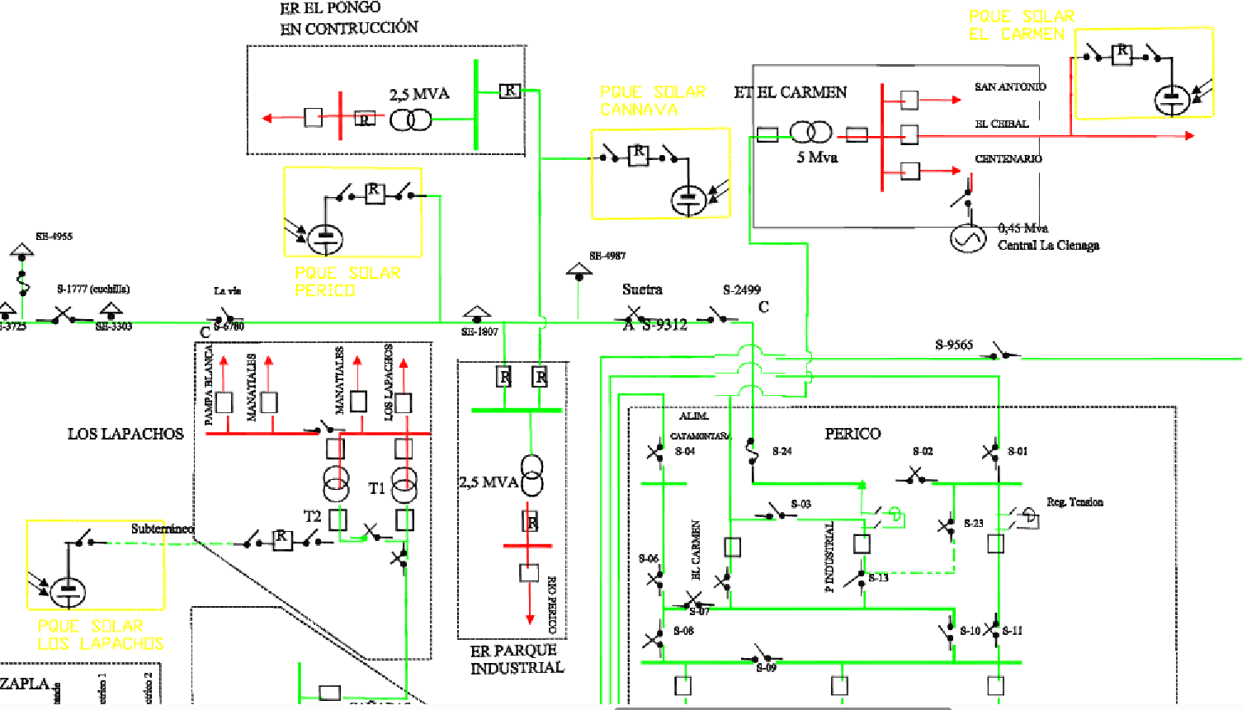
Figure 1 SADI network and PV project connections
The facilities to ensure the power capacity of the three photovoltaic projects according to PVsyst - Simulation report Grid-Connected System version 7.4.2 (18th September 2023)- will consist of:
Table 2 System Summary
 |  | El Carmen PV PP |  | Cannava PV PP |  | Los Lapachos PV PP
Solar Modules | Wp | 650 | Trinasolar TSM-650DEG21C20 | 650 | Trinasolar TSM-650DEG21C20 | 650 | Trinasolar TSM- 650DEG21C20
N° of Modules |  | 650 | 5400 | 10,800 |  | 10,800
Nominal Power | kWp  kWe | 3,515  3,000 |  | 7,074  6,000 |  | 7,020  6,000
Trackers | Vanguard 1P Dual row technology  1P60  1P30 | 71  38 |  | 180 | Dual-row technology, model Agile 1P | 180
N° of Inverters | Huawei Technologies Model SUN2000-330 KTL | 11  Nom. power 300 kW  App. Power 330 kVA |  | 22  Nom. power 300 kW  App. Power 330 kVA |  | 22  Nom. power 300 kW  App. Power 330 kVA
Transformers | Apparent Power  Quantity | 6600 kVA  0,8/13,2 kV  1  Brand HUAWEI  Serie 21913UAP9001203  Equipment 30001213 Model JUPITER-3000K-H1 13.2kV |  | 6600 kVA  0,8/33 kV  1  Brand HUAWEI  Serie 1957UAP9001204  Equipment 30001221 Model JUPITER-9000K-H1 33kV |  | 6600 kVA  0,8/33 kV  1  Brand HUAWEI  Serie 1958UAP9001206  Equipment 30001216 Model JUPITER-6000K-H1 33kV
Reclosers | 630A-33kV | 3 |  | 3 |  | 3
Voltage transformer | 33:$\sqrt{3}$/0,11:$\sqrt{3}$  Cl0,5-20VA | 3 |  | 3 |  | 3
Current  Transformer | 80-160/5/5A  Cl0,5s-30VA | 3 |  | 3 |  | 3
Main meter | Cl 0,2S | Schneider Electric ION 8650  SN:MW-2403A998-02 |  | Schneider Electric ION 8650  SN: MW-2404A267-02 |  | Schneider Electric ION 8650  SN: MW-2404A255-02
Back up meter | Cl 0,2S | Schneider Electric  PM 9000  SN: MZ-2303B129-01 |  | Schneider Electric  PM 9000  SN: MZ-2303A172-01 |  | Allen Bradley  PM 5000  SN: 217M4CA6BZ

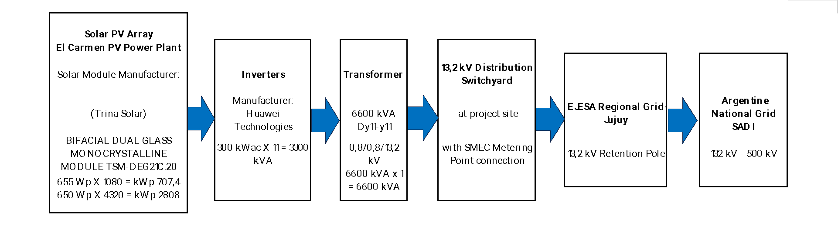
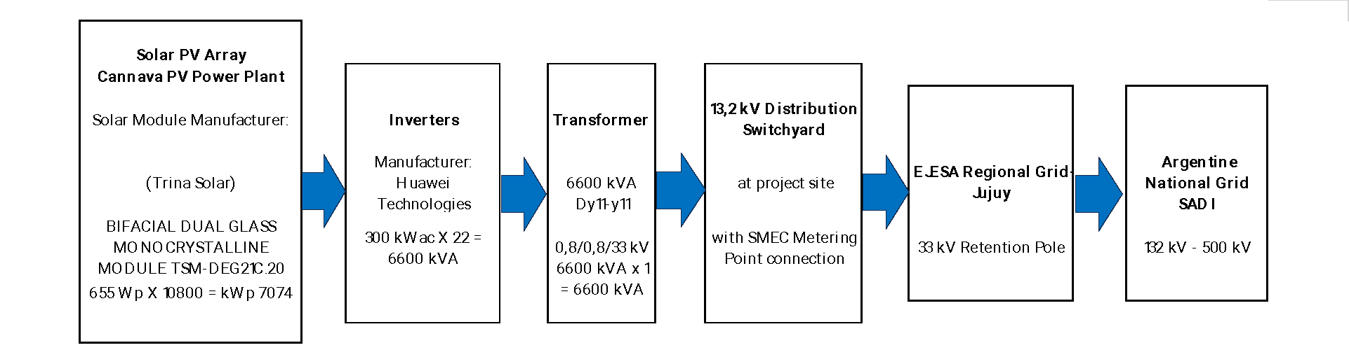
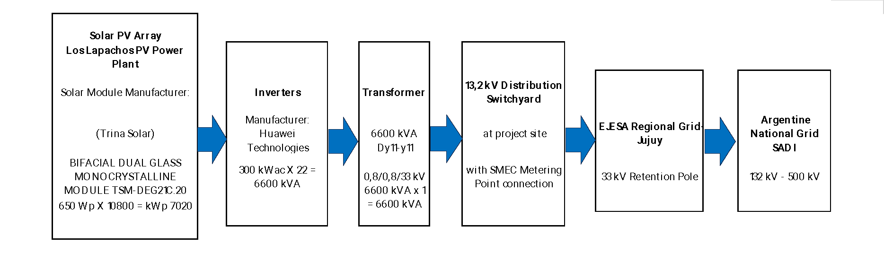
Figure 2: Power blocks diagram of PV power plants
Two-way digital meters (main and backup) will be installed at the exit of the Distribution Center at each project site to measure the electricity supply directly and continuously to the new interconnection point with EJESA. The accuracy class of the planned electricity meters is 0.2S, which will be verified after commissioning.
The expected useful life of the project equipment is 30 years, according to conservative solar industry standards in this context and the solar panels manufacturer.

Project location
The Valle Sur project is located in the south of the Valles (geographical region of the province of Jujuy). Therefore, the three sites share historical, political, geographic, climatic and cultural characteristics.
According to the Environmental Impact Study (EIS) carried out in Chapter 2 Executive Summary, shows that the selected sites are currently in disuse, presenting an herbaceous cover and low landscape value, due to the previous transformation by agricultural activities.
El Carmen Project occupies an area of 8.4 hectares. The property coordinates are 24°18'39.49"S 65°15'16.12"O and the following figure shows the details of the polygon coordinates.
Figure 3: El Carmen Project Gauss Kruger coordinates
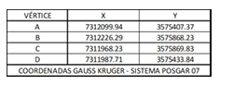
Figure 4: El Carmen Project location
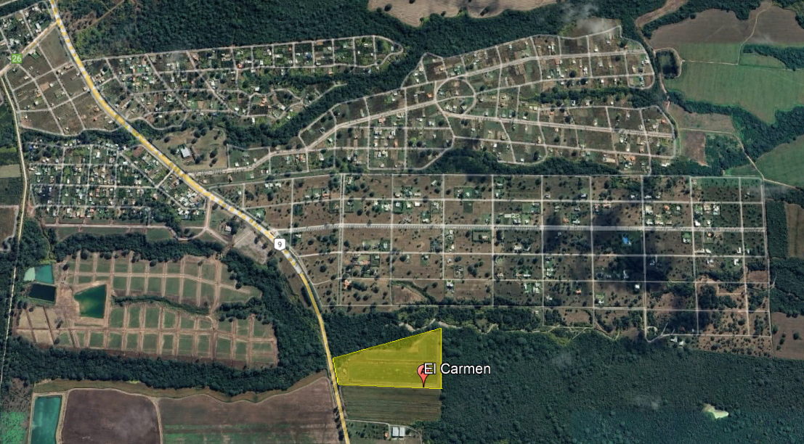
Cannava Project occupies an area of 19.74 hectares. The property coordinates are 24°20'24.27"S 65°04'50.45"O and the following figure shows the details of the polygon coordinates.
Figure5: Cannava Project Gauss Kruger coordinates
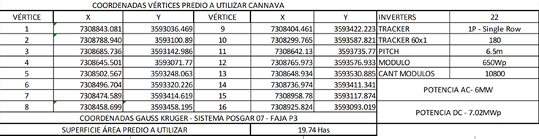
Figure 6: Cannava Project location
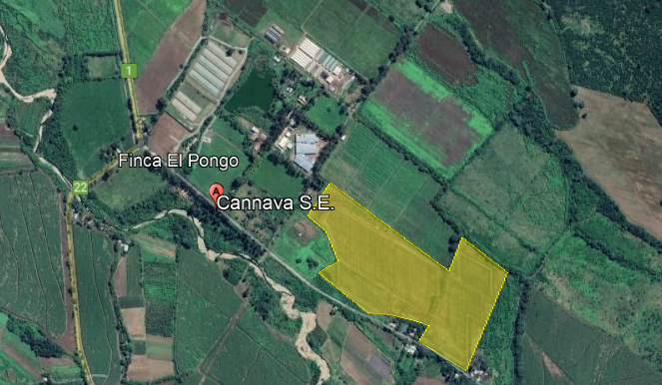
Los Lapachos Project occupies an area of 16.7 hectares. The property coordinates are 24°27'50.27"S 65° 2'31.79"O and the following figure shows the details of the polygon coordinates.

Figure: 7 Los Lapachos Project Gauss Kruger coordinates
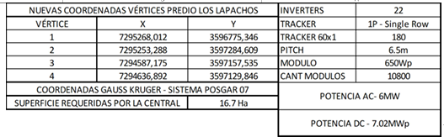

Figure: 8 Los Lapachos Project location
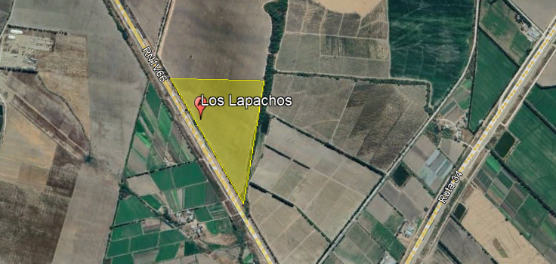

Additional information about the GHG Project
Each photovoltaic plant will operate automatically and independently with minimal intervention. In the event of problems with the external power grid or the inverters, they will automatically disconnect from the grid. In most cases, the inverters will automatically reconnect once the problems have been resolved.
The installations have been designed under the parameters required by international standards for solar photovoltaic installations and national standards for power generation and transmission.
The solar panels will be connected in series forming strings; each string will be mounted on a support structure called a solar tracker in a row. Each solar tracker will be driven by an independent mechanism. This type of modular installation allows each structure to be placed independently to cause the least possible impact. Solar trackers are structures that allow the solar panel to face the direction in which the sun's rays penetrate the earth's atmosphere. In this way, the energy captured by the panels is greater, and energy production is increased for the same number of panels and surface area occupied.
Figure: 9 El Carmen Project Layout
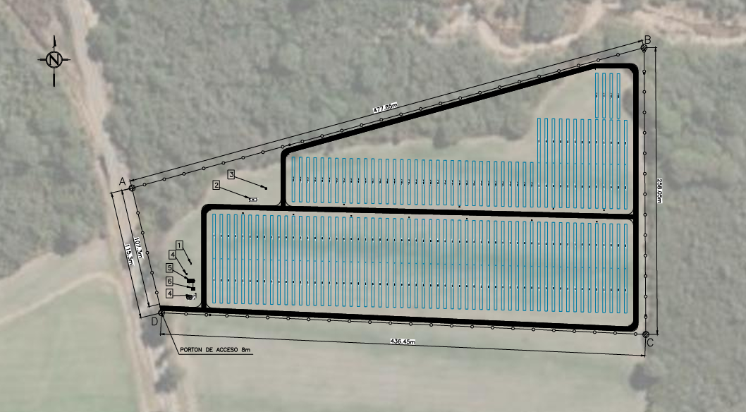
Figure: 10 Cannava Project Layout
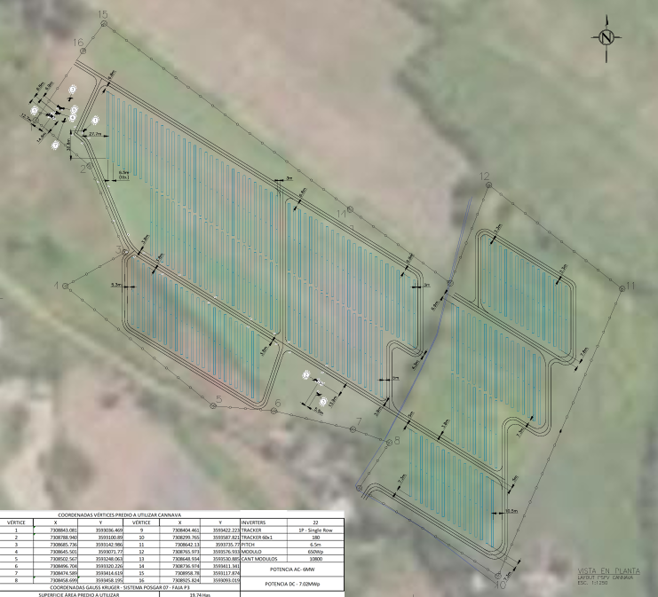

Figure: 11 Los Lapachos Project Layout
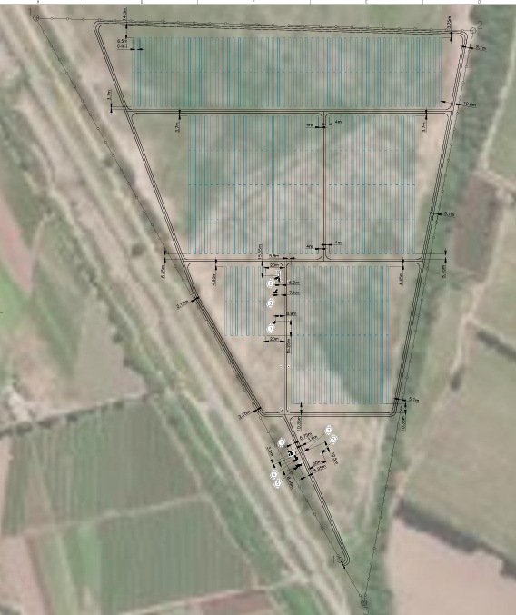

Quantification of GHG emissions reduction

Quantification methodology
As stated in the approved methodology AMS-I-D: Grid connected renewable electricity generation (Version 18.0); if the project activity is the installation of a new grid-connected renewable energy plant/unit, the reference scenario is as follows:
“The baseline scenario is that the electricity delivered to the grid by the project activity would have otherwise been generated by the operation of grid-connected power plants and by the addition of new generation sources into the grid.”
According to the methodology the combined margin CO2 emission factor for grid connected power generation must be calculated using the latest version of the: “Tool 07: Tool to calculate the emission factor for an electricity system” (t CO2/MWh)

Applicability conditions of the methodology
Valle Sur Solar PV Power Bundle Project is a type of renewable energy generation project that is supplying electricity to a national grid in accordance with scope of the applied methodology AMS-I-D: Grid connected renewable electricity generation (Version 18.0), section 2.2 paragraph 4. The following table explains and justifies compliance with the applicability conditions of the methodology used.
AMS-I-D (ver. 18.0) conditions of applicability | Applicability of the project activity
2. This methodology comprises renewable energy generation units, such as photovoltaic, hydro, tidal/wave, wind, geothermal and renewable biomass:  (a) Supplying electricity to a national or a regional grid; or  (b) Supplying electricity to an identified consumer facility via national/regional grid through a contractual arrangement such as wheeling. | The project activity is a renewable energy generation through photovoltaic units,  (a) Supplying electricity to a national or a regional grid  Condition is applicable.
4. This methodology is applicable to project activities that:  (a) Install a Greenfield plant;  (b) Involve a capacity addition in (an) existing plant(s);  (c) Involve a retrofit of (an) existing plant(s);  (d) Involve a rehabilitation of (an) existing plant(s)/unit(s); or  (e) Involve a replacement of (an) existing plant(s). | The project activity is installation of a Greenfield power plant.  Condition is applicable.
5. Hydro power plants with reservoirs that satisfy at least one of the following conditions are eligible to apply this methodology:  (a) The project activity is implemented in an existing reservoir with no change in the volume of reservoir;  (b) The project activity is implemented in an existing reservoir, where the volume of reservoir is increased and the power density of the project activity, as pe definitions given in the project emissions section, is greater than 4 W/m²;  (c) The project activity results in new reservoirs and the power density of the power plant, as per definitions given in the project emissions section, is greater than 4 W/m². | Since the project activity is a renewable energy generation through PV units, this condition is not applicable
6. If the new unit has both renewable and non-renewable components (e.g. a wind/diesel unit), the eligibility limit of 15 MW for a small-scale CDM project activity applies only to the renewable component. If the new unit co-fires fossil fuel, the capacity of the entire unit shall not exceed the limit of 15 MW.  7. Combined heat and power (co-generation) systems are not eligible under this category. | The project activity units are only renewable components as photovoltaic solar panels, and total installed capacity is 15.000 kWe, which does not exceed the eligibility limit of 15 MW for a small-scale CDM project activity applies only to the renewable component.  Condition is applicable.  Since the project activity is a renewable energy generation through photovoltaic units, this condition is not applicable.
8. In the case of project activities that involve the capacity addition of renewable energy generation units at an existing renewable power generation facility, the added capacity of the units added by the project should be lower than 15 MW and should be physically distinct from the existing units. | Since the project activity is installation of a Greenfield plant which does not involve the capacity addition of renewable energy generation units at an existing renewable power generation facility, this condition is not applicable.
9. In the case of retrofit, rehabilitation or replacement, to qualify as a small-scale project, the total output of the retrofitted, rehabilitated or replacement power plant/unit shall not exceed the limit of 15 MW. | Since the project activity is installation of a Greenfield plant, which does not involve the case of retrofit, rehabilitation, or replacement, this condition is not applicable.
In the case of landfill gas, waste gas, wastewater treatment and agro-industries projects, recovered methane emissions are eligible under a relevant Type III category. If the recovered methane is used for electricity generation for supply to a grid then the baseline for the electricity component shall be in accordance with procedure prescribed under this methodology. If the recovered methane is used for heat generation or cogeneration other applicable Type-I methodologies such as “AMS-I.C.: Thermal energy production with or without electricity” shall be explored. | Since the project activity is a renewable energy generation through photovoltaic solar units, which does not involve landfill gas, waste gas, wastewater treatment, and agro-industries projects recovered methane emissions eligible under a relevant Type III category, this condition is not applicable.
11. In case biomass is sourced from dedicated plantations, the applicability criteria in the tool “Project emissions from cultivation of biomass” shall apply. | Since the project activity is renewable energy generation through photovoltaic solar units which do not involve biomass, this condition is not applicable.
The Valle Sur PV Power Plants Bundle Project is made up of three new photovoltaic plants, El Carmen (3 MWe), Cannava (6 MWe) and Los Lapachos (6 MWe), which together add up to 15 MWe of installed capacity, making it a small-scale project.
As per applied methodology AMS-I-D: Grid connected renewable electricity generation (Version 18.0) refers to “TOOL07: Tool to calculate the emission factor for an electricity system” to calculate the emission factor for the project activity, the following table explains and justifies compliance with the applicability conditions of the Tool07-Version 07.0, section 2.2
Applicability conditions of “Tool 07: Tool to calculate the emission factor for an electricity system” Version 07.0 (Section 2.2) | Applicability of the project activity
3. This tool may be applied to estimate the OM, BM and/or CM when calculating baseline emissions for a project activity that substitutes grid electricity that is where a project activity supplies electricity to a grid or a project activity that results in savings of electricity that would have been provided by the grid (e.g. demand-side energy efficiency projects). | This condition is applicable. OM, BM, and CM are estimated using the tool under section 3.7.3 GHG emissions reduction/removal in the baseline scenario for calculating baseline emissions. Argentina´s “Secretaría de Energía” which publishes and calculates the Emission Factor following TOOL07- v7 calculate the Argentine grid’s emission factor.
4. Under this tool, the emission factor for the project electricity system can be calculated either for grid power plants only or, as an option, can include off-grid power plants. In the latter case, two sub-options under the step 2 of the tool are available to the project participants, i.e. option IIa and option IIb. If option IIa is chosen, the conditions specified in “Appendix 1: Procedures related to off-grid power generation” should be met. Namely, the total capacity of off-grid power plants (in MW) should be at least 10 per cent of the total capacity of grid power plants in the electricity system; or the total electricity generation by off-grid power plants (in MWh) should be at least 10 per cent of the total electricity generation by grid power plants in the electricity system; and that factors which negatively affect the reliability and stability of the grid are primarily due to constraints in generation and not to other aspects such as transmission capacity. | The Argentine grid's emission factor is calculated by Argentina´s “Secretaría de Energía” which publishes and calculates the Emission Factor following TOOL07- v7.  Since the project activity is grid connected, this condition is applicable and the emission factor has been calculated accordingly
5. In case of CDM projects the tool is not applicable if the project electricity system is located partially or totally in an Annex I country. | The project activity is located in Argentina, a non-Annex I country. Therefore, this criterion is not applicable.
6. Under this tool, the value applied to the CO2 emission factor of biofuels is zero. | The project activity is a PV project and does not involve biofuels. Condition is not applicable.
As per applied methodology AMS-I-D: Grid connected renewable electricity generation (Version 18.0) refers to TOOL21: Demonstration of additionality of small-scale project activities (Version 13.1) and to “TOOL01: Tool for the demonstration and assessment of additionality” to demonstrate de additionality of the project activity, the following table explains and justifies compliance with the applicability conditions of the Tool21-version 13.1 and Tool01-Version 07.0.0
Applicability conditions of “Tool 21: Demonstration of additionality of small scale project activities - Version 13.1 | Applicability of the project activity
4. The use of the methodological tool “Demonstration of additionality of small-scale project activities” is not mandatory for project participants when proposing new methodologies. Project participants and coordinating/managing entities may propose alternative methods to demonstrate additionality for consideration by the Executive Board. | The project activity is the installation of a new grid Solar PV Power Plant, (Greenfield power plant), and complies with AMS-I-D: Grid connected renewable electricity generation (Version 18.0).  Project participants are not proposing a new methodology to demonstrate additionality, hence, this condition is applicable.
Project participants and coordinating/managing entities may also apply “TOOL19: Demonstration of additionality of microscale project activities” as applicable. | The project complies with AMS-I-D: Grid connected renewable electricity generation (Version 18.0) paragraph 6 for small scale. This condition is not applicable.

Applicability conditions of “Tool 01: Tool for the demonstration and assessment of additionality”, - Version 07.0.0 | Applicability of the project activity
9. The use of the “Tool for the demonstration and assessment of additionality” is not mandatory for project participants when proposing new methodologies. Project participants may propose alternative methods to demonstrate additionality for consideration by the Executive Board. They may also submit revisions to approved methodologies using the additionality tool. | The project activity is the installation of a new grid Solar PV Power Plant, (Greenfield power plant), and complies with AMS-I-D: Grid connected renewable electricity generation  Project participants are not proposing a new methodology to demonstrate additionality, hence, this condition is not applicable.
10. Once the additionally tool is included in an approved methodology, its application by project participants using this methodology is mandatory. | This additionality tool is included in the AMS-I-D: Grid connected renewable electricity generation approved methodology hence this condition is applicable.

As per applied “Tool 1: Tool for the demonstration and assessment of additionality -ver. 07.0.0” applies a step-wise approach for the demonstration of additionality that refers to: “TOOL27: Investment Analysis ver. 14.0” to demonstrate de additionality of the project activity, the following tables explains and justifies compliance with the applicability conditions of the mentioned tool:
Applicability conditions of “ Tool 27: Investment analysis; version 14.0” | Applicability of the project activity
2. This methodological tool is applicable to CDM project activities and programmes of activities (PoAs) that conduct an investment analysis for the demonstration of additionality and/or the identification of the baseline scenario. | The project activity is the installation of a new grid Solar PV Power Plant, (Greenfield power plant), that applies “Tool 1: Tool for the demonstration and assessment of additionality - ver. 07.0.0” to demonstrate the addionality of the project activity.  According to paragraph 28 of Tool 1, project participants may select to complete steps 2 and 3 of the step-wise approach into Step 2 (Investment Analysis) or Step 3 (Barrier analysis). As per Step 2 (Investment Analysis) has been chosen to demonstrate additionality through “Tool 1: Tool for the demonstration and assessment of additionality -ver. 07.0.0” this condition is applicable.
3. In case the applied approved baseline and monitoring methodology contains requirements for the investment analysis that are different from those described in this methodological tool, the requirements contained in the methodology shall prevail. | As per “Tool 27: Investment analysis version 14.0” has been chosen in Step 2 of the step-wise approach of “Tool 01: Tool for the demonstration and assessment of additionality -ver. 07.0.0”, this condition is applicable.

Methodology deviations (if applicable)
Not applicable

Project boundaries, sources and GHGs
According to the guidance specified in AMS-I-D: Grid connected renewable electricity generation (Version 18.0), "the spatial extent of the project boundary includes the project power plant/unit and all power plants physically connected to the electricity system that the CDM project power plant is connected to".

Spatial limits of the project
The project boundary will include, for each PV power plant, the solar photovoltaic array, the inverters and transformers equipment and the metering equipment, as shown in the diagram below .
Figure 10: Spatial limits of the project
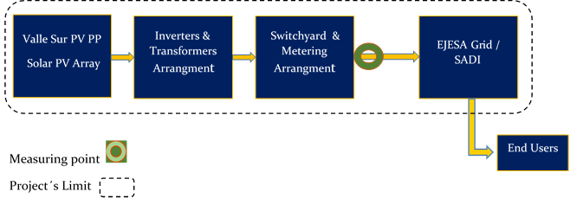

Carbon reservoirs and GHG sources
Valle Sur Project´s photovoltaic power generation comprises a single source or reservoir. According to section, 5.2 paragraph 19 “Baseline scenario for Greenfield power plant. The baseline scenario is that the electricity delivered to the grid by the project activity would have otherwise been generated by the operation of grid-connected power plants and by the addition of new generation sources into the grid.”
Emission sources included in or excluded from the project boundary:
Source |  | Gas | Included | Justification
Baseline | CO2 emissions from electricity generation in fossil fuel fired power plants that are displaced due to the project activity | CO₂ | Yes | Main emission source
Baseline |  | CH₄ | No | Minor emission source
Baseline |  | N₂O | No | Minor emission source
Project | For dry or flash steam geothermal power plants, emissions of CH4 and CO2 from non-condensable gases contained in geothermal steam | CO₂ | No | Based on the evidence-gathering activities (Documental review and on-site inspection) it is evident the GHG project does not flash steam geothermal power plant (installation of a Greenfield power plant (Solar photovoltaic plant).
Project |  | CH₄ | No
Project |  | N₂O | No
Project | For binary geothermal power plants, fugitive emissions of CH4 and CO2 from non-condensable gases contained in geothermal steam | CO₂ | No | Based on the evidence-gathering activities (Documental review and on-site inspection) it is evident the GHG project does not binary geothermal power plant (installation of a Greenfield power plant (Solar photovoltaic plant).
Project |  | CH₄ | No
Project |  | N₂O | No
Project | For binary geothermal power plants, fugitive emissions of hydrocarbons such as n-butane and isopentane (working fluid) contained in the heat exchangers | Low GWP hydrocarbon/refrigerant | No | Based on the evidence-gathering activities (Documental review and on-site inspection) it is evident the GHG project does not binary geothermal power plant (installation of a Greenfield power plant (Solar photovoltaic plant)
Project | CO2 emissions from combustion of fossil fuels for electricity generation in solar thermal power plants and geothermal power plants | CO₂ | No | Based on the evidence-gathering activities (Documental review and on-site inspection) it is evident the GHG project does not solar thermal power plant and geothermal power plant (installation of a Greenfield power plant (Solar photovoltaic plant).
Project |  | CH₄ | No
Project |  | N₂O | No
Project | For hydro power plants, emissions of CH4 from the reservoir | CO₂ | No | Based on the evidence-gathering activities (Documental review and on-site inspection) it is evident the GHG project does not hydroelectric power plant installation of a Greenfield power plant (Solar photovoltaic plant).
Project | For hydro power plants, emissions of CH4 from the reservoir | CH₄ | No
Project | For hydro power plants, emissions of CH4 from the reservoir | N₂O | No
Project | Biomass from dedicated plantations | CO₂ | No | Based on the evidence-gathering activities (Documental review and on-site inspection) it is evident the GHG project consists of the installation of a solar power plant that does not involved biomass from dedicated plantations.
Project | Biomass from dedicated plantations | CH₄ | No
Project | Biomass from dedicated plantations | N₂O | No
Project | Utilization of electricity from grid or from fossil fuel generators by PSP for pumped mode. | CO₂ | No | Based on the evidence-gathering activities (Documental review and on-site inspection) it is evident the GHG project consists of the installation of a Greenfield power plant (Solar photovoltaic plant) that does not consider a pumped storage project (PSP) in the plant.
Project |  | CH₄ | No
Project |  | N₂O | No

Time limits and analysis periods
In accordance with BCR Standard ver. 3.4 June 28, 2024 section 11.5, the renewable quantification period may be at most seven years and may be renewed at most two times, for a maximum total length of 21 years.

Project start date
According to the BCR Standard ver. 3.4 section 11.4 “The start date for GHG Projects is when the activities that result in actual reductions/removals of GHG emissions begin. That is when the implementation, construction, or real action of a GHG Project begins”.
In this sense, the Cannava photovoltaic power plant was enabled by EJESA on October 1, 2024. The El Carmen photovoltaic plant on November 1, 2024, and the Los Lapachos power plant on December 1, 2024.

Quantification period of GHG emission reductions
Valle Sur Project is framed within the activities in the energy, transport and waste sectors, the quantification periods are those established by the BCR Standard as 7 years and shall be renewed at least twice, for a maximum total length of 21 years.
Cannava Project 01/10/2024 to 30/09/2045
El Carmen Project 1/11/2024 to 31/10/2045
Los Lapachos Project 01/12/2024 to 30/11/2045

Monitoring periods
The monitoring periods will be between one and three years as established by the Biocarbon Standard version 3.4 chapter 22 (closing date of December 31 of the calendar year).

Identification and description of the baseline or reference scenario
Based on BCR Guidelines Baseline and Additionality, AMS-I-D: Grid connected renewable electricity generation (Version 18.0) and "TOOL07 to calculate the emission factor for an electricity system." version 7.0., the baseline scenario is identified as a Greenfield power plant.
According to Section 5.2, Paragraph 19 of AMS-I-D (ver. 18), the baseline scenario for a Greenfield Power Plant “is that the electricity delivered to the grid by the project activity would have otherwise been generated by the operation of grid-connected power plants and by the addition of new generation sources into the grid”

Additionality
Based on the BCR Guidelines for Baseline and Additionality Version 1.3|March 1, 2024, point 6 states “BCR Standard does not include activities that are automatically additional”. That mean, in BCR Standard are not considered “positive list” of eligible project types. In addition, point 8 of the mentioned Guidelines states that project holders in sectors such as energy, transport and waste, shall use the “am-tool-21-v13.1 Demonstration of additionality of small scale project activities”.
As per Guidelines on TOOL21: Demonstration of additionality of small-scale project activities (Version 13.1), it has to be provided an explanation to show that the project activity would not have occurred anyway due to at least one of the following barriers:
(a) Investment barrier: a financially more viable alternative to the project activity
would have led to higher emissions;

(b) Technological barrier: a less technologically advanced alternative to the
project activity involves lower risks due to the performance uncertainty or low
market share of the new technology adopted for the project activity and so
would have led to higher emissions;

(c) Barrier due to prevailing practice: prevailing practice or existing regulatory or policy requirements would have led to implementation of a technology with
higher emissions;

(d) Other barriers: without the project activity, for another specific reason identified by the project participant, such as institutional barriers or limited information, managerial resources, organizational capacity, financial resources, or capacity to absorb new technologies, emissions would have been higher.

The most significant barrier is identified as the investment barrier according to context of the project activity to demonstrate in a conservative and transparent manner that the proposed project activity is financially attractive or unattractive.

TOOL21: Demonstration of additionality of small-scale project activities (Version 13.1), provides Appendix Provisions of small-scale and microscale tools for automatic additionality as a flow chart to guide the users to help navigate provisions for automatic additionality across.

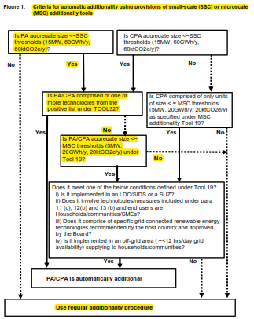

Figure 2 Criteria for automatic additionality using provisions of small-scale (SSC) or microscale (MSC) additionally tools
Is Valle Sur Project size <=SSC thresholds (15MW, 60GWh/y, 60ktCO2e/y)?
Yes
Is Valle Sur Project comprised of one or more technologies from the positive list under TOOL32?
No
Is Valle Sur Project aggregate size <= MSC thresholds (5MW, 20GWh/y, 20ktCO2e/y) under Tool 19?
No
Since the application of the guide flow chart does not lead to the automatic additionality of the project and the total power of the project is equal to 12 MW, the regular additionality procedure is applied.

Best practice examples of Investment Analysis is defined in the “ANNEX 34, EB 35 methSSC_guid15_v01_Non-binding best practice examples to demonstrate additionality for SSC project activities” as:
“Best practice examples include but are not limited to, the application of investment comparison analysis using a relevant financial indicator, application of a benchmark analysis or a simple cost analysis (where CDM is the only revenue stream such as end-use energy efficiency). It is recommended to use national or global accounting practices and standards for such an analysis”

The investment analysis is applied by using “TOOL27-Investment analysis (Version 14.0)” to evaluate financial status of the project activity to discuss the Investment barrier.
The steps of “am-tool-01-v7.0.0_Tool for the demonstration and assessment of additionality” is utilized in order to determine method of financial analysis.

Procedure for demonstrating additionality in accordance with TOOL01.Version 07.0.0
The step-by-step approach proposed by TOOL01: Version 07.0.0 has been followed
to establish the additionality of the project. It is detailed below:

Step 2: Investment Analysis

According to paragraph 29 of TOOL01: v.07.0.0 "Tool for the demonstration and assessment of additionality" it is determined that the proposed project activity is not an economically or financially viable option. To carry out the investment analysis, the methodological tool "TOOL 27.v.12.0_ Investment Analysis" has been taken as a reference, which came into force on 02Nov.22, and whose period includes the date of decision to carry out the project, 28 December 2022

Sub-step 2a: Determine the appropriate analysis method

According to paragraph 32 of TOOL01: v.07.0.0 "Tool for the demonstration and
assessment of additionality", the following three options are available for project
analysis:
Option I: Simple Cost Analysis
Option II: Investment Comparison Analysis
Option III: Benchmark analysis

The project will generate revenue from the sale of electricity, so Option I is not
applicable.

Option II is also not applicable since there is no comparable investment alternative
available to the project participant because the only option is generation of electricity energy by the Argentine grid.

Sub-step 2b: Option III. Apply Benchmark Analysis

The project proponents have considered the after-tax IRR for the investment analysis at the time of decision making. As project proponents, they are interested in the returns that the project generates on the investment costs that they finance in the form of 100 percent equity.
For the selection and validation of the appropriate benchmark for the calculated IRR, paragraph 15 of TOOL 27.v12.0 "Investment Analysis", states that "Local commercial lending rates or WACC are appropriate benchmarks for a project IRR.
Required/expected returns on equity are appropriate benchmarks for an equity IRR. Benchmarks supplied by relevant national authorities are also appropriate”.
Of these options, the proponents consider that the required/expected returns on equity are appropriate benchmarks for an equity IRR.

Comparative Base Value
According to paragraph 18 of TOOL 27.v.12.0, "If there is only one possible project
developer, either internal company benchmarks/expected returns may be applied, or the benchmark based on standard conditions in the market may be used."

Considering that the project activity has a single proponent that finances 100 percent of the project, (100 percent equity), for transparency and simplicity, the proponents consider the benchmark based on standard market conditions to be a reasonable indicator to evaluate the IRR of equity.

According to point 19 of TOOL 27.v.12.0, "If the benchmark is based on parameters
that are standard in the market, the cost of equity should be determined either by: (a) selecting the values provided in the Appendix; or by (b) calculating the cost of equity using CAPM". For the sake of transparency and simplicity, the project developers consider it reasonable to use as a benchmark for the IRR of capital the value of the Appendix of Tool 27 v.12.0 "Default values for the cost of equity (expected return on equity)" corresponding to Argentina Group 1, which is 23.48%
in real terms. It is noted that at the date of preparation of this PDD, Tool 27 v.14.0_Investment Analysis_EB 122_31May2024-onwards is in force, which shows the value of 24.01% in real terms for Argentina Group 1 projects. Following a conservative approach, the minimum default value of 23.48% in real terms has been taken.
Finally, it should be noted that the cash flow presented in this process was prepared in real terms since it does not include inflation adjustment in any of its variables. For this reason, we consider that it is not necessary to adjust the benchmark rate for inflation, as proposed in point 16 of Tool 27 v.12.0 "In situations where an investment analysis is carried out in nominal terms and the available IRR benchmarks are in real terms, project participants shall convert the real term values of benchmarks to nominal values by adding the inflation rate"

Sub-step 2c: Calculation and comparison of financial indicators (only applicable to Options II and III). (See El Carmen, Cannava and Los Lapachos cash flows in Annex I_Valle Sur)

Table 3: Input values used in investment analysis of El Carmen, Cannava and Los Lapachos PV PP

Project details | Jujuy Province |  |  | Source
Project location | El Carmen | Cannava | Los Lapachos
Total AC capacity (MW) | 3 | 6 | 6 | General Project Development, (GPD)
Estimated commissioning date | 02/10/2024 | 13/09/2024 | 06/11/2024 | GPD
Plant life (years) | 30 | 30 | 30 | PV panels manufacturer's specifications
Generation and sale of energy
Production @ P50(%)  Annual Generation (MWh) | See Cash Flow "Produccion" spreadsheet | See Cash Flow "Produccionspreadsheet | See Cash Flow "Produccion" spreadsheet | Supplier information. In accordance with Report EB 48-ANNEX 11_ Third party Huawei optimizer PVSyst.
Generation rate contract value (USD/MWh) | 79.00 | 79.00 | 79.00 | Ctto. PPA EJESA- JEMSE - Página 11- Artículo 6.1
Canon JEMSE | 7.00 % | 7.00 % | 7.00% | Oferta de Cesión de Posición Contractual- Página 4- Artículo 2
Operating, maintenance and overhead expenses
O & M Expenses | See Cash Flow "O&M" spreadsheet | See Cash Flow "O&M" spreadsheet | See Cash Flow "O&M" spreadsheet | Planilla 10_COp_JEMSE_Solar_48mW_2024.07
Overhead | 11.32% | 11.32 % | 11.32% | Financial statements 31/12/2023 Pag. 17
Financial parameters
Total investment USD | 3,431,472 | 5,229,108 | 5,411,479 | S/project budget
Demobilization expenses | 0.00 | 0.00 | 0.00 | N/A
Terminal value | 0.00 | 0.00 | 0.00 | N/A
Equity Financing | 100.0% | 100.0 % |  | Industrias Juan F. SECCO
Working capital
Days of accounts receivable | 35 | 35 | 35 | According to contract payment conditions
Accounting and tax depreciation
Depreciable value | See Cash Flow "Inversión" spreadsheet | See Cash Flow "Inversión" spreadsheet | See Cash Flow "Inversión" spreadsheet | Amortization values provided by technology supplier
Taxes
Gross income (%) | 1.80% | 1.80% | 1.80% | Ley 6372. Resolución general (DPR) 1658/2024
Tax law 25,413 on credits | 0.40% | 0.40% | 0.40% | LEY 25413 - Decreto 380/2001, Art. 13° (texto s/D. 409/2018, art. 1 y D. 301/2021, arts. 8° y 9°)
Tax law 25,413 on debits | 0.40% | 0.40% | 0.40% | LEY 25413 - Decreto 380/2001, Art. 13° (texto s/D. 409/2018, art. 1 y D. 301/2021, arts. 8° y 9°)
Income Tax | 35.00% | 0.40% | 0.40% | LEY 20628 y modif., Art. 73°, texto s/LEY 27630, Decreto 824/2019 y RG (AFIP) 5168

Table 4: Projects IRR vs. Benchmark
Project Developer  Industrias Juan F. Secco | IRR without VCC |  |  | ROE Benchmark
Project location | El Carmen | Cannava | Los Lapachos | 23.48%
Project location | 4.68% | 8.27% | 7.84% | 23.48%
The project activity cannot be considered financially attractive given that the project's IRR are lower than the benchmark ROE.
Sub-step 2d: Sensitivity analysis
In addressing Guide 27 and 28 of Tool 27 v.12.0 Investment Analysis, the following factors have been subject to sensitivity analysis:
1. Plant Load Factor
2. Operation and Maintenance Cost
3. Project Cost
4. Rate
The rationale for sensitivity is: "The ultimate objective of sensitivity analysis is to determine the probability of occurrence of a scenario different from the scenario presented, in order to provide a cross-check of the reasonableness of the assumptions used in the development of the investment analysis."
Table 5: Sensitivity Analysis of the each PV power plant project
 | Equity IRR W/O VCC |  | Benchmark (ROE)
EL Carmen PV PP | 4.68% |  | 23.48%
Sensitivity Analysis | Equity IRR
Variation % | -10% | Normal | 10% | Variation with respect to benchmark
Energy Production | 3.61% | 4.68% | 5.71% | 311.2%
O&M | 4.79% | 4.68% | 4.58% | 390.2%
Project Costs | 5.71% | 4.68% | 3.81% | 311.2%
Energy Price | 3.61% | 4.68% | 5.71% | 311.2%

 | Equity IRR W/O VCC |  | Benchmark (ROE)
Cannava PV PP | 8.27% |  | 23.48%
Sensitivity Analysis | Equity IRR
Variation % | -10% | Normal | 10% | Variation with respect to benchmark
Energy Production | 7.00% | 8.27% | 9.50% | 147.2%
O&M | 8.36% | 8.27% | 8.19% | 180.9%
Project Costs | 9.54% | 8.27% | 7.20% | 311.2%
Energy Price | 7.00% | 8.27% | 9.5% | 146.1%

 | Equity IRR W/O VCC |  | Benchmark (ROE)
Los Lapachos PV PP | 7.84% |  | 23,48%
Sensitivity Analysis | Equity IRR
Variation % | -10% | Normal | 10% | Variation with respect to benchmark
Energy Production | 6.59% | 7.84% | 9.04% | 159.7%
O&M | 7.92% | 7.84% | 7.75% | 196.4%
Project Costs | 9.07% | 7.84% | 6.78% | 158.9%
Energy Price | 6.59% | 7.84% | 9.04% | 159.7%
The results of the sensitivity analysis show that even with a variation of ± 10% in project cost, operation and maintenance cost, energy production and energy price, the IRR of the equity is significantly lower than the reference rate. It is also evident from the results given above that each project remains additional even under the most favorable conditions.
Reference index | Probability of default
Power Production  (Plant Load Factor) | The PLF has been considered for financial analysis according to the "Guidelines for Reporting and Validation of Plant Load Factors" set forth in EB48 Annex 11.  It is highly unlikely that a variation in the PLF of more than 10% will occur since the energy production and its reduction over the years was provided in the report of the equipment supplier, (third party not involved in the project),
O&M | The sensitivity analysis reveals that O&M costs are irrelevant to the outcome of the IRR value. Furthermore, it is known that these costs are subject to upward escalation due to breakage and inflationary pressure. In short, their reduction over time is highly unlikely.
Project cost | The estimated project cost for the financial analysis is considered from the GPD available at the time of decision making. However, even if we consider actual project costs that differ very little from the estimates, the benchmark is not exceeded. In any case, the Sensitivity is analyzed for a variation of +/-10%.
Value of the fee | For the investment analysis, the tariff considered is 79,00 USD /kWh and is determined by the energy supply contract to JEMSE S.A., which is fixed for the entire 20-year contract period.
Based on the results obtained, it is concluded that the Valle Sur project is unlikely to be financially and economically attractive, therefore the project is considered additional

Uncertainty management
The data used for the quantification of the baseline are based on the methodologies mentioned in point 3.7.3 and on the information provided by official agencies (Secretaría de Energía de la Nación) that have traceable and confidential data provided by each generator in Argentina.

Leakage and non-permanence
According to AMS-I-D: Grid connected renewable electricity generation (Version 18.0) have to be considered the procedure described in the most recent version of ACM0002 Methodology (version 21.0): “No other leakage emissions are considered. The emissions potentially arising due to activities such as power plant construction and upstream emissions from fossil fuel use (e.g. extraction, processing, transport etc.) are neglected.”
In compliance with BCR Tool “Permanence and Risk Management” project holder assurance the permanence of the project activities through of the contract signed between Industrias Juan F. Secco and EJESA.
Monitoring of project and ensuring the permanence of project activities will be carried out through verifications, which will be carried out by a Conformity Assessment Body (CAB) and with a frequency between one and three years as established by the Biocarbon Standard version 3.4 chapter 22.

Mitigation results
The mitigation results achieved as a result of the implementation of the Valle Sur project are verifiable under ISO 14064-3:2019 and in accordance with the requirements of the BCR standard.

Eligible areas within GHG project boundaries (AFOLU sector projects)
Nos applicable

Stratification (Projects in the AFOLU sector)
Nos applicable

GHG emissions reduction/removal in the baseline scenario
Based on AMS-I-D: Grid connected renewable electricity generation (Version 18.0) the baseline emissions include only CO2 emissions from electricity generation in fossil fuel fired power plants that are displaced due to the project activity. The methodology assumes that all project electricity generation above baseline levels would have been generated by existing grid-connected power plants and the addition of new grid-connected power plants. The baseline emissions are to be calculated as follows:
B𝐸𝑦 =𝐸𝐺𝑃𝐽, ×𝐸𝐹𝑔𝑟𝑖𝑑,,
Where:
B𝐸𝑦 = Baseline emissions in year y (t CO2/yr)
E𝐺𝑃𝐽,𝑦 = Quantity of net electricity generation that is produced and fed into the grid as a result of the implementation of the CDM project activity in year y (MWh/yr)
According to the PVSyst production calculation software for photovoltaic systems, the expected power generation for 20 years with a probability of occurrence P50 is shown in the table below;
Year | El Carmen (MWh) | Cannava (MWh) | Los Lapachos (MWh)
1 | 5.990 | 12.609 | 12.526
2 | 5.981 | 12.541 | 12.499
3 | 5.954 | 12.484 | 12.443
4 | 5.924 | 12.420 | 12.381
5 | 5.891 | 12.351 | 12.312
6 | 5.853 | 12.270 | 12.233
7 | 5.810 | 12.180 | 12.143
8 | 5.766 | 12.087 | 12.050
9 | 5.721 | 11.993 | 11.956
10 | 5.677 | 11.901 | 11.863
11 | 5.638 | 11.820 | 11.781
12 | 5.605 | 11.751 | 11.712
13 | 5.575 | 11.687 | 11.647
14 | 5.545 | 11.626 | 11.585
15 | 5.517 | 11.567 | 11.526
16 | 5.491 | 11.513 | 11.471
17 | 5.467 | 11.462 | 11.420
18 | 5.440 | 11.406 | 11.365
19 | 5.410 | 11.343 | 11.302
20 | 5.375 | 11.270 | 11.229

E𝐹𝑔𝑟𝑖𝑑, = Combined margin CO2 emission factor for grid connected power generation in year y calculated using TOOL07 (t CO2/MWh)
To determine the combined emission factor of the Argentine Interconnection System (SADI), the following six steps described in paragraph 14 of "am-tool-07-v7.0" have been followed;
Step 1: Identify the relevant electricity systems.
To determine the electricity emission factors, the project's electricity system is defined by the spatial extent of power plants that are physically connected (including imports) through transmission lines that can be sent without significant transmission constraints. In this case, to the SADI. The “Sistema Argentino de Interconexión”, (SADI), interconnects all the country's electricity-generating plants.
Its objective is for the entire country to be connected by a single, common electrical system. This allows the state to have greater control over the national electrical system, improve its operation and avoid failures that may occur because of the connection of regional electrical systems subject to different regulations, which when connected to a common system, may have incompatibilities that prevent its correct operation.
This system is managed and regulated by the National Regulatory Entity of Electricity (ENRE) and by the Wholesale Electricity Market Administration Company, Sociedad Anónima (CAMMESA).
Step 2: Choose whether to include off-grid power plants in the project electricity system (optional) Project participants may choose between the following two options to calculate the operating margin and build margin emission factor:
Option I: Only grid power plants are included in the calculation.
Option II: Both grid power plants and off-grid power plants are included in the calculation.
Option I is defined.
Step 3: Select a method to determine the operating margin (OM)
According to the data provided by CAMMESA and the "TOOL07: Tool to calculate the emission factor for an electricity system" the participation of Low-cost/must-run (LCMR) resources is less than 50% (according to CAMMESA the LCMR generation reached 41%), therefore following the Flow chart below, Simple OM should be considered.
In this opportunity the ex ante option is selected for Valle Sur Project, therefore:
For the simple OM, the simple adjusted OM and the average OM, the emissions factor can be calculated using either of the two following data vintages:
- Ex ante option: if the ex ante option is chosen, the emission factor is determined once at the validation stage, thus no monitoring and recalculation of the emissions factor during the crediting period is required. For grid power plants, use a 3-year generation-weighted average, based on the most recent data available at the time of submission of the CDM-PDD to the DOE for validation.
For off-grid power plants, use a single calendar year within the five most recent calendar years prior to the time of submission of the CDM-PDD for validation.
Step 4: Calculate the operating margin emission factor according to the selected method.
The simple OM may be calculated by one of the following two options:
(a) Option A: Based on the net electricity generation and a CO2 emission factor of each power unit; or
(b) Option B: Based on the total net electricity generation of all power plants serving the system and the fuel types and total fuel consumption of the project electricity system. Option B can only be used if:
(i) The necessary data for Option A is not available; and
(ii) Only nuclear and renewable power generation are considered as low-cost/must-run power sources and the quantity of electricity supplied to the grid by these sources is known; and
(iii) Off-grid power plants are not included in the calculation (i.e. if Option I has been chosen in Step 2).
As the Argentina´s Secretaría de Energía publish and calculate the Emission Factor following TOOL07 v7.0 the option B will be used. Under this option, the simple OM emission factor is calculated based on the net electricity generation and an emission factor for each power unit, as follows:
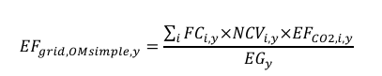
The following table shows the Emission Factor Estimates made in the country; data provided by the Secretariat of Energy - Strategic Planning of the Nation
Table: 6 Operating Margin
Operating Margin
 |  | 2021 | 2022 | 2023
EFGrid Simple OM | tCO2/MWh | 0.4589 | 0.4499 | 0.4294
EG m,y sin LCMR | MWh | 90,893,000 | 88,061,000 | 79,261,000
Emisiones | tCO2 | 41,712,283 | 39,616,554 | 34,024,515
Suma control | tCO2/MWh | 0.4589 | 0.4499 | 0.4293
Weighted average EF | tCO2/MWh | 0.44674

Step 5: Calculate the build margin (BM) emission factor
In terms of vintage data, project participants can choose between one of the following two options:
(a) Option 1 - for the first crediting period, calculate the build margin emission factor ex ante based on the most recent information available on units already built for sample group m at the time of CDM-PDD submission to the DOE for validation. For the second crediting period, the build margin emission factor should be updated based on the most recent information available on units already built at the time of submission of the request for renewal of the crediting period to the DOE. For the third crediting period, the build margin emission factor calculated for the second crediting period should be used. This option does not require monitoring the emission factor during the crediting period;
(b) Option 2 - For the first crediting period, the build margin emission factor shall be updated annually, ex post, including those units built up to the year of registration of the project activity or, if information up to the year of registration is not yet available, including those units built up to the latest year for which information is available. For the second crediting period, the build margin emissions factor shall be calculated ex ante, as described in Option 1 above. For the third crediting period, the build margin emission factor calculated for the second crediting period should be used.
Option 1 is selected for the Valle Sur Project
Table: 7 Build Margin
Build Margin
 |  | 2023
BM | tCO2/MWh | 0.0860
EG m,y | MWh | 24,574,691
Emisiones | tCO2 | 2,113,513
Suma control | tCO2/MWh | 0.08600366
BM | tCO2/MWh | 0.0860

Step 6: Calculate the combined margin (CM) emissions factor
The calculation of the combined margin (CM) emission factor (EFgrid,CM,y) is based on one of the following methods:
(a) Weighted average CM; or
(b) Simplified CM
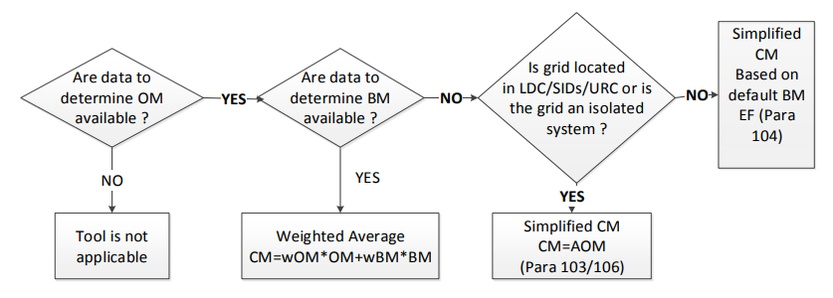
Therefore, option (a) Weighted average CM applies to the Valle Sur Project, where
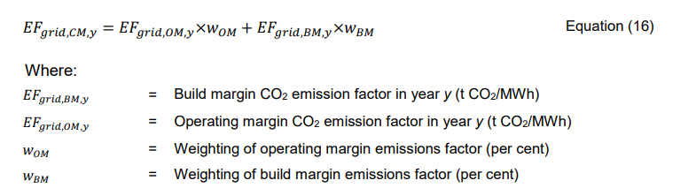
According to the tool,
The following default values should be used for W_{OM} and W_{BM} :
Wind and solar power generation project activities: W_{OM} = 0.75 and W_{BM} = 0.25 (owing to their intermittent and non-dispatchable nature) for the first crediting period and for subsequent crediting periods
Therefore, EF grid,CM,y = 0.3566 tCO2/MWh

GHG emissions reduction/removal in the project scenario
According to the methodology AMS-I-D: Grid connected renewable electricity generation (Version 18.0, EB 81) the emission reduction is calculated as:
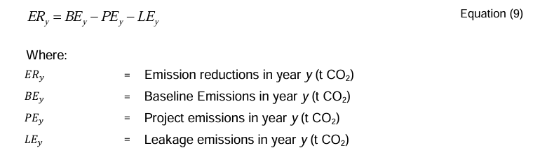
Section 5.6 Project Emissions, paragraph 39 say “For most renewable energy project activities, PEy = 0. However, for the following categories of project activities, project emissions have to be considered following the procedure described in the most recent version of “ACM0002: Grid-connected electricity generation from renewable sources”:
- Emissions related to the operation of geothermal power plants (e.g. non condensable gases, electricity/fossil fuel consumption);

- Emissions from water reservoirs of hydro power plants.
Due to Valle Sur Project characteristics, (PV Power Planta), the project emission are zero.

Tabla 8: Estimated net GHG reduction
Year | GHG emission reductions in the baseline scenario (tCO2e) | GHG emission reductions in the project scenario (tCO_{2e}) | GHG emissions attributable to leakages (tCO_{2e}) | Estimated Net GHG Reduction (tCO_{2e})
2024 (since atep) | 1,851 | 0 | 0 | 1,851
2025 | 11,061 | 0 | 0 | 11,061
2026 | 11,011 | 0 | 0 | 11,011
2027 | 10,954 | 0 | 0 | 10,954
2028 | 10,894 | 0 | 0 | 10,894
2029 | 10,824 | 0 | 0 | 10,824
2030 | 10,744 | 0 | 0 | 10,744
2031 (to atep) | 8,883 | 0 | 0 | 8,883
Total | 76,222 |  |  | 76,222
Total estimated annual average 10,889 tCO₂e/y
The expected project generation is summarized in the following table:
Table 9: Expected electric energy generation
YEAR | EGPJ,y(MWh)
2024 (since appropriate date) | 5,194
2025 | 31,021
2026 | 30,881
2027 | 30,725
2028 | 30,554
2029 | 30,356
2030 | 30,133
2031 (to appropriate date) | 24,916
TOTAL | 213,781
7 years average | 30,540

Compliance with applicable legislation
SECCO complies with Ley N° 19.550 de Sociedades, Ley N° 20.744 de Contrato de Trabajo (LCT), Ley N°24.557 de Riesgos del Trabajo, among others, has traceability of all the information mentioned in this document and has a legal and administrative area that guarantees access to and knowledge of the relevant legislation and regulations and updates of these when they occur.
SECCO is a private legal entity committed to due compliance with the laws and regulations applicable to its business, as well as to the care and satisfaction of its customers.
Considering that each sector and project has its own specificity, characteristics and technicality, SECCO carries out a decentralized regulatory control, i.e., each area involved identifies, monitors, analyzes and communicates internally the regulations relevant to its function. The details of how each area carries out the above and its traceability are detailed in the internal procedure "REGULATIVE MANAGEMENT SYSTEM"
In addition to the above, Secco identify on their web site (https://etica.resguarda.com/secco/ar_es.html) different reporting channels (whatsapp, e-chat, e-mail and a telephone number) and an email address (compliance@secco.com.ar) in all generation plants and offices to make complaints, which are received by a compliance officer who guarantees their confidentiality and treatment

Carbon ownership and rights

Project holder
Individual or organization | INDUSTRIAS JUAN F SECCO S. A.
Contact person | Hernan Juri
Job position | Administration & Finance Manager
Address | Rosario, Argentina.  Juan Pablo II 5665 (Circunvalación Ave. and Uriburu Ave. collector)
Phone number | +54 (0341) 409-4000
Email | hjuri@secco.com.ar

Other project participants
Individual or organization | Sustainable Carbon Finance LLC
Contact person | Alejandra Camara
Job position | Proposer
Address | CABA, Argentina  La Pampa 1940
Phone number | Landline: +541147865007  Cellular phone: +5491135202929
Email | alejacamara@gmail.com
Sustainable Carbon Finance LLC has no agreements on the credits generated during the implementation of the Valle Sur Project.

Agreements related to carbon rights
Regarding carbon rights, Industrias Juan F. Secco and JEMSE /EJESA signed an agreement on the production and supply of renewable energy that specifically addresses this issue. The following is the key information required and excerpts from the agreement that verify what is stated in this document
(a) parties signing the agreement(s);
Jujuy Energía y Minería Sociedad Del Estado (JEMSE)
Empresa Jujeña de Energía S.A. (EJESA)
INDUSTRIAS JUAN F SECCO S. A.
- purpose of the agreement;
JEMSE and EJESA develop a Power Purchase Agreement (PPA) in which EJESA agrees to purchase and pay for all registered and/or unsupplied energy generated within the framework of the Proyecto Solar Fotovoltaico Distribuido de la Provincia de Jujuy. Following this, JEMSE and SECCO develop an Associative Agreement in which JEMSE agrees to assign and transfer to SECCO its contractual position in the PPA Agreement. SECCO assumes ownership of the PPA Agreement and will pay JEMSE a fee described in the third clause of the Associative Agreement under Participation Percentage concept.
- date of the agreement;
28th December 2022
- name of the GHG project;
Proyecto Solar Fotovoltaico Distribuido de la Provincia de Jujuy – Valle Sur
- period of quantification of GHG emission removals/reductions;
01/09/2024 to 31/10/2031
(f) responsibilities, obligations, and rights of each of the signatory parties.
SECCO is the exclusive beneficiary in all matters related to Green Certificates, Renewable Energy Certificates, Carbon Certificates and/or similar. See PPA Agreement-Art. 6.2 and Art. 12 in the Associative Agreement.

Land tenure (Projects in the AFOLU sector)
Not applicable

Climate change adaptation
SECCO is a leading company in the country and the region, with more than 80 years of experience. In its beginnings, SECCO consolidated its position in the metal-mechanic activity by repairing the drive engines of the generator sets owned by its customers and its own, being the owner of an industrial plant in constant growth and updating with the latest technology located in the city of Rosario, Province of Santa Fe. Gradually and from the change in the business conception that took place in the country, SECCO was strengthened in the field of the provision of services developing great experience, particularly in the generation of electric power and gas compression.
The great growth of the company took place at the beginning of 2001 when, due to the economic situation of the country, SECCO began to grow exponentially with the generation of electric energy through engines generated with fossil fuels.
As early as 2005, the company's executive board made clear in a board minute the importance of combating climate change. In 2008 it submitted a project to CDM that dealt with the capture of waste gases at the wellhead to generate electricity. This project was not registered for various reasons, but it was a pioneer in the development of the methodology used:
(https://cdm.unfccc.int/Projects/Validation/DB/HIU1MR6WZ19GKZ73Y9UHXLBSQI0J2O/view.html)
Being a provider of integral solutions in power generation for the most demanding clients in the public and private sector, thanks to its technological advances and experience in the industry and hand in hand with internationally renowned brands, SECCO assembles, installs, commissions, enables, operates and maintains solar, hybrid, mono-fuel and multi-fuel power generation plants and units of high complexity capable of generating energy according to the specific requirements of each client. SECCO reaches every corner of the country, responding to diverse demands and ensuring the achievement of the expected results.
SECCO has more than 10 years of experience in Process Management for the design, construction, qualification, and operation of Power Generation Plants from renewable sources, performing from the design and engineering of the plants to the administrative management, environmental studies, commissioning and start-up of these, and in all cases developing a customized solution for each client and environmental needs.
The company has the know-how, personnel and capacity for the design, development of engineering and suppliers, construction, commissioning, operation and maintenance of photovoltaic and hybrid generation plants that meet the needs of each client.
As a background in photovoltaic, SECCO carried out the conversion project of the Piedra Negra Thermal Power Plant, which is located at 3,600 meters above sea level, incorporating a solar plant with more than 5 thousand panels and banks with lithium ion batteries for energy accumulation, in order to guarantee the reliability of the System, transforming it into the first Hybrid Power Plant (photovoltaic/storage/thermal) at altitude for an isolated system in Latin America, ensuring one of the highest percentages of availability in the market.
SECCO has more than 1,500 MW installed in more than 130 Generation Plants that generate in isolated systems or connected to the National Interconnected System (SADI) providing solutions tailored to the needs of each client with state-of-the-art and highly complex equipment. Has installed more than 50 MW in MSW Biogas Projects, more than 30 MW in substrate Biogas Projects and a hybrid plant composed of solar and thermal energy with energy accumulation to guarantee the reliability of the system. Last year, Industrias SECCO registered before the BCR the "CASA La Calera, San Luis Solar Project" ID BCR-AR-131-1-001, a 20 MW photovoltaic project installed in the province of San Luis. To date SECCO is working on the completion and installation of solar energy projects for 48 MW distributed in 7 solar plants in the province of Jujuy); totaling 178MW installed in renewable energy.
Table 10: SECCO´s renewable projects in the pipeline and finished
CT NAME | OBJECT | SOURCE | CLIENT | MW INSTALLED | YEAR PEM
CT LA CALERA | OWN CT WITH O&M | SOLAR | CEMENTOS AVELLANEDA S.A. | 20 | 2023
CT JEMSE | OWN CT WITH O&M | SOLAR | EJESA | 48 | 2023
CT SAN MARTIN NORTH III DI | OWN CT WITH O&M | BIOGAS MSW | CAMMESA | 4,2 | 2023
CT SAN MARTIN NORTH III AGC | OWN CT WITH O&M | BIOGAS MSW | CAMMESA | 7,5 | 2023
CT VARIOUS | RENTAL WITH O&M | BIOGAS SUST. with Heat Recovery | VARIOUS | 23 | 2021/2022
CT BLACK STONE | OWN CT WITH O&M | HYBRID (SOLAR + STORAGE + THERMAL) | EJESA | 12,4 | 2021
CT SAN MARTIN NORTE III D | OWN CT WITH O&M | BIOGAS MSW | CAMMESA | 7,5 | 2021
CT SAN MIGUIEL | RENTAL WITH O&M | BIOGAS MSW | TECSAN | 5,2 | 2021
CT ENSENADA | OWN CT WITH O&M | BIOGAS MSW | CAMMESA | 7,5 | 2019
CT BIOGAS AVELLANEDA | OWN CT WITH O&M | BIOGAS SUST. with Heat Recovery | CAMMESA | 7,5 | 2019
CT KDM | O&M | BIOGAS MSW | KDM S.A. | 24 | 2012
CT EDAM | O&M | BIOGAS SUBSTRATES | EDAM S.A. | 12,7 | 2012

In line with the above, in 2019 the Code of Ethics and Conduct was implemented, which expressly regulates SECCO's commitment to the implementation of best environmental practices in the different sectors in which it operates, as well as the continuous improvement of environmental protection, safety and hygiene systems to obtain results of lower environmental impact as an integral part of the company's operations strategy. The Code of Ethics is part of the Company's Integrity Program, which is in force and enforceable for all employees and internal officers, suppliers, distributors, service providers, consultants, among others. It is publicly available and can be accessed from the web page .
The above actions of the company contribute to achieving the objectives set out in the Second Adaptation Communication of the Argentine Republic and are in line with the same, where "35 priority adaptation measures are identified in seven sectors of the country to address the different territorial, socioeconomic and environmental.

Risk management
The Environmental Impact Assessment (EIA) was carried out by independent experts and made it possible to analyze the type, magnitude, and complexity of the project and its relationship with the characteristics of the social, physical, and biological environment that could potentially be affected. The methodological analysis used complies with national, provincial, and municipal regulations.
The EIA was presented at the beginning of 2019 and involved the Identification and Characterization of Environmental Impacts, Risk Analysis and Environmental Sensitivity for the preparation, construction, and operation stages.
In April of the same year, the Secretariat of Environmental Quality approved the Feasibility of the project under Resolution No. 419/2023-SCA.
Resolution No. 97/2023-SCA approves the change of name from Finca El Pongo (as it appears in the EIA) to Cannava.
Chapter 6 of the EIA studies the Identification and Characterization of Environmental Impacts in all stages of the project.
The technique called Delphi Method was applied, which allows obtaining a table of Importance of the different environmental components considered for the description of the existing environmental situation, according to the importance or merit that they present to be "protected or conserved" from the impacts of the project or activity.
In conclusion, for the Valle Sur Project, the action determined as a negative impact was site preparation for construction phase. In all cases, land use and employment were the environmental components with the greatest positive evaluation.
According to the EIA presented Valle Sur Project is considered viable technically, legally, organizationally, economically and environmentally.
Chapter 7 establishes the Measures Mitigation Plan that arise in response to the negative impacts that were detected.
Internally SECCO has implemented an Integrity Program, which can be viewed on the website https://www.secco.com.ar/ composed of:
- Code of Ethics and Conduct
- Management Support
- Prevention of illegal activities with the public sector
- Training policy
- Whistleblower protection
- Whistleblower channels and ethics hotline
- Due diligence to business partners
- Customer due diligence
- Compliance Officer
- Complimentary gift policy

Reversal Risk
“Risk and permanence tool version 1.1” was used for identifying potential financial risks, since environmental and social risks were considered in the EIA.
To consider the risk of increased investment and/or maintenance budget, sensitivity analyses were made to the economic model.
Regarding minimizing reversal risks, it should be considered the term of the current contract is 20 years from the Commercial Qualification of the Photovoltaic Plant (PPA-Art 3.3). And the contract also provides for early exit clauses that consider the payment of compensation and the mechanism for calculating the Asset Price in the event of reversion or upon termination of the contract (PPA-Cláusula Décimo Primera)

Sustainable development safeguards (SDSs)
Valle Sur project is in accordance with “Sustainable Development Safeguards SDSs Tool version 1.1.” and with the Argentinian law N°27401 /2017 de Responsabilidad Penal de Personas Jurídicas.
It is important to highlight the land is property of the province of Jujuy, and in art. 2.11.e) of the Association Agreement, it is established as an obligation on the part of JEMSE to cede to SECCO the full and peaceful use and enjoyment of the land, and in point f) JEMSE undertakes to guarantee the availability and permanence of the land for 20 years. There were no native populations on the ceded land.
In El Carmen, Los Lapachos and Cannava sites, the main use of the land is agricultural (mainly corn and soy) but currently all of them are in disuse, presenting an herbaceous cover.
As evidence is attached the EIA, it contains details of what was analyzed in Chapter 5. Environmental Risk and Sensitivity Analysis and in Chapter 6. Identification and Characterization of Environmental Impacts.
The Delphi Method and Conesa Fernández Vítora methodology was applied.
The following image shows the impacts classification according to the EIA for the three sites.
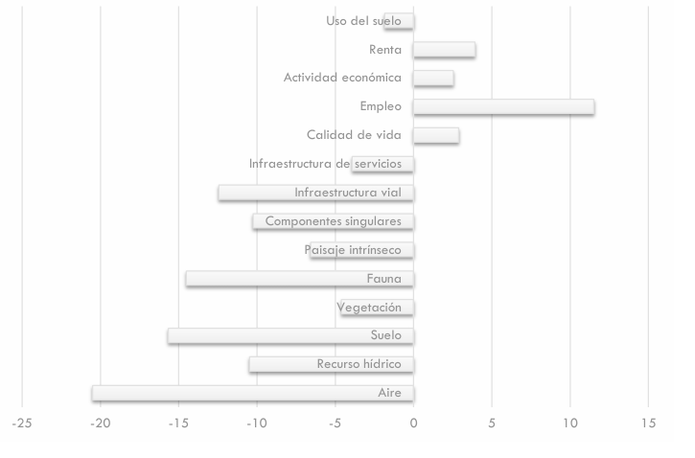
IFigure 11 Cannava project environmental impacts
The negative impacts correspond to the preparation of the site related to the change in land use and removal of vegetation and execution phase. The air impact is due to the alteration of its quality due to the emission of combustion gases, particulate matter and noise generation, either from the movement of vehicles or from tasks related to site preparation over execution phase.
From the positive point of view, employment component receives the highest rating following the better quality of life conditions and the economic activities relationship.
Figure12: Los Lapachos project environmental impacts
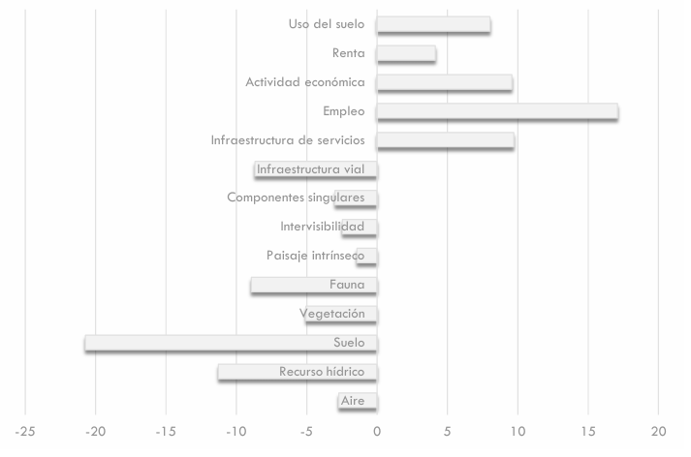

Figure13: El Carmen project environmental impacts
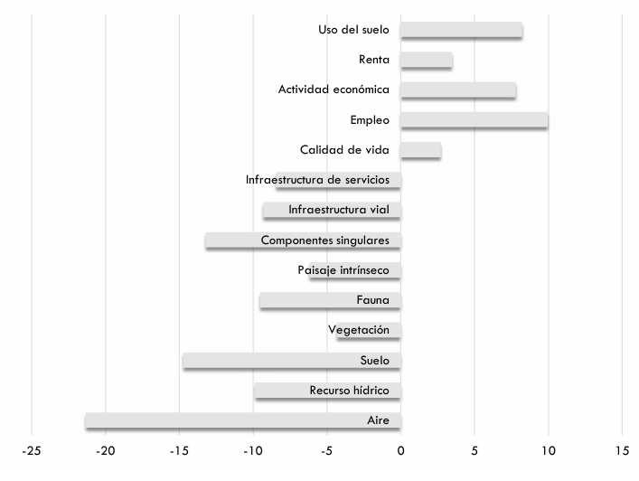
.
An Environmental Management Plan (EMP) was prepared whose objective is to ensure the correct environmental management of the different actions during the construction, operation and closure or dismantling phases. In this way, the impact in the environmental quality of the receiving environment of the undertaking, in its natural and socioeconomic aspects, will be avoided.
The components: air, biotic, perceptual, soil, water resources, impacts on the Socio-Economic Environment and Territorial Development, road and service infrastructure have a detail EMP (Chapter 8 EIA).
The EIA involved both in-house and survey tasks in the area. Regarding socio-economic aspects, the impact of the project was analyzed on: biodiversity and ecosystems, cultural heritage, involuntary resettlement, native communities and erosion risk. The area of Direct Influence was even taken into account (covering the area where each solar plant will be installed and the immediately adjacent areas) and the Area of Indirect Influence (covering the Santa Clara, San Pedro, Chalicán and Fraile Pintado area)
For the analysis, the methodology proposed by Hernández (2013) was adopted and as can be seen, the Valle Sur Project resulted in a low rating, without the need to implement mitigation measures or management plans.
Table 5 Socio-economic aspects
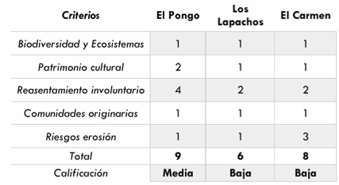

Stakeholder engagement and consultation
The stakeholders meeting was conducting on November 3 2023 where the "Distributed Solar Photovoltaic Project of the Province of Jujuy" and specific details of the Cannava and Los Lapachos projects were described. On November 30, 2023 was carried out El Carmen meeting.
The consultation process is described below:
- the scope of stakeholder consultations: local authorities, media, schools educational authorities in the area and the community.
- the number of stakeholders consulted: 71 people attended the meeting on 3rd November and 29 people participated in the meeting in 30th November.
- the means used to invite interested parties to participate in the consultations; The invitation was sent to the Mayor (Intendente) of the municipality of San Antonio (El Carmen) and Perico (Cannava and Los Lapachos) and was published in the local newspaper "El Tribuno" and "El Pregón" on 11/25/23, 11/29/23 and 11/23/23.
- It was also published on social networks such as Facebook, JEMSE's website and Linkedin, Facebook of the Government of Jujuy and the graphic invitation was also placed in the House of Culture, Espacio de la Primer Infancia and the Municipalidad.
- The information that was made available to stakeholders during the consultation process: The project presentation (characteristics, execution deadlines, generation), its coherence with the provincial objectives, the EIA and its results. It was also communicated that the project would apply to obtain carbon credits, and a general explanation about this.
- the meetings, workshops and other processes developed in the framework of the stakeholder consultation: The contact email contacto@secco.com.ar was made available during the stakeholders meeting diffusion where they could send questions or doubts about the project.
For evidence regarding to invitations, meeting, assistance and opinion survey see the folder STAKEHOLDERS MEETING.

Summary of comments received
The comments received in the opinion survey are transcribed below.
Table 11: Summary of comments received
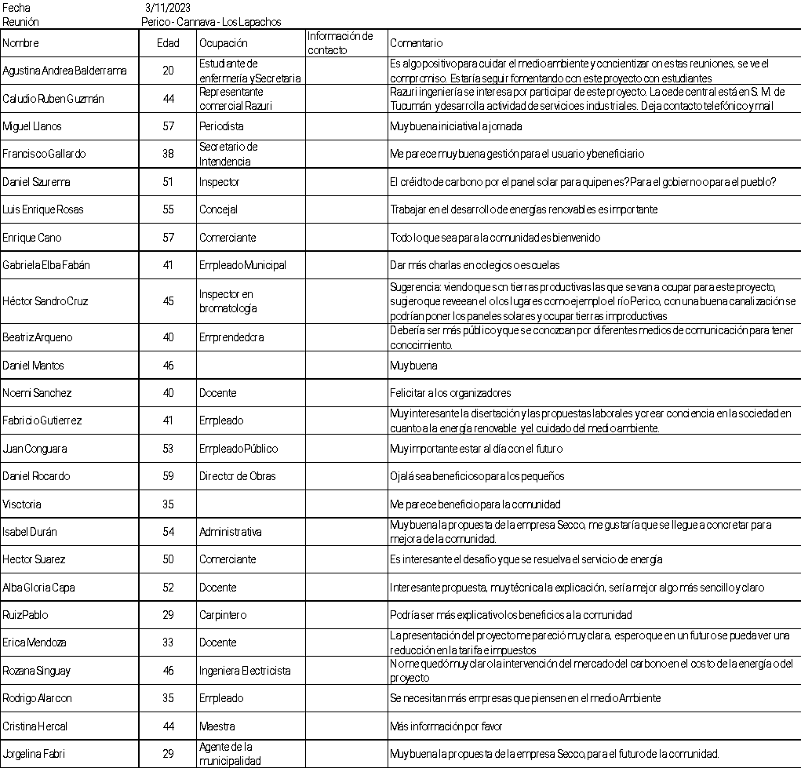

Consideration of comments received
Unfortunately, no participant left their contact information or sent the same comment to the postal address, so it was impossible to respond formally to the suggestions or questions. In any case, after the presentation, the concerns were discussed between the interested party and the representatives of EJESA and SECCO.

Sustainable Development Goals (SDGs)
The Tool for Determining the Contributions of GHG Projects to Achieving the Sustainable Development Goals (SDGs) proposed by BioCarbon was used as a support and basis for the identification of the SDGs on which the project has an impact and its rationale.
All the Sustainable Development Goals that are linked to the Valle Sur Project, their description and objectives are specified below. It should be clarified that these were not incorporated in the Tool proposed by BioCarbon due to their specificity and their specific framework for action in the surrounding community.
  - SDG 3 Ensure healthy lives and promote well-being for all and all ages
SECCO understands that the development and strengthening of alliances is fundamental to achieving the necessary engagement with the community and surrounding organizations.
Objectives:
Organize at least one annual on-site training with El Carmen's volunteer firefighters and generate an exchange of knowledge. Ensure that they are familiar with the facilities and promote efficient emergency response
  - SDG 5: Gender equality.
Searches for permanent personnel will not have any clarification on gender preference and the estimated salary for such functions is defined independently of who occupies the position.
As part of the Secco policy described above, during the construction and assembly phase an attempt was made to employ women. The search for personnel was open to both genders; no CVs were received from women who met the technical requirements. If a new search is to be carried out, it will be under the same modality.
Secco believes that the Argentina northern region preserves the idiosyncrasy and customs of the indigenous peoples more deeply than in the rest of the country and this is the reason why it was difficult to incorporate women into this kind of jobs.
Objective: to increase the participation of women involved in the Valle Sur Project.
  - SDG 7: Affordable and clean energy
The project generates up to 30.540 GWh/year that are incorporated into the country's energy matrix.
Objective: to maintain photovoltaic generation following good operation and maintenance practices.
  - SDG 8: Decent Work and Economic Growth
The project generated temporary jobs during construction and assembly, and during operation at least 2 people from Jujuy are employed on a stable basis for operation and maintenance.
Due to the socio-economic characteristics of the Argentina northern region, it is important that Secco monitors and ensures that all employees hired by Secco and third parties are under Argentine labour law N° 20.744. For the same reasons, it is essential to apply Secco's procedures on workplace safety, seeking a rate of zero fatal accidents (Seguridad Laboral, procedures PRG – SMA – 023 and Política de gestión integrada). Thus, fulfilling goal 8.8.
Objectives:
Seeking zero fatal accidents.
Ensure that all employees hired by Secco and third parties are under Argentine labour law.
Prioritize the hiring of local workers.
  - SDG 10 Reduced inequalities
In order to guarantee equal opportunities, there will be at least one meeting per year with the community and its representatives to record the needs raised, which will be considered internally and incorporated into SECCO's budget to be executed in the following year.
Ensure compliance with the PROCEDIMIENTO GESTION NORMATIVA that the reporting channels opere properly (fulfilling goal 10.3).
Objectives:
Hold an annual exchange meeting with the community and its representatives.
Avoid causes for complaints and, in the event of receiving them, give the treatment established in the procedure.
  - SDG 13: Climate Action
Up to 10,889 tCO2/a will be reduced.
Objective: to maintain photovoltaic generation following good operation and maintenance practices.

REDD+ Safeguards (For REDD+ projects)
Not applicable

Special categories, related to co-benefits (optional)
Not applicable

Grouped projects (if applicable)
According to BCR STANDARD and methodologies Valle Sur project is not a grouped project. The areas and plants identified in this document are the only ones that make up the Valle Sur Project. It is not planned to add additional instances to those already included in this project document.

Other GHG program
Not applicable

Double counting avoidance
In compliance with the Biocarbon Registry Standard version 3.4, the Avoiding Double Counting (ADC) Tool version 2.0 is applied to ensure that the project does not and will not commit any type of double counting with its carbon credits.
According to section 7 of the ADC Tool, double counting is defined as counting a greenhouse gas mitigation result in tonnes of CO2 in the following scenarios:
(a) a ton of CO2e is counted more than once to demonstrate compliance with the same GHG mitigation goal;
(b) one ton of CO2e is counted to demonstrate compliance with more than one GHG mitigation goal;
(c) a ton of CO2e is used more than once to obtain remuneration, benefits, or incentives;
(d) one ton of CO2e is verified, certified, or accredited assigning more than one serial to a single mitigation result.
As of the date of preparation of this document, this project has not issued any carbon credits, therefore it does not meet any of the conditions mentioned in the ADC Tool for a double counting situation to be considered to have been generated. However, SECCO undertakes not to commit any of the parameters defined above as double counting
In turn, section 8.4 of the ADC Tool defines that if the project owners wish to sell their carbon credits to the CORSIA program, a Host Country Attestaion (HCT) must be presented certifying that the host country is aware of what has happened with this project and that it will not consider the CO2 reductions of the project in the preparation of the Nationally Determined Contributions (NDCs) reports within the framework of the Paris Agreement. The sole owners of the Carbon credits to be issued by this project will be the exclusive property of SECCO.

Monitoring plan
Valle Sur monitoring plan is in accordance with the BCR Tool. Monitoring, Reporting and Verification (MRV) version 1.0 and with PROCEDIMIENTO DE MONITOREO Y CONTROL DE LOS PS FV JUJUY development for Secco for any photovoltaic project in Jujuy province (attach as evidence).
The Monitoring Plan developed was based on:
- IEC 61724 PV Plant Performance Standard.
- Best Practice Guidelines / Version 5.0 – Solar Power Europe O&M Report.
- PVsyst – Simulation report.
Secco has all its generation plants linked to the SCADA system and operated from the Operations Center (COG) located in Rosario that operates 24 hours a day, seven days a week.
The Plan contains the following key scope:
Roles and responsibilities of the COG operators
Control and monitoring of all PV PS parameters.
Reporting of alarms, events and faults.
Presentation of reports on generation, performance and events that occur.
Due to the project participant's choice of an ex-ante emission factor, the most important variable to monitor is the project's electricity generation. It will be measured according to the national rules and regulations for wholesale market participants. SMECs will be installed at the distribution center in medium voltage in each site; protection relays in medium voltage cells (at SECCO's distribution center) and multi-meters (at the solar farm's transformation centers) in the medium voltage cells.
All meters will have records and generation data ready to be downloaded remotely, the information will be acquired at programmable intervals ranging from a minimum to a maximum of one hour.
The information is supported by the operational team (COG). Data is included in an Excel spreadsheet for emission reduction calculations on a monthly basis. All data collected as part of the monitoring process is archived electronically and retained for at least two years after the end of the last crediting period. After that period the information will be stored in backup copies that can be reconstructed if necessary.
Parameter | SDG 3 Ensure healthy lives and promote well-being for all and all ages
Unit | training/year
Description | Organize at least one annual on-site training with El Carmen's volunteer firefighters and generate an exchange of knowledge. Ensure that they are familiar with the facilities and promote efficient emergency response.
Source | Safety and Environment Area of Industrias Juan F. Secco
Purpose of monitoring | Fulfillment of SDG 3.d.1.
Monitoring frequency | Annual

Parameter | SDG 5 Gender equality
Unit | % of women involved in the Valle Sur Project
Description | Searches for stable personnel without any clarification of gender preference and the estimated salary for such functions is defined independently of who occupies the position.
Source | Human Resources of Juan F. Secco Industries
Purpose of monitoring | Achieving SDG 5
Monitoring frequency | Annual

Parameter | SDG 7: Affordable and clean energy
Unit | MWh/year
Description | Amount of net electricity generation supplied by the project plant/unit to the grid in the year.
Source | SMEC Class 0.2 meters  Cannava PV power Plant:  Schneider Electric ION 8650; SN: MW-2404A267-02  El Carmen PV power Plant:  Schneider Electric ION 8650; SN: MW-2403A998-02  Los Lapachos PV power Plant:  Schneider Electric ION 8650; SN: MW-2404A255-02
Purpose of monitoring | Calculation of reference emissions.  Billing per MWh generated.
Monitoring frequency | Continuous measurement  The calibration frequency of the measurement and control equipment of photovoltaic plants was established through the Minutes of the Meeting on "Calibration of Energy Meters and Pyrometers" signed by the representatives of EJESA and SECCO on 05/11/2024. This calibration will be carried out every four (4) years.

Parameter | SDG 8: Decent Work and Economic Growth
Unit | Occupational injuries/year  Local People hired/year
Description | Seeking zero fatal accidents.  Ensure that all employees hired by Secco and third parties are under Argentine labour law.  Prioritize the hiring of local workers.
Source | Safety and Environment and Human Resources of Juan F. Secco Industries
Purpose of monitoring | Fulfillment of SDG 8.
Monitoring frequency | Annual

Parameter | SDG 10 Reduced inequalities
Unit | Meeting/year  Complaints/year
Description | Hold an annual exchange meeting with the community and its representatives.  Avoid causes for complaints and, in the event of receiving them, give the treatment established in the procedure.
Source | Human Resources of Industrias Juan F. Secco
Purpose of monitoring | Fulfillment of SDG 10.
Monitoring frequency | Annual

Parameter | SDG 13: Climate Action
Unit | tCO₂/year
Description | Maintain photovoltaic generation following good operation and maintenance practices.
Source | Chief Operating Officer, Juan F. Secco Industries
Purpose of monitoring | Fulfillment of SDG 13.
Monitoring frequency | Annual

Parameter | EGfacility_{,y}
Unit | MWh/year
Description | Amount of net electricity generation supplied by the project plant/unit to the grid in the year.
Source | SMEC Class 0.2 meters  Cannava PV power Plant:  Schneider Electric ION 8650; SN: MW-2404A267-02  El Carmen PV power Plant:  Schneider Electric ION 8650; SN: MW-2403A998-02  Los Lapachos PV power Plant:  Schneider Electric ION 8650; SN: MW-2404A255-02
Purpose of monitoring | Calculation of reference emissions.  Billing per MWh generated.
Monitoring frequency | Continuous measurement  The calibration frequency of the measurement and control equipment of photovoltaic plants was established through the Minutes of the Meeting on "Calibration of Energy Meters and Pyrometers" signed by the representatives of EJESA and SECCO on 05/11/2024. This calibration will be carried out every four (4) years.

© 2024 BioCarboN
n Cert→. All rights reserved. This format can only be used for projects for certification and registration with BioCarbon. Reproduction in whole or in part is prohibited.
NOTE: This Project Document (PD) shall be completed following the instructions included. However, it is important to highlight that these instructions are complementary to the BCR Standard, and the Methodology applied by the project holder, in which more information on each section can be found.

https://cammesaweb.cammesa.com/informe-anual/
http://datos.energia.gob.ar/dataset/7d47693a-c533-4e76-ae24-374c3205715a/archivo/898b40b3-c0f0-4d1b-971c-b1b88daa050d
attp according to each project
https://www.secco.com.ar/?gclid=CjwKCAiA5sieBhBnEiwAR9oh2gBW2GokgnZJGAxE14BhMTayzV8mfaJW8A9JxDNNHu_hkh01vvckaRoCs0gQAvD_BwE#!/company#values
https://www.argentina.gob.ar/sites/default/files/segunda_contribucion_nacional_final_ok.pdf
https://servicios.infoleg.gob.ar/infolegInternet/anexos/295000-299999/296846/norma.htm

